**Getting PDFs to work well with TeXnicCenter**

Once you have TeXnicCenter open, in the ribbon along the top:

* Choose “Build”
* Choose “Define Output Profiles...”
* Switch the tab to “Viewer” (circled on the snip below)
* Switch the profile to anything that ends with pdf (circled on the snip below)
* Make sure that all nine of the entries on the snip below are as indicated (note that the path name has been cut off a bit in the snip, but that part is usually correct by default)
* Make sure you do this for every profile that ends in pdf!
* 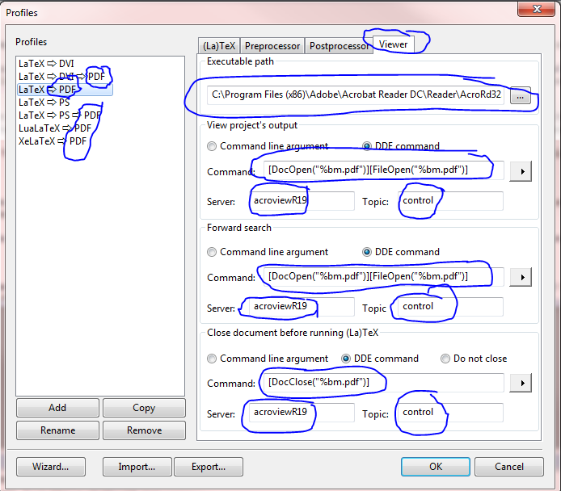
* Note: We usually only use LaTeX ⇒ PDF or LaTeX ⇒ PS ⇒ PDF, so those are the two most important profiles to update.