To get gsview to update when re-compiling (rather than opening a new window):

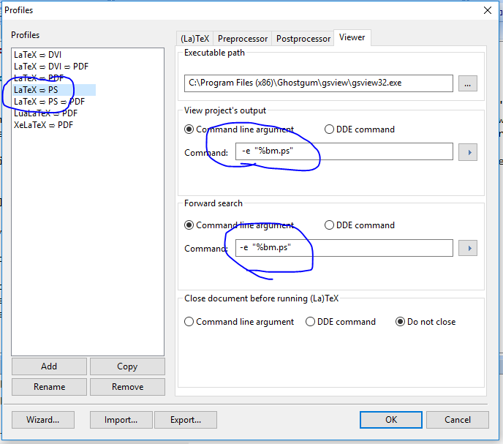

If you have Adobe Acrobat Pro DC, you need to use an ‘acroviewA19’ instead of an ‘acroviewR19’. I believe that if you have the Reader instead of the Pro version, you would still use the R. Note that the computers in Maclean 169 have the Pro version, so use the A. My guess is that your personal machine has the free reader, so the R. (The 19 is based on the version of your Adobe product. If you have an older version, figure out what version you have and use the year-code.)

