**Directions on how to configure TeXnicCenter in the campus computer labs.**

Note: The way the campus computers are set up, you will have to do this for every computer that you use on campus. But once you’ve set it up on a particular computer, you should be able to continue to use that particular computer for the rest of the semester without having to set it up again. (So it is to your benefit to sit at the same computer each day.)

Note: For installation on your personal computer, you may have to find the correct folders for the latex.exe and GSview.

The program latex.exe is used to actually run LaTeX (TeXnicCenter is just an interface to help us write the code). The output of LaTeX is either a .dvi file, a .ps file, or a .pdf file. There are often some issues with .pdf viewers interfacing with the LaTeX interfaces, such as TeXnicCenter, so I usually compile to .ps files (that is, postscript files). LaTeX naturally creates a .dvi file, but the .dvi viewers tend to be a bit fragile, so I often don’t use them anymore. GSview is a good .ps viewer (that does not require you to first convert the file to another format, which is the Adobe default that is set on the campus computers).

To configure TeXnicCenter, follow these steps (note that a lot of these are snips, so click on what is circled):

1. On the desktop, open the “Mathematics” folder.
2. Click on TeXnicCenter
3. We will set it up *carefully* - do not automatically choose all of the defaults, or it won’t work properly!
   1. For the first dialog box, agree to work in English.
   2. The next box starts a Configuration dialog. Hit “Next” to start the configuration.
   3. We need to tell TeXnicCenter where the latex.exe file is:
      1. 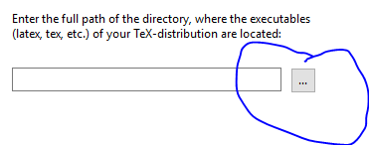
      2. 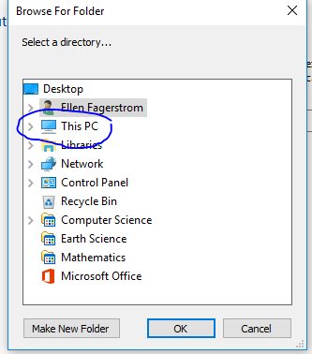
      3. 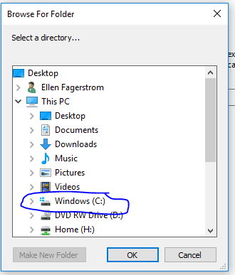
      4. 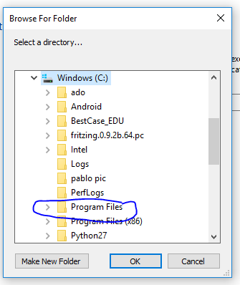
      5. Then you’ll have to scroll down to get to:
      6. 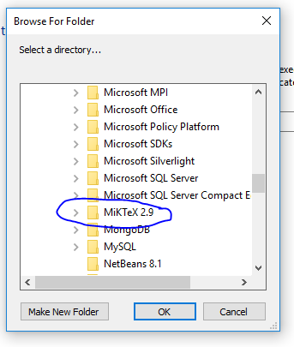
      7. Scroll down again to get to
      8. 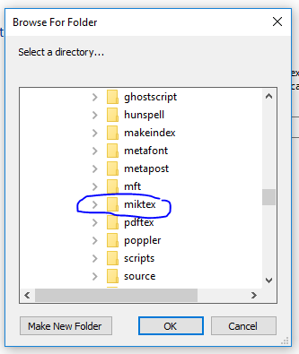
      9. 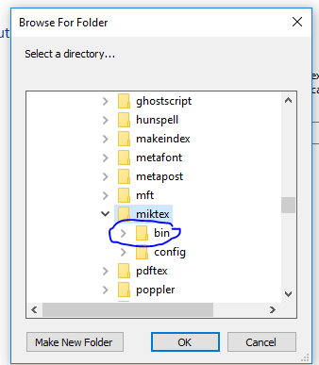
      10. 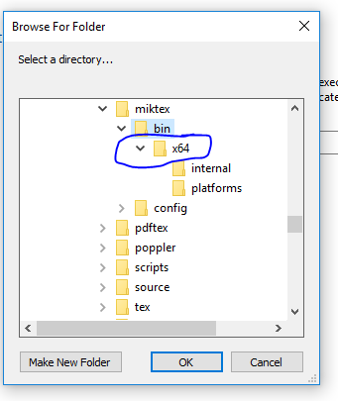
      11. 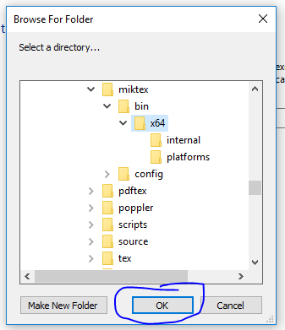
   4. Now we should be back at the Configuration Wizard and can continue:
   5. 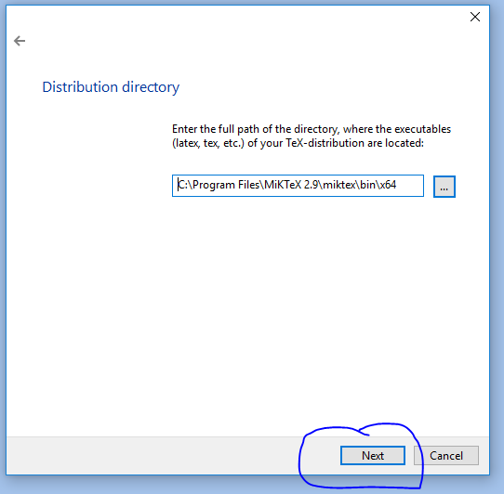
   6. The next dialog is to tell TeXnicCenter what to use for a postscript viewer. Do *not* choose the default! It won’t actually view postscript files (it just converts them to pdfs instead, which would become burdensome to be constantly doing when working with LaTeX). Instead:
   7. 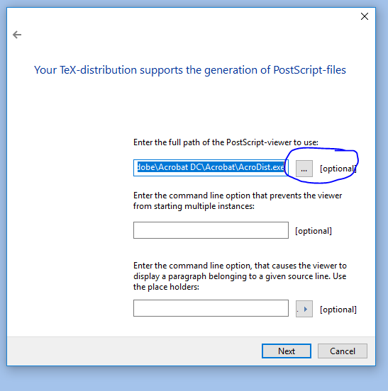
   8. 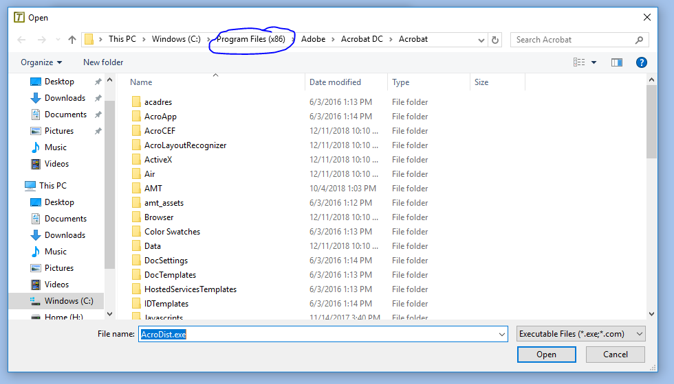
   9. 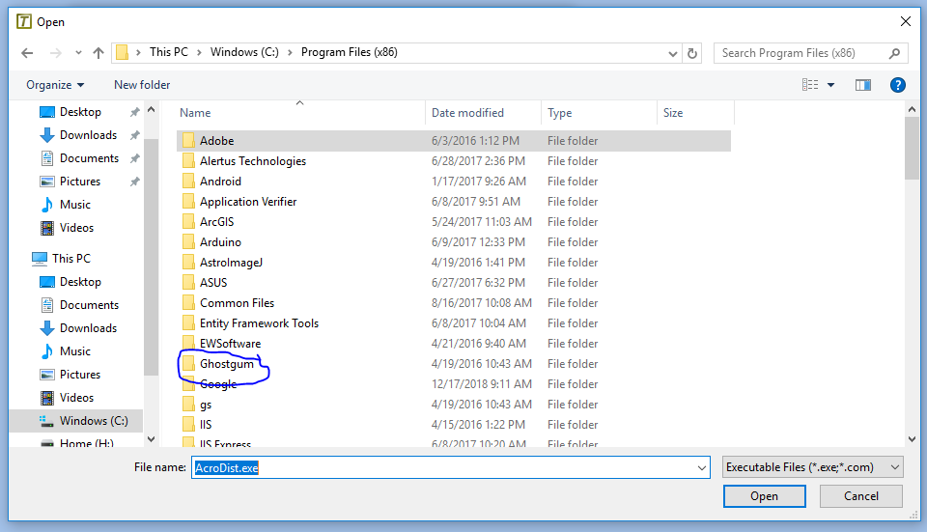
   10. 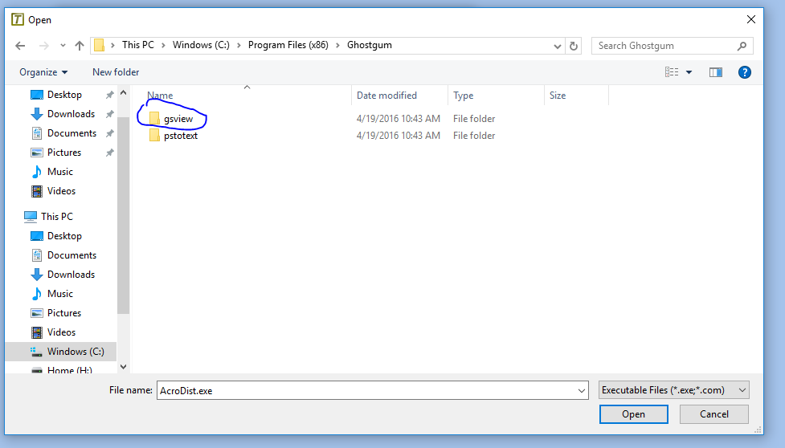
   11. 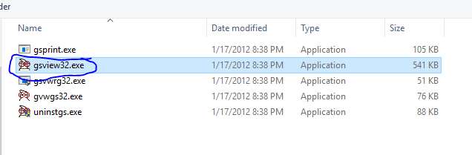
   12. That should take you back to the Configuration Wizard.
   13. 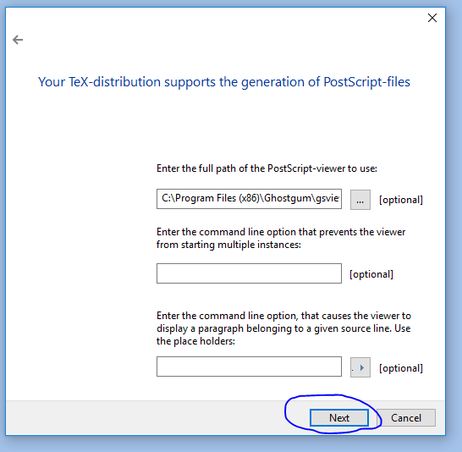
   14. 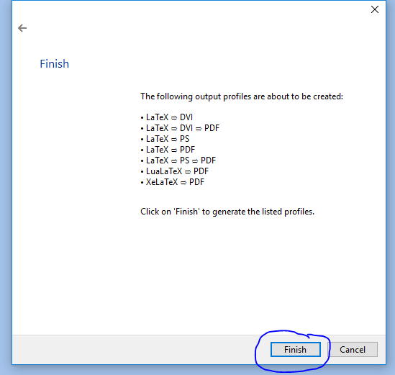
   15. Now your TeXnicCenter should be set up to use for .ps files (as well as .dvi files, which are part of the default LaTeX setup).

Note: If you didn’t get this all done when you first opened TeXnicCenter and yet no longer get the Configuration Wizard to help you, you can set it up by using the pulldown menus in the ribbon: “Build”, then “Define Output Profiles…”. That will open up a new dialog. It, by default, opens up to the tab for setting up (La)TeX. Note that you may have to set up the latex.exe path name for multiple profiles. If what you need to set up is the Viewer instead, switch to that tab. You will also likely need to switch to the Profile that you want to use (such as LaTeX -> PS for the .ps file viewer).