[](http://www.mnstate.edu/)

**Co-Teaching Summer Institute**

**Minnesota State University Moorhead**

**Thursday, August 13, 2015**

**Friday, August 14, 2015**

C:\Users\knutson\AppData\Roaming\SoftChalk\LessonBuilder 9\pagebreak.png

**The Co-Teaching Book of Lists**

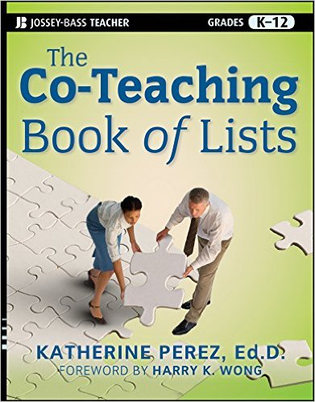**by Katherine Perez**

**Agenda**

**Day One:**

8:15 - 8:30 **Registration and Coffee**

8:30 - 9:45   **What co-teaching is: What it is not; Advantages for Teacher and Students**

* **Chapter One: Co-Teaching in a Nut Shell**

9:45 - 10:00 **BREAK**

10:00 - 11:30 **Overview of Co-Teaching Models**

* **Chapter Two: Co-Teaching Models**

11:30 - 12:45 **LUNCH BREAK**

12:45 - 1:45 - **Where do you Start? Working as a Collaborative Team. Developing your Action Plan (Part 1).**

* **Chapter Three: Where Do I Start?**
* **Chapter Five: Collaborations: Working as a Team**

1:45 - 2:00 **BREAK**

2:00 - 3:30 **Co-teaching Road Map. Administrative issues. Developing your Action Plan (Part 2).**

* **Chapter Four: Where Do You Go? A Co-Teaching Road Map**
* **Chapter Seven: School Wide Organization: Administrative Issues**

**Day Two:**

8:30 - 9:45 **Organizing and Planning for Success; Accommodations and Modifications**

* **Chapter Six: Organizing and Planning for Success**
* **Chapter Eight: Accommodations and Modifications That Make a Difference**

9:45 - 10:00 **BREAK**

10:00 - 11:30- **Instructional Strategies**

* **Chapter Nine: Instructional Strategies for Different Types of Learners**
* **Plus ++ Handouts**

11:30 - 12:45 - **LUNCH BREAK**

12:45 - 1:45 - **Questions/Answers - Applying you Learned and Developing your Action Plan (Part 3).**

1:45 - 2:00 **BREAK**

2:00 - 3:15 - **Applying What You Learned and Developing your Action Plan (Part 4).**

3:15 - 3:30 - **Participation Certificates and Review of Follow Up Visit.**

**Welcome!**

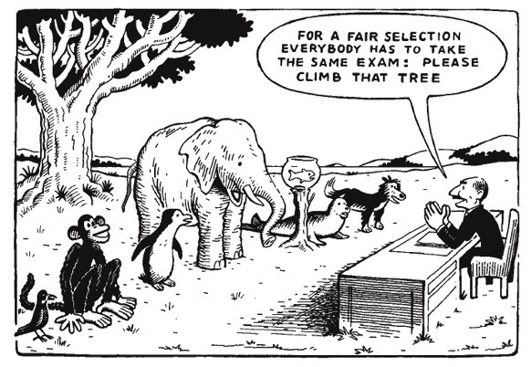

***Read the Story from Harry Wong: pg. XV***

C:\Users\knutson\AppData\Roaming\SoftChalk\LessonBuilder 9\pagebreak.png

# ****Originally... Co-Teaching is...****



**Our goal with this Co-Teaching Summer Institute is to expand**

**the possibility of utilizing CO-TEACHING**

**into more than usage within the original concept of CO-TEACHING.**

C:\Users\knutson\AppData\Roaming\SoftChalk\LessonBuilder 9\pagebreak.png

**Characteristics of Co-Teaching:**

* **Two or more licensed teachers**
* **Instruction in single classroom setting**
* **Both (or all) are actively involved and physically present**
* **Deliver instruction collaboratively**
* **Share leadership**
* **Communication and Collaboration are PRIORITY!**
* **Share in PLANNING**
* **Share in ASSESSMENT**
* **Meet the needs of students**
* **Share RESOURCES**
* **Share ACCOUNTABILITY**

**What is Co-Teaching?**

**Co-Teaching is two or more professionals working together to provide instruction to students in an inclusive setting.**

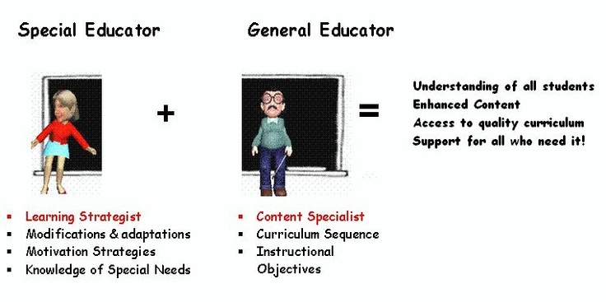**A General Model**

True or False

* Co-Teaching is easy. (False)
* Co-Teaching is the only way! It is right for EVERY teacher in ANY situation. (False)
* Co-Teaching can "FIX WEAK" teachers. (False)
* Co-Teaching is teaching where "I'm on" and your "off". (False)
* Co-Teaching is also known as "TEAM TEACHING". (False)
* Co-Teaching allows one teacher to dominate the discussion. (False)
* Co-Teaching allows the specialist to work only with "special needs" children. (False)
* Co-Teaching works when both teachers work together as equals; they are consistent in planning, instruction delivery, applied practice time, and assessment. (True)

**\*\*Review page 5: List 1.4: Framework for Co-Teaching**

C:\Users\knutson\AppData\Roaming\SoftChalk\LessonBuilder 9\pagebreak.png

**Advantages for Teacher and Students**

* Students develop better attitudes about themselves, academic improvement, and social skills
* Teacher-to-student ratio in increased, leading to better teaching and learning conditions
* Teachers are able to use research-proven teaching strategies effectively.
* A greater sense of community is fostered in the classroom.
* Co-teachers report professional growth, personal support, and enhanced motivation.
* Increased job satisfaction can be experienced because needs for survival, power, freedom and choice, a sense of belonging, and fun are met. (Villa, Thousand, & Nevin, 2013, p. 19)

C:\Users\knutson\AppData\Roaming\SoftChalk\LessonBuilder 9\pagebreak.png

# 9:45 - 10:00 ****BREAK****



C:\Users\knutson\AppData\Roaming\SoftChalk\LessonBuilder 9\pagebreak.png

# Overview of Co-Teaching Models

(Handouts)

# Co-Teaching Examples from St. Cloud State:

# Using Co-Teaching with Student Teachers

(Handouts)

C:\Users\knutson\AppData\Roaming\SoftChalk\LessonBuilder 9\pagebreak.png

# Getting started

* Review Page 20 from Beninghof and Kunkel (2012)
* Located in Handout review the models and decide which ones you are most interested in.

|  |  |  |  |  |
| --- | --- | --- | --- | --- |
| **Model** | **We’ll Try this one…** | **We tried this and liked it!** | **We tried this and will pass…** | **Comments** |
| **Lead and Support Model** |  |  |  |  |
| **Duet Model** |  |  |  |  |
| **Speak and Add/Chart Model** |  |  |  |  |
| **Skills Group Model** |  |  |  |  |
| **Station Teaching Model** |  |  |  |  |
| **Learning Style Model** |  |  |  |  |
| **Parallel Teaching Model** |  |  |  |  |
| **Complimentary Instruction Model** |  |  |  |  |
| **Adapting Model** |  |  |  |  |

C:\Users\knutson\AppData\Roaming\SoftChalk\LessonBuilder 9\pagebreak.png

### Activity: "Blanket the Table"

1. Divide into groups
2. Provide scrap pieces of paper
3. Have participants stand around their table
4. Set timer for 1-2 minutes
5. Direct students to state out loud an example of material covered (Co-Teaching Models) and how they might use it. Have them write it on the paper and drop it on the table.
6. Goal is to blanket the table with as many ideas as possible.

C:\Users\knutson\AppData\Roaming\SoftChalk\LessonBuilder 9\pagebreak.png

# 11:30 - 12:45 ****LUNCH BREAK****

# C:\Users\knutson\AppData\Local\Microsoft\Windows\Temporary Internet Files\Content.IE5\F3QEYGW1\lunch[1].jpg

C:\Users\knutson\AppData\Roaming\SoftChalk\LessonBuilder 9\pagebreak.png

# ****Chapter Three: Where Do I Start?****

### ****Classroom Behavior Tolerance Scale****

### 

C:\Users\knutson\AppData\Roaming\SoftChalk\LessonBuilder 9\pagebreak.png

|  |  |  |  |
| --- | --- | --- | --- |
| **Worksheet for Establishing Co-Teaching Expectations** | | | |
| **Co-Teaching Team: Date:** | | | |
| **Expectations** | **Mine** | **Partners** | **Our classrooms** |
| **Classroom Policies and**  **procedures** |  |  |  |
| **Teaching style/preferences** |  |  |  |
| **Behavior Management** |  |  |  |
| **Academic Goals** |  |  |  |
| Taken from Co-Teaching in the Differentiated Classroom; Fattig & Taylor | | | |

## C:\Users\knutson\AppData\Roaming\SoftChalk\LessonBuilder 9\pagebreak.png

### ****Value Cards****

### 

### C:\Users\knutson\AppData\Roaming\SoftChalk\LessonBuilder 9\pagebreak.png

# ****Chapter Four: Where Do You Go? A Co-Teaching Road Map****

Refer to Guidelines in Chapter 4

C:\Users\knutson\AppData\Roaming\SoftChalk\LessonBuilder 9\pagebreak.png

1:45 - 2:00 **BREAK**



C:\Users\knutson\AppData\Roaming\SoftChalk\LessonBuilder 9\pagebreak.png

# ****Co-teaching Road Map. Developing your Action Plan (Part 2).****

## ****Chapter Five: Collaborations: Working as a Team****

### ****Building a Collaborative Relationship****

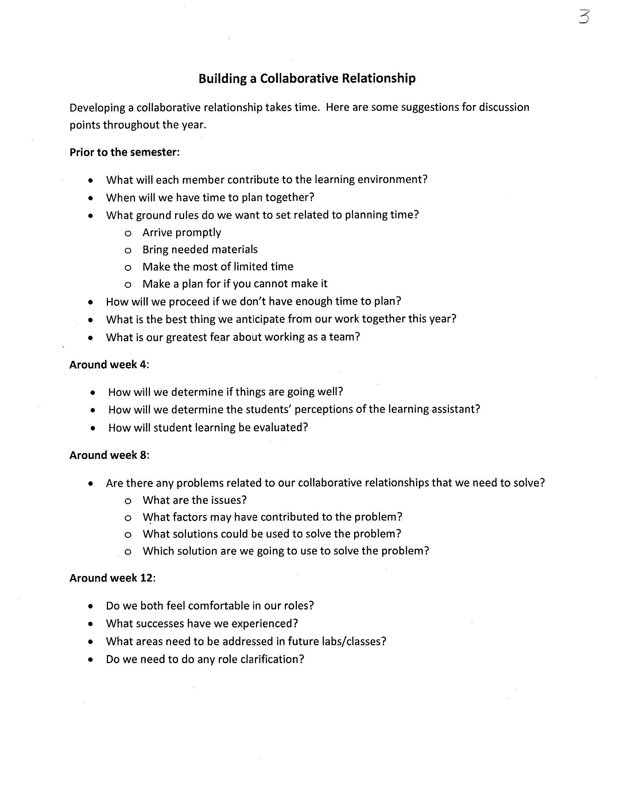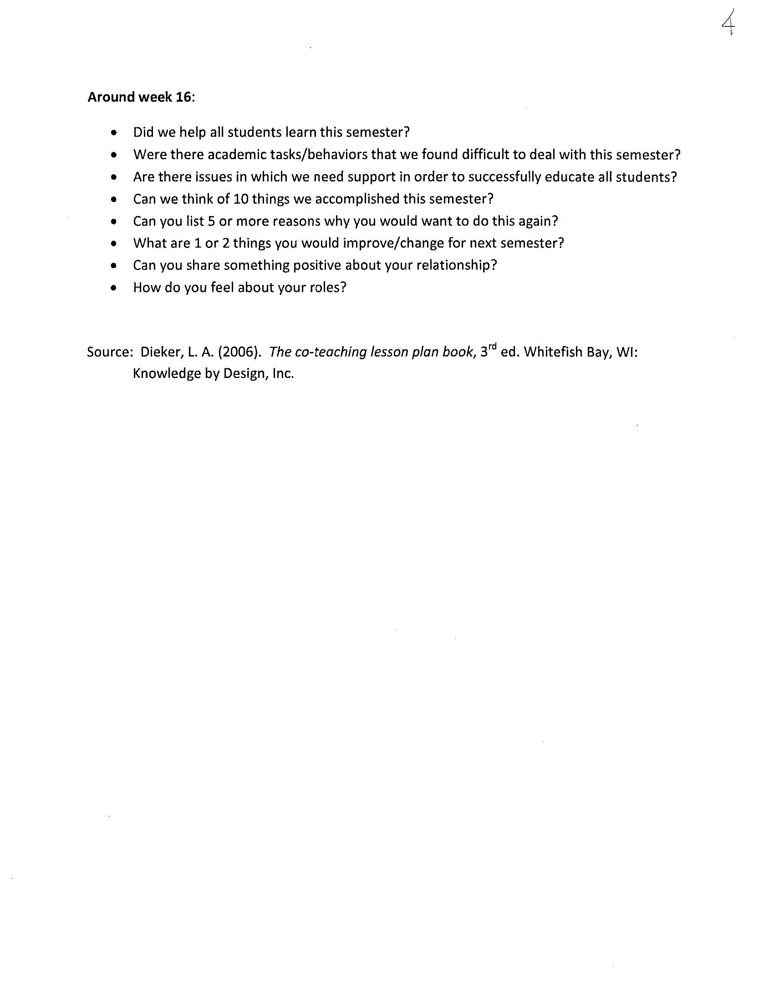C:\Users\knutson\AppData\Roaming\SoftChalk\LessonBuilder 9\pagebreak.png

# What can cause conflict?

**Co-Teaching Issues for Discussion and Planning**

Strengths the experienced teacher brings are: Strengths the student teacher brings are:

\_\_\_\_\_\_\_\_\_\_\_\_\_\_\_\_\_\_\_\_\_\_\_\_\_\_\_\_\_\_\_\_\_\_\_\_\_ \_\_\_\_\_\_\_\_\_\_\_\_\_\_\_\_\_\_\_\_\_\_\_\_\_\_\_\_\_\_\_\_\_\_\_\_

\_\_\_\_\_\_\_\_\_\_\_\_\_\_\_\_\_\_\_\_\_\_\_\_\_\_\_\_\_\_\_\_\_\_\_\_\_ \_\_\_\_\_\_\_\_\_\_\_\_\_\_\_\_\_\_\_\_\_\_\_\_\_\_\_\_\_\_\_\_\_\_\_\_

\_\_\_\_\_\_\_\_\_\_\_\_\_\_\_\_\_\_\_\_\_\_\_\_\_\_\_\_\_\_\_\_\_\_\_\_\_ \_\_\_\_\_\_\_\_\_\_\_\_\_\_\_\_\_\_\_\_\_\_\_\_\_\_\_\_\_\_\_\_\_\_\_\_

\_\_\_\_\_\_\_\_\_\_\_\_\_\_\_\_\_\_\_\_\_\_\_\_\_\_\_\_\_\_\_\_\_\_\_\_\_ \_\_\_\_\_\_\_\_\_\_\_\_\_\_\_\_\_\_\_\_\_\_\_\_\_\_\_\_\_\_\_\_\_\_\_\_

My fears as faculty about co-teaching are: Fears as a student teacher have about co-teaching are:

\_\_\_\_\_\_\_\_\_\_\_\_\_\_\_\_\_\_\_\_\_\_\_\_\_\_\_\_\_\_\_\_\_\_\_\_\_ \_\_\_\_\_\_\_\_\_\_\_\_\_\_\_\_\_\_\_\_\_\_\_\_\_\_\_\_\_\_\_\_\_\_\_\_

\_\_\_\_\_\_\_\_\_\_\_\_\_\_\_\_\_\_\_\_\_\_\_\_\_\_\_\_\_\_\_\_\_\_\_\_\_ \_\_\_\_\_\_\_\_\_\_\_\_\_\_\_\_\_\_\_\_\_\_\_\_\_\_\_\_\_\_\_\_\_\_\_\_

\_\_\_\_\_\_\_\_\_\_\_\_\_\_\_\_\_\_\_\_\_\_\_\_\_\_\_\_\_\_\_\_\_\_\_\_\_ \_\_\_\_\_\_\_\_\_\_\_\_\_\_\_\_\_\_\_\_\_\_\_\_\_\_\_\_\_\_\_\_\_\_\_\_

\_\_\_\_\_\_\_\_\_\_\_\_\_\_\_\_\_\_\_\_\_\_\_\_\_\_\_\_\_\_\_\_\_\_\_\_\_ \_\_\_\_\_\_\_\_\_\_\_\_\_\_\_\_\_\_\_\_\_\_\_\_\_\_\_\_\_\_\_\_\_\_\_\_

**Ground Rules for operating as a team:**

1. There will be no unspoken resentments. We will deal with any conflict in an open manner.
2. \_\_\_\_\_\_\_\_\_\_\_\_\_\_\_\_\_\_\_\_\_\_\_\_\_\_\_\_\_\_\_\_\_\_\_\_\_\_\_\_\_\_\_\_\_\_\_\_\_\_\_\_\_\_\_\_\_\_\_\_\_\_\_\_\_\_\_\_\_\_\_\_\_\_\_\_\_\_\_
3. \_\_\_\_\_\_\_\_\_\_\_\_\_\_\_\_\_\_\_\_\_\_\_\_\_\_\_\_\_\_\_\_\_\_\_\_\_\_\_\_\_\_\_\_\_\_\_\_\_\_\_\_\_\_\_\_\_\_\_\_\_\_\_\_\_\_\_\_\_\_\_\_\_\_\_\_\_\_\_
4. \_\_\_\_\_\_\_\_\_\_\_\_\_\_\_\_\_\_\_\_\_\_\_\_\_\_\_\_\_\_\_\_\_\_\_\_\_\_\_\_\_\_\_\_\_\_\_\_\_\_\_\_\_\_\_\_\_\_\_\_\_\_\_\_\_\_\_\_\_\_\_\_\_\_\_\_\_\_\_

**Logistics**

Both faculty and student teachers are to identify three pet peeves that that may affect their co-teaching relationship?

\_\_\_\_\_\_\_\_\_\_\_\_\_\_\_\_\_\_\_\_\_\_\_\_\_\_\_\_\_\_\_\_\_\_\_\_\_\_\_\_\_\_\_\_\_\_\_\_\_\_\_\_\_\_\_\_\_\_\_\_\_\_\_\_\_\_\_\_\_\_\_\_\_\_\_\_\_\_\_\_\_

\_\_\_\_\_\_\_\_\_\_\_\_\_\_\_\_\_\_\_\_\_\_\_\_\_\_\_\_\_\_\_\_\_\_\_\_\_\_\_\_\_\_\_\_\_\_\_\_\_\_\_\_\_\_\_\_\_\_\_\_\_\_\_\_\_\_\_\_\_\_\_\_\_\_\_\_\_\_\_\_\_\_

\_\_\_\_\_\_\_\_\_\_\_\_\_\_\_\_\_\_\_\_\_\_\_\_\_\_\_\_\_\_\_\_\_\_\_\_\_\_\_\_\_\_\_\_\_\_\_\_\_\_\_\_\_\_\_\_\_\_\_\_\_\_\_\_\_\_\_\_\_\_\_\_\_\_\_\_\_\_\_\_\_\_

C:\Users\knutson\AppData\Roaming\SoftChalk\LessonBuilder 9\pagebreak.png

## Team Development Wheel

This is a **Team Development Wheel**... There are four (4) stages of group work. There is no RULE that your team will move fluently through the stages. Teams will move back and forth throughout these stages.

Click on a sub section of the shape to the right to view information about teach stage.

## Stage 1: Forming

There can be extreme politics for person’s jockeying for positions.

Within this stage participants also fall into the "honeymoon" syndrome... with the pretense that all is well.

## Stage 2: Storming

Within this stage there is an honest expression of difference in opinion.

**Conflict Avoidance Syndrome--** There are times when it is your ethical responsibility to speak up.

\*\*Remember, storming is natural! If you are on a team that has never stormed, research states that you will not be effective.

## Stage 3: Norming

**Rule Development**

Within this stage, your team will set rules, guidelines, and establish protocols to be successful.

## Stage 4: Performing

Within in this stage, your group begins to work together effectively.

C:\Users\knutson\AppData\Roaming\SoftChalk\LessonBuilder 9\pagebreak.png

# **Administrative Issues**

* **Chapter Seven: School Wide Organization: Administrative Issues**

## Barriers to consider and discuss are:

* Lack of Professional development
* Negative experience at a previous site
* Co-teachers having conflicting personalities or philosophies
* Reluctant to lose control of classroom and curriculum
* Lack of teacher knowledge and skill
* School cultural issues
* Rigid hierarchy among staff
* Limited human or material resources
* Lack of administrative support
* Lack of parental understanding or support

## How Administrators Can Support Co-Teaching

* Facilitate and support team building
* Develop flexible scheduling with common planning times
* Allow co-teachers to stay together for more than one year
* Begin co-teaching with willing participants to build success
* Provide on-going professional development, support and follow-up
* Provide needed resources
* Engage in discussions of what is working and what is not working
* Develop staff in the development of co-teaching
* Encourage observation of effective c-teaching partnerships
* Inform parents of your co-teaching practices
* Get feedback from parents on co-teaching (survey or parent discussion panel)
* Provide adequate common planning time for co-teaching teams

C:\Users\knutson\AppData\Roaming\SoftChalk\LessonBuilder 9\pagebreak.png



# ****Co-Teaching Summer Institute****

## ****Minnesota State University Moorhead****

**Friday, August 14, 2015**

C:\Users\knutson\Pictures\1_MSUM Photos\Dragon_MSUM LOGO.jpg

C:\Users\knutson\AppData\Roaming\SoftChalk\LessonBuilder 9\pagebreak.png

# ****Agenda****

# ****Day Two:****

### 8:30 - 9:45 Organizing and Planning for Success; Accommodations and Modifications

* Chapter Six: Organizing and Planning for Success
* Chapter Eight: Accommodations and Modifications That Make a Difference

### 9:45 - 10:00 BREAK

### 10:00 - 11:30- Instructional Strategies

* Chapter Nine: Instructional Strategies for Different Types of Learners
* Plus ++ Handouts

### 11:30 - 12:45 - LUNCH BREAK

### 12:45 - 1:45 - Questions/Answers - Applying What you Learned and Developing your Action Plan (Part 3)

### 1:45 - 2:00 BREAK

### 2:00 - 3:15 - Applying What You Learned and Developing your Action Plan (Part 4)

### 3:15 - 3:30 - Participation Certificates and Review of Follow Up Visit.

C:\Users\knutson\AppData\Roaming\SoftChalk\LessonBuilder 9\pagebreak.png

8:30 - 9:45

# Organizing and Planning for Success - Chapter 6

|  |  |
| --- | --- |
| Considerations for organizing your classroom for effective co-teaching: | |
| Factors to consider for  co-teaching | Our customized plan to address each factor |
| Physical organization of the rom |  |
| Classroom procedures |  |
| Classroom climate |  |
| Classroom management |  |
| Classroom Expectations |  |
| Classroom agreements |  |

C:\Users\knutson\AppData\Roaming\SoftChalk\LessonBuilder 9\pagebreak.png

# Accommodations and Modifications That Make a Difference - Chapter Eight:

# Accommodations

**Changing HOW the students access curriculum**

* When making accommodations, do not change the integrity of the task
* When making accommodations, do not change the basic instruction
* Accommodations may have an impact on ASSESSMENT
* Accommodations may result in changing the delivery of instruction
* Accommodations do NOT mean the student gets additional services



Instructional practices that enable special needs students to acquire, retain, and demonstrate knowledge and understanding of content. Students are expected to learn the same content, and teachers maintain the same instructional goals. Some examples of accommodations:

* Extended time
* Pre-teaching
* Oral directions
* Use of calculator or other adaptive devices

C:\Users\knutson\AppData\Roaming\SoftChalk\LessonBuilder 9\pagebreak.png

# Modifications

**Changing WHAT the student learns**

* Modifications may affect the length of the assignment
* Modifications may change the level of difficulty of material
* Modifications may change the approach of grading
* Modifications may alter the quantity of material to be mastered
* Modifications may have an impact on the assessment process
* Modifications may influence the pacing of instruction
* Modifications may change the complexity of questioning and higher level thinking skills

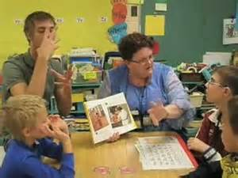

Significant changes made to the curriculum that enables a student to be successful in the general education classroom. Modification changes the curriculum objectives in some way. Some examples of Modifications:

* The quantity of reading, written work, and the like are reduced
* Modifications reflect the educational rights of the student and should be included in the IEP.
* Changes in grading procedure should be indicated on the report card; refer to your district policies.

C:\Users\knutson\AppData\Roaming\SoftChalk\LessonBuilder 9\pagebreak.png

# Interventions

**Changing HOW Instruction is delivered**

* Different curriculum
* Different teaching and learning strategies
* Smaller-group instruction
* Direct, explicit skill instruction

C:\Users\knutson\AppData\Roaming\SoftChalk\LessonBuilder 9\pagebreak.png

# Common Mistakes of Co-Teaching

# 

**1. Bathroom Stall Planning (also known as Parking lot planning, Hallway planning, etc...)**

* Failure to have a "regular" scheduled meeting

**2. Leaving on a Jet Plane**

* Failure to debrief the lesson ASAP
* Share your professional GUT reaction on how the lesson went
* Do SOMETHING!
  + use a Post It note with (+) or (-)
  + Swap with each other/ Review your GUT reaction!

**3. Tightening the Corset**

* Lack of FLEXIBILITY
* Control Issues/ Monopolization

**4. Too many cooks in the Kitchen**

* Role Confusion
* Who is to do what?

**5. Can you hear me now?**

* Must have CLARIETY
  + Clear about goals
  + Clear about Roles
  + Clear about grading

**6. Hansel and Gretel Role Assumicide**

* Assume role assignments

|  |  |  |  |  |
| --- | --- | --- | --- | --- |
| Collaborative Teaching Responsibilities | | | | |
| *Avoid Assumicide*  **Directions:** Discuss the following questions with your partner and reach a conclusion in each case regarding who will bear the responsibility for the tasks. | | | | |
| Who will be responsible for | Classroom Teacher | Specialist/ Student Teacher | Other | Shared |
| Identifying goals and objectives for the course? |  |  |  |  |
| Designing IEP objectives for the special education students? |  |  |  |  |
| Planning instructional activities to achieve the goals? |  |  |  |  |
| Selection instructional materials? |  |  |  |  |
| Teaching specific class content? |  |  |  |  |
| Teaching study skills and learning strategies? |  |  |  |  |
| Collecting data on student performance? |  |  |  |  |
| Establishing and implementing a classroom management plan? |  |  |  |  |
| Establishing and implementing a classroom management plan? |  |  |  |  |
| Maintaining home contact? |  |  |  |  |
| Modifying curriculum and materials as necessary? |  |  |  |  |
| Designing tests, homework assignments, etc…? |  |  |  |  |
| Providing individual assistance to students? |  |  |  |  |
| Taking responsibility for daily routines (eg. Attendance, lunch accounts, etc…) |  |  |  |  |
| Directing paraprofessionals, parent volunteers, and other support staff? |  |  |  |  |
| Communicating to all appropriate parties regarding the special education students? |  |  |  |  |
| Copyright 2012 Beninghof and Kunkel pg. 63 | | | | |

C:\Users\knutson\AppData\Roaming\SoftChalk\LessonBuilder 9\pagebreak.png

# 9:45 - 10:00 BREAK



# Instructional Strategies

## Instructional Strategies for Different Types of Learners - Chapter Nine



## Plus ++ Handouts

|  |  |  |  |
| --- | --- | --- | --- |
| Instructional Delivery Methods  Copyright 2012 Beninghof and Kunkel | | | |
| **Delivery Methods** | **Advantages** | **Disadvantages** | **TIPS** |
| **Case Studies** | \*Applicable to real life  \*Problem Solving  \*Non- Threatening | \*Time Consuming  \*Oversimplification of reality | \*Don’t worry about putting lots of detail into Case study  \*Read Case Studies in advance!  \*Flip classroom model  \*Guidelines:  -pacing  -debrief |
| **Games** | \*Increase Student engagement  \*Interesting  \*Engages sportsmanship opportunities  \*\*Marzano’s Research supports inconsequential competition as good | \* Student’s “Buy In”  \*May trigger “This is stupid” remarks  \*Could engage “Gamesmanship” (Win at all cost) | \*Good Directions  \*Establish rules early  \* Follow rules  \*Determine grouping needs  \*Promote Sportsmanship over Gamesmanship |
| **Individual Reflection** | \*Debriefing opportunity  \*Review (it’s personal) | \*Takes time (keep it short)  \*Opportunity to get distracted | \*Clear focused Prompts  \*Optional Sharing |
| **Readings** | \*Allows self-pace  \*Opportunities to go back and re-read | \*Early finishers  \*Reading level of readers  \*Reading level of selection  \*ESL students  \*Style of data | \*Use appropriate reading levels  \*Allow for individual learning styles  \*Have plan for early finishers |
| **Role Playing/Skits** | \*Visual  \*Increases Retention | \* Student’s “Buy In”  \*May trigger “This is stupid” remarks  \* Demonstration/ Model might limit vision  \*Some skits are student generated- teacher may need to guide creative process to keep appropriate to learning | \*Don’t call it a “Role Play”  \*Determine grouping needs  \*Give purpose  \*Give solid instruction directions  \*Give Demonstration/ Model  \*Allow practice time before presentations  \*Debrief skits at the end/tie into lesson  \*Give a lot of choices  \*Have Props available! |
| **Lecture** | \*Able to give a lot of data in a short period of time  \*Easy to prepare  \*Teacher keeps control | \*Boring for student  \*Only helps student retain 5% of information | \*Formative Assessment throughout and then USE lecture for review  \*Add visuals  \* Add interactive breaks using information  \*Follow **7-7-7 Rule**  -no more than 7 minutes at a time  -no more than seven bullets on a slide  -no more than seven words in each bullet |
| **Videos** | \*Interesting  \*Availability (U-tube/ Ted talks)  \*Helps the visual learner  \*Gives another perspective  \*Shows another example  \*Some videos engage emotional learning (humor/empathy/anger/etc…). Emotional learning increases retention. | \*Flip Classroom  \*Equipment  \*Technology  \*Cost  \*Availability  \* Appropriateness  \*Relevance to learning not obvious/ \*Busy work  \*Have students seen it already?  \*ESL student needs | \*Keep video’s short, relevant  \*State a viewing purpose  \* Pause video periodically and review valuable information  \*Assign notes with viewing/ Fill in the blank handouts  \*Give solid instruction directions  \*Debrief video at the end  \*Follow-up with an assessment to enhance retention (graded or non-graded)  \*Use current trends (Instagram/Vines) |
| **Demonstrations** | \*Higher retention  \*Practice | \*Time  \*Inappropriate demonstrations with inappropriate directions | \*Give purpose  \*Give solid instruction directions  \*Allow practice time  \*Debrief /review as needed |
| **Cooperative Learning** | \*Share ideas  \*Takes pressure of the individual student  \*Increases social skills | \*Student monopolizes project  \*Active non-participants | \*Give roles and responsibilities  \*Small groups:  -2 per group is ideal (anything over a group of two is an  organizational toothache for the teacher)  -3-4 in a group is max.  -When there are 5 or more, this increases likelihood of  active non participants. |
| **Group Discussions** | \*Gives different perspectives  \*Formative assessment  \*Sparks ideas  \*Increases social skills  \*Increases listening and communication skills | \*Time  \*Getting “off task/topic” | \*Time Frames  \*No Mike? Teacher stands far away from speaker so he/she  must project voice for all to hear  \*Paraphrase- restate comments for clarification  \* State rules for disagreements; respecting opinions  \*Have a plan for “off task/topic” discussions |

C:\Users\knutson\AppData\Roaming\SoftChalk\LessonBuilder 9\pagebreak.png

# 11:30 - 12:45 - LUNCH BREAK



C:\Users\knutson\AppData\Roaming\SoftChalk\LessonBuilder 9\pagebreak.png

# Questions/Answers



C:\Users\knutson\AppData\Roaming\SoftChalk\LessonBuilder 9\pagebreak.png

# Applying What you Learned and Developing your Action Plan (Part 3)



C:\Users\knutson\AppData\Roaming\SoftChalk\LessonBuilder 9\pagebreak.png

# 1:45 - 2:00 BREAK



C:\Users\knutson\AppData\Roaming\SoftChalk\LessonBuilder 9\pagebreak.png

# Applying What You Learned and Developing your Action Plan (Part 4)



C:\Users\knutson\AppData\Roaming\SoftChalk\LessonBuilder 9\pagebreak.png

# Participation Certificates



C:\Users\knutson\AppData\Roaming\SoftChalk\LessonBuilder 9\pagebreak.png

# Review of Follow Up Visit



C:\Users\knutson\AppData\Roaming\SoftChalk\LessonBuilder 9\pagebreak.png

# Contact Information

## Dr. Tim Harms



Professor of Mathematics Education

**Minnesota State University Moorhead**

1104 7th Ave S.

Moorhead, MN 56563

218-477-4016

Email: harms@mnstate.edu

### Dr. Julie Knutson



Assistant Professor of Health and Physical Education

**Minnesota State University- Moorhead**

1104 Seventh Avenue South

Office: Nemzek Hall 103 E

Office Phone: 218.477. 2051

Email: [julie.knutson@mnstate.edu](mailto:julie.knutson@mnstate.edu)

## Dr. Valerie Ritland



School of Teaching and Learning

Office: LO 216B   
Phone: 218.477.2546   
Email: [**ritland@mnstate.edu**](mailto:ritland@mnstate.edu)

C:\Users\knutson\AppData\Roaming\SoftChalk\LessonBuilder 9\pagebreak.png

# Evaluations



C:\Users\knutson\AppData\Roaming\SoftChalk\LessonBuilder 9\pagebreak.png

