The house is located in Northern Minnesota at 46 degree N. latitude. It is super insulated (12” walls with 30” of insulation in the ceiling) with good southern exposure and an attached pool area (46‘x36’) with a 22,000 gal pool. The pool was primarily designed for energy storage with recreational use as a side. For the past 15 years we have heated the pool with an outdoor wood water heater and the plan was to store the energy in the pool and use a water to air heat pump to remove the heat energy from the pool and use it for space and water heating. This past year we decided to do the second phase of our energy efficient design, construct the solar collector and hook up the heat pump

We started installing the collector around the middle of Sept. It was designed with an extra large size (40’ x 12’ of collector area) and set a a higher angle (about 70 degrees) for greater efficiency in the winter. Because of my limited time I hired someone to both replace old shingles on the house and pool area, and install the framework for the collector. We had the unglazed collector up and operating by the middle of October. Tested it out extensively to check for leaks and how fast it drained once the system shut off. I was extremely impressed that it increased pool temperature by around 3 degrees in one day in the middle of Oct. I did however add another vacuum break on the return line to increase the rate of drainage and to make sure drainage was complete. We then installed the framework for the glazing and the glazing. Each panel is a 4’ x 12’ sheet of corrugated poly carbonate. I insulated with 6” of fiberglass insulation behind the collector and on the top and sides.

We are now installing a heat pump to remove heat from the pool and use that heat in space heating and water heating for the house. We had to switch from chlorine disinfecting the pool to the copper-silver ion/UV disinfection because of chlorine effects on the copper in the heat pump. We should have done this years ago for health reasons.

We hope to have everything hooked up after New Years(2010) for extensive testing in late winter and spring. So far we are quite impressed with the collector. Even in the short December, 0 degree days of northern Minnesota, on perfectly clear days we have reached temperatures of 140 degrees in the collector. On hazy days it will still reach 100 degrees. This helps maintain and even increase the pool temperature.

The cost of the system is broken down below.

construction materials - $2300
10 panel kit of 4x12 Vortex panels with with automatic controls - $3,021
10 4x12 clear corrugated poly carbonated panels - $685.70
sealants and screws - $80

Total ---------------------------------------- $6,087

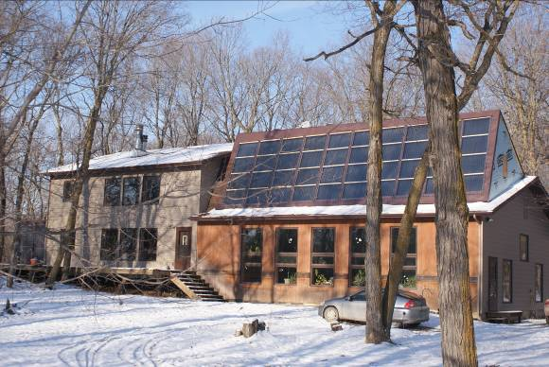
Collector from the front. On the ground below the collector we will be constructing a greenhouse.

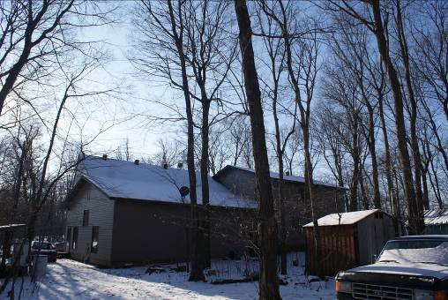
Back of collector. Collector installed below roof extension. The extension had to have a steeper angle that the original roof line because of the size and steeper angle of the collector.
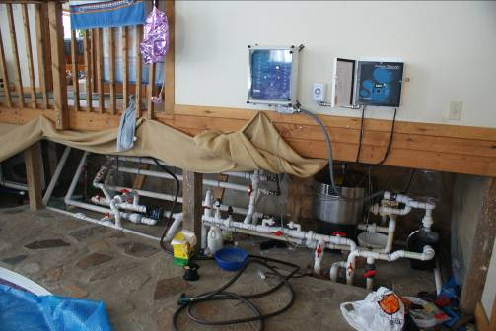
Pool water distribution system. It is designed so only the filter system can be connected, the filter with the solar collector connected, and/or the filter and the outside wood water heater connected. Each can be disconnected separately for maintenance. The control boxes above are for solar collector operation and copper-silver ion/UV pool disinfectant operation.

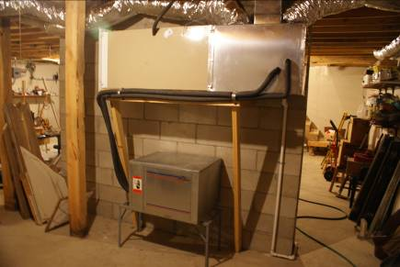
The water to air heat pump (below, in the process of being installed.) The water from the pool will be connected to the front It will go through a heat exchanger where the working fluid (R22) will draw heat from the pool water and vaporize, go into the heat exchanger in the plenum above, condense and give up its heat to the air passing through the exchanger into the house. The heat that remains in the fluid is passed to the house hot water system, through water lines also connected to the front of the heat pump, from the preheating tank in the hot water line for the house, thereby heating the water for the house. The structure above the heat pump is the electric back-up furnace.

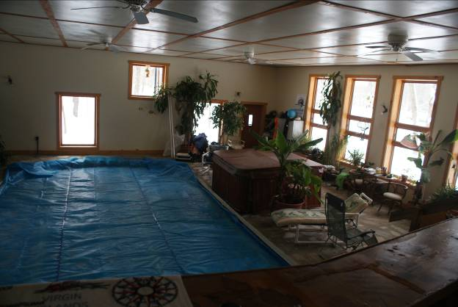

Above and below are pictures of the pool area. It is enclosed in an super insulated wall and ceiling structure designed for water energy storage in the pool and below floor storage with air ducts in sand below the cement floor. Hot water is pumped into the pool from the solar collector and the wood water heater behind the house and hot air will be pumped into the duct work beneath the floor from the green house to be built in front of the pool area.

The pool is normally covered with a solar cover to prevent the house from becoming too humid. If it gets too dry we open up a part of the cover.
