**Psy 230 Lab Assignment 11 Name ________________________***Please use the attached output to answer the questions below. Please type your answers to each of the following questions and submit to the D2L assignment folder by the due date.*

1. We want to assess whether net worth is associated withage.  
Specify:

*H0:*

*H1:*

2. Use a few sentences to describe the relationship depicted by the scatter plot. Be sure to describe the form and direction of the relationship.

3. Find the correlation coefficient to determine whether the relationship is significant   
(2-tailed test, alpha = .05). Indicate your decision (Retain or Reject Ho).

4. Find the Regression Coefficients matrix and write the regression equation. Please note that the constant *(a)* is the y-intercept and Age *(b)* is the slope.

5. Calculate (by hand) the estimated net worth of a wealthy 60-year-old (x).

6. On the scatter plot “R Squared Linear = 0.524” is displayed. What does this mean specifically? (Hint: See Ch. 15 of your stats text….)

7. I want to use this data to predict net worth of a 30-year old. What would your advice be? (Hint: See Ch. 16 of your stats text….)

Annually, Forbes Magazine presents a summary of the richest Americans. Included is information on net worth of the individuals as well as their ages. We would like to determine whether net worth and age form a linear relationship. In addition, if these variables are significantly correlated, we would like to estimate the net worth of wealthy Americans (y), based on their age (x).

# Age and Net Worth of 36 of the Richest Americans

|  |  |
| --- | --- |
| Age | Net Worth (in millions) |
| 81.00 | 1400.00 |
| 75.00 | 925.00 |
| 76.00 | 1250.00 |
| 66.00 | 865.00 |
| 77.00 | 700.00 |
| 58.00 | 320.00 |
| 59.00 | 660.00 |
| 48.00 | 460.00 |
| 64.00 | 860.00 |
| 76.00 | 800.00 |
| 57.00 | 300.00 |
| 72.00 | 490.00 |
| 64.00 | 300.00 |
| 62.00 | 438.00 |
| 81.00 | 876.00 |
| 75.00 | 560.00 |
| 76.00 | 1100.00 |
| 71.00 | 750.00 |
| 66.00 | 800.00 |
| 43.00 | 345.00 |
| 61.00 | 690.00 |
| 73.00 | 1300.00 |
| 45.00 | 400.00 |
| 50.00 | 550.00 |
| 47.00 | 425.00 |
| 57.00 | 466.00 |
| 82.00 | 850.00 |
| 52.00 | 530.00 |
| 52.00 | 330.00 |
| 64.00 | 460.00 |
| 66.00 | 600.00 |
| 66.00 | 345.00 |
| 50.00 | 290.00 |
| 54.00 | 400.00 |
| 46.00 | 320.00 |
| 56.00 | 530.00 |

**Correlations**

[DataSet1] E:\regression data.sav

| **Correlations** | | | |
| --- | --- | --- | --- |
|  | | age | Net Worth (in millions) |
| age | Pearson Correlation | 1 | .724** |
| Sig. (2-tailed) |  | .000 |
| N | 36 | 36 |
| Net Worth (in millions) | Pearson Correlation | .724** | 1 |
| Sig. (2-tailed) | .000 |  |
| N | 36 | 36 |
|  | | | |

**Graph**

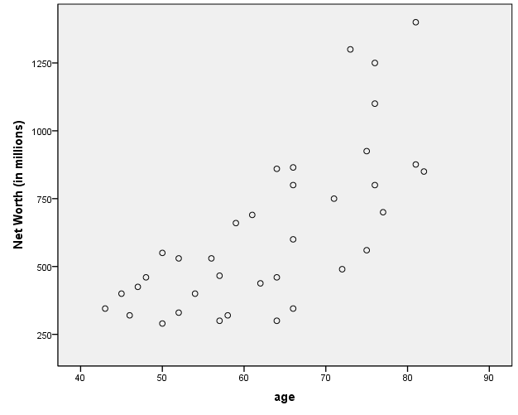

**Regression**

| **Variables Entered/Removedb** | | | | | | | | | | |
| --- | --- | --- | --- | --- | --- | --- | --- | --- | --- | --- |
| Model | | Variables Entered | | | Variables Removed | | | Method | | |
| 1 | | agea | | | . | | | Enter | | |
| a. All requested variables entered.  b. Dependent Variable: Net Worth (in millions) | | | | | | | | | | |
| **Model Summary** | | | | | | | | | | | |
| Model | | R | R Square | | | Adjusted R Square | | | Std. Error of the Estimate | | |
| 1 | | .724a | .524 | | | .510 | | | 209.346 | | |
| a. Predictors: (Constant), age | | | | | | | | | | | |
| **Coefficientsa** | | | | | | | | | | | | | | |
| Model | | | | Unstandardized Coefficients | | | | | | Standardized Coefficients | | | t | Sig. |
| B | | | Std. Error | | | Beta | | |
| 1 | Constant *(a)* | | | -559.338 | | | 197.438 | | |  | | | -2.833 | .008 |
| Age *(b)* | | | 18.881 | | | 3.085 | | | .724 | | | 6.121 | .000 |
| a. Dependent Variable: Net Worth (in millions) | | | | | | | | | | | | | | |

