**Psy 230 Measures of Central Tendency (G&W Ch. 3)**

**Central Tendency**

-        a single score that is representative of the entire distribution

-         specifies the typical score

**The Mean**

- arithmetic average

- for a population:

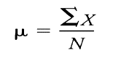

-for a sample:

$$M=\frac{\sum{X}}{n}$$

  Characteristics of the mean

- value of each data point contributes to the value of the mean

-  change a single score or add new score, mean will change

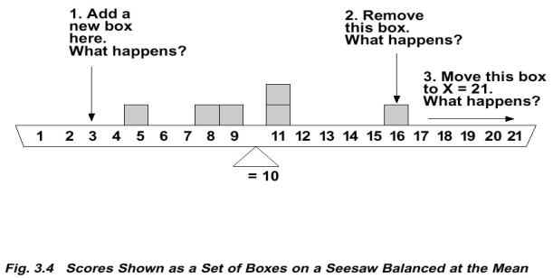

- add/subtract constant from each score - add/subtract constant to mean

- multiply/divide by constant - same to mean

We will often need to combine two sets of scores and find the overall mean for the combined groups. We want the overall mean to consider the sizes of each set, so the set with the larger sample size contributes more to the overall mean. This is called the **weighted mean.**

http://web.mnstate.edu/malonech/images/clip_image003.gif

**The Median (50th percentile)**

- the score that divides the distribution in half - so that half of the scores are above the median and half of the scores are below the median

Computing the Median

- when n is odd - median is middle score

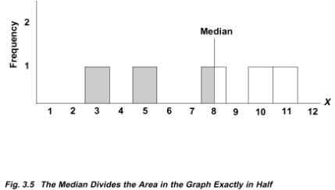

  - when n is even - median is average of two middle scores

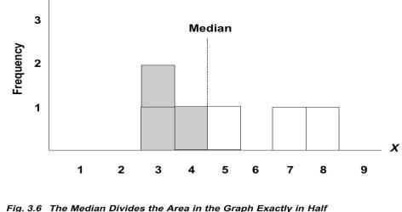

- when several scores of the same value are in the middle (most difficult)

- use interpolation (based on Real Limits!)

- count # of tied values

- count # of scores below tied value

- find # of additional scores needed to get to the middle most score

- form fraction: # needed / # tied

- add fraction to lower real limit of interval containing the tied scores

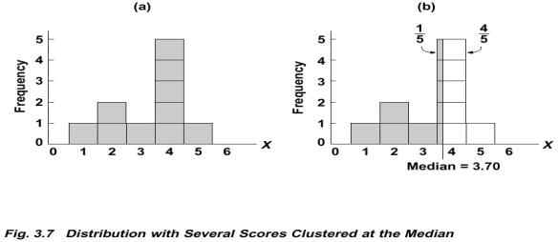

**The Mode**

- the most common score (the score or category with the highest frequency)

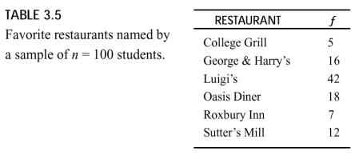

- Mode = ?

- the mode is a score or category - not a frequency!

- multiple modes are common - bimodal distributions

Selecting a measure of Central Tendency for interval and ratio scales

- use mean, but

- use median when

extreme scores

undetermined values (e.g., infinite, didn't finish)

open-ended distributions (e.g., no upper limit, "5 or more")

ordinal scales

The median is not influenced by extreme scores to either side of the dividing point. The only scores that have an effect are the two scores immediately next to the median.

-        data set A: 6, 5, 4, 3, 2

-        data set B: 10, 5, 4, 3, 2

-        data set C: 20, 5, 4, 3, 2

The mean is influenced by extreme scores.

Extreme scores can obscure the measure of central tendency.