**Psy 230 Stats/Methods I  
Correlation (G&W Ch. 15)**

**I.  Situations in Which Correlations are Used**

**1.  Prediction**

**2.  Validity**

**3.  Reliability**

**4.  Theory Verification**

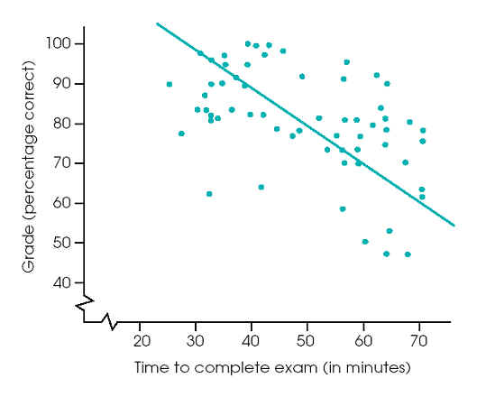

**Figure 16-1 (p. 522)**The relationship between exam grade and time needed to complete the exam. Notice the general trend in these data: Students who finish the exam early tend to have better grades.

**II.  The Pearson Correlation Coefficient**

**A. Correlation measures:**

**1.  Direction of relationship**

**2.  Form of relationship**

**3.  Degree of relationship**

**Conceptually, Pearson computes**

ftp://web.mnstate.edu/malonech/Psy231/Notes/Correlation%20GW16_files/image002.gif

**Hours Studied (X)            Errors on Test (Y)**

**0                                            19**

**1                                             6**

**2                                             2**

**4                                             1**

**4                                             4**

**5                                             0**

**3                                             3**

**5                                             5**

**B. Calculations**

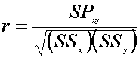

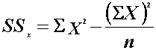

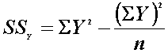

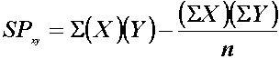

**C.  Hypothesis testing with Pearson correlation**

**Ho: ρ = 0 (no population correlation) OR  
In the population, there is no correlation between x and y.**

**H1 : ρ≠ 0   OR  
In the population, there is a correlation between x and y.**

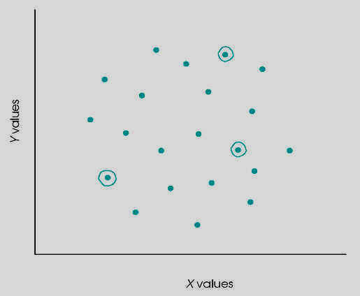

**Figure 16-12 (p. 539)**A scatterplot of a population of *X* and *Y* values with a near-zero correlation. However, a small sample of *n* = 3 data points from this population shows a relatively strong, positive correlation. Data points in the sample are circled.

**Degrees of Freedom**

**df = n - 2**

**Look up the critical values in Table B.6 (p. 709)**

**IV. coefficient of determination  ***

**Indicates the strength of the relationship between x and y.  Measures the proportion of y variability that is associated with the x variable.**