**Psy 230 Hypothesis Testing**

I. Logic of Hypothesis Testing

A. Hypothesis Testing

- an inferential procedure that uses sample data to evaluate a hypothesis about a population

- general scheme

1. State hypothesis about population

2. obtain random sample

3. compare (M - m)

- assumption: if treatment has effect it adds a constant to each score

*n*=16

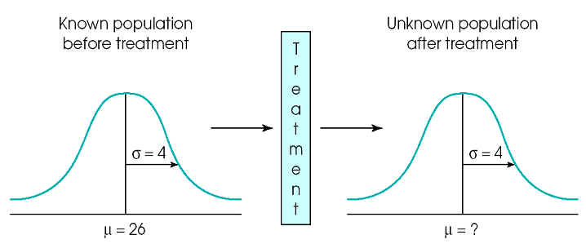

B. Procedure

1. State Hypothesis

Ho = null hypothesis, treatment has no effect

H1 = treatment has effect (alternative or experimental hypothesis)

2. Set criteria for decision

- there is always some discrepancy between sample stats and pop. parameters

- sampling error

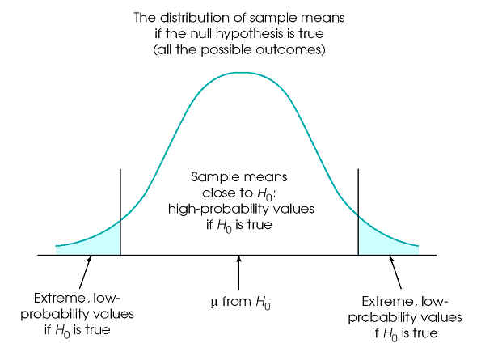

The set of potential samples is divided into those that are likely to be obtained and those that are very unlikely if the null hypothesis is true.

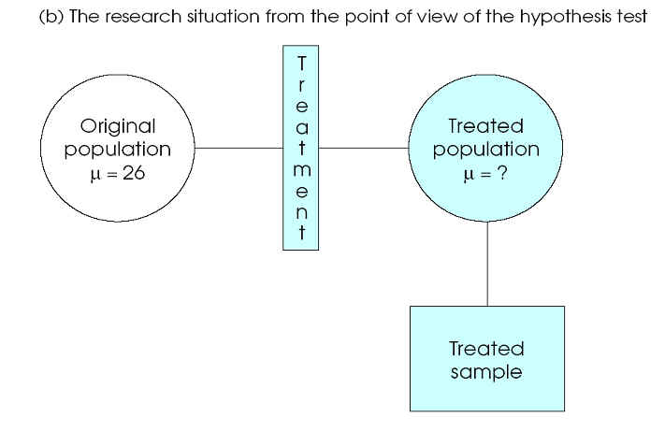3.  Collect sample data

  4. Evaluate Null hypothesis

Reject Ho

Retain Ho (Fail to reject Ho)

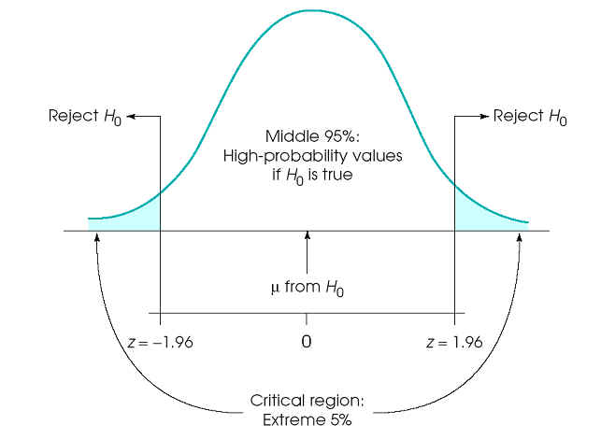

.

C. Errors in Hypothesis Testing

1. Type I error - reject Ho when true

2. Type II error - fail to reject Ho when false

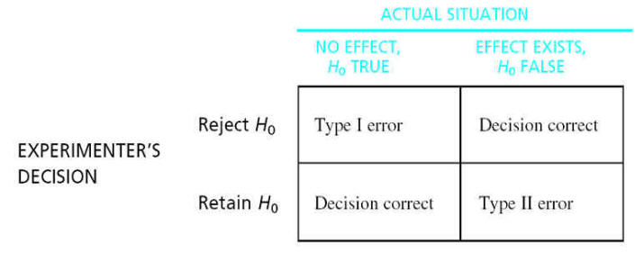

 II. Evaluating Hypotheses

A. Alpha Level (a)

- minimize risk of type I error

1. determine what data are expected if Ho true

2. determine what data are unlikely if Ho true

3. use distribution of sample means separated into two parts

- M expected (hi probability) if Ho true

- M unlikely (low probability) if Ho true

4. alpha level defines very unlikely (e.g., extreme 5% of distribution) scores to obtain by chance

- M compatible with middle of distribution

- M compatible with extremes of distribution

5. When Ho falls into tails, we reject Ho

- very unlikely sample if the treatment had no effect

 B. z scores in Hypothesis Testing

z = obtained difference / difference due to chance

$$Z=\frac{M- μ}{σ_{M}}$$

C. More about Alpha levels

a = 0.05, critical region +/- 1.96

a = 0.01, critical region +/- 2.58

a = 0.001, critical region +/- 3.30

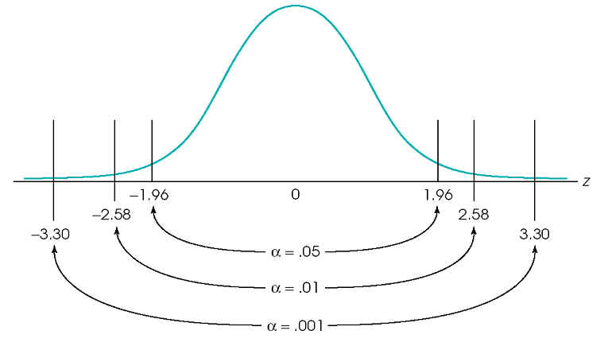

D. Assumptions

1. random sampling

2. independent observations

3. homogeneity of variance, s not changed by treatment

4. normal sampling distribution (sample size, population distribution)

III. Directional (one-tailed) tests

A. Critical region in only one tail

a = 0.05, critical region 1.64

a = 0.01, critical region - look up

a = 0.005, critical region - look up

a = 0.001, critical region - look up

- reject Ho with smaller difference between M and m

- more "sensitive"

- increase the possibility of Type I error (false alarm)

B. Power

- the probability of detecting a treatment effect when one is indeed present.

- power is the opposite of Type II error (when a treatment effect really exists in the population).

-power = 1 – (type II error) or 1 – (beta)

-as type II error decreases, power increases

- by decreasing type I error (move from .05 to .01) we directly increase type II error (and thereby decrease power).

**The Relationship between Power and Sample Size**

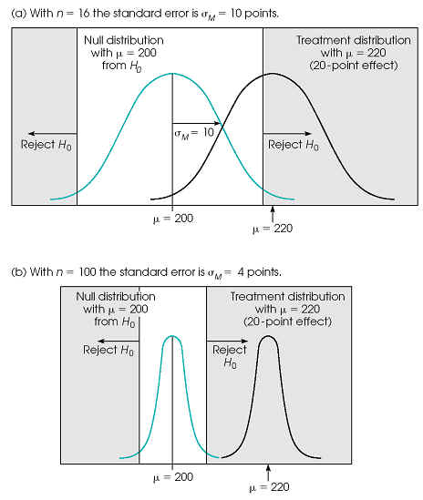

**The Relationship between Power and Effect Size**

