**Intro. to t-Statistic  
and the Single Sample t-Test**

I. Introduction

***t = observed difference between the two means / difference expected by chance***

A. The *t-*statistic is a substitute for *z*

- *z* is same as *t* except *z* requires more information about the population. We rarely have much information about the population, so we end up using *t* much more often than *z*.

- to use *z*, you must know *σ* (the population standard deviation)

- what do you do if you don't know *σ* ?

- *t* statistic allows you to use sample standard deviation *s* instead of *σ*

Remember that ***S2 = SS/n – 1*** SO 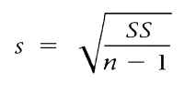

Remember: ftp://web.mnstate.edu/malonech/images/SS.jpg because sometimes we'll be given SS, but other times we'll need to calculate SS ourselves

- then use estimated standard error for a sample - ***SM***

or more direct way is to use variance in calculating estimated standard error

- Calculate a *t* statistic instead of a *z* statistic (very similar formula)

$t= \frac{M- μ}{S_{M}}$ where

- Rule - if you know the population standard deviation, use *z*. If you do NOT know the population standard deviation, use *t*.

B. Degrees of Freedom

***df = n - 1***

- the greater *n* is, the more closely S represents σ, and then the better t represents z

C. t distribution

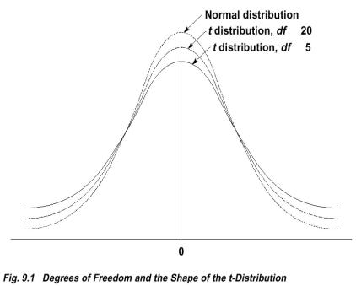

- generally not normal - flattened and stretched out

- *z* approximates normal distribution; likewise *t* approximates *z*

- shape determined by *df*

- Table B.2 shows critical values for the t-statistic ( p. 703)

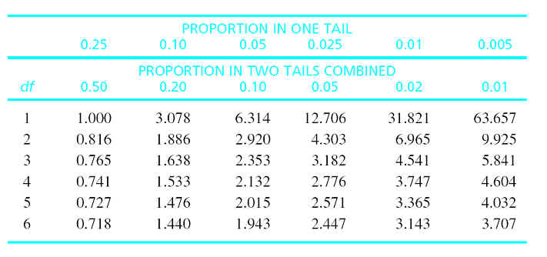

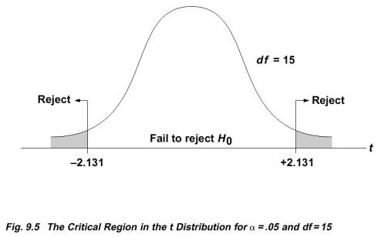

II. Hypothesis Testing with t statistic--Single Sample t-test

A. Formula

$t= \frac{M- μ}{S_{M}}$ where ${S_{M}}_{= \sqrt{\frac{S^{2}}{n}}}$ or $S_{M= \frac{S}{\sqrt{n}}}$

B. Steps (just like z)

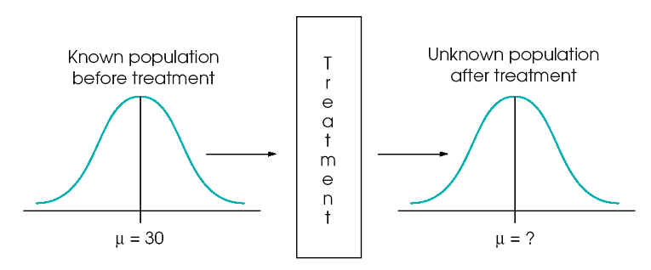

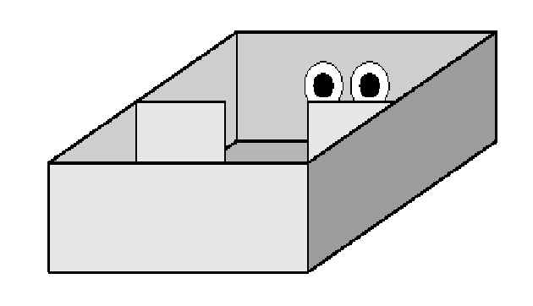

*n* = 16 birds, *µ* = ?, *s* = ?   
 We need to estimate *µ* and *s*.

*M* = 39 minutes on the plain side and *SS* = 540

**Do birds spend equal amounts of time in the plain chamber and the chamber with eyespots? Use a 2-tailed test and set alpha at .05.**

 1) State the hypotheses.

2) Locate the critical region of the t-distribution

3) Calculate the t-statistic

4) Make a decision regarding the null and alternative hypotheses.