**Psy 230 Regression (GW Ch. 16)**

**Regression--the statistical technique used to find the best-fitting straight line (i.e., the regression line) for a set of data.**

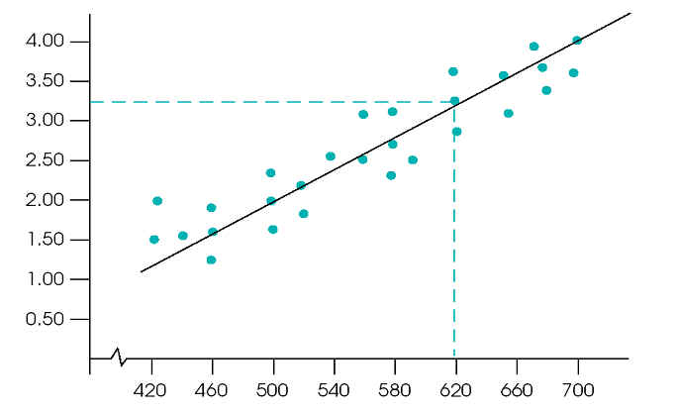

A linear relationship between two variables can be expressed by the following equation:

ftp://web.mnstate.edu/malonech/images/SZ4.ht5.gif

where the value of "b" is the slope and the value of "a" is the y-intercept

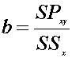

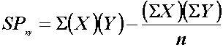

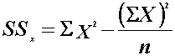

ftp://web.mnstate.edu/malonech/images/SZ4.ht7.gif

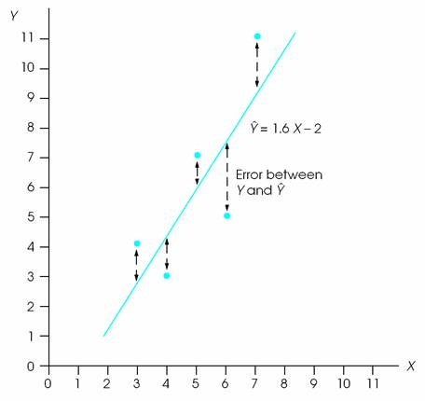

 Caution when interpreting predicted values from regression equations:

1) The predicted value is not perfect. There will be some error between predicted Y values and the actual data...As absolute value of the correlation coefficient gets closer to zero, the magnitude of the error will increase.

 2) The regression equation should not be used to make predictions for X values that fall outside of the range of values covered by the sample data.