**Psy 230 Chapter 11  
Related (Paired) Samples t-test**

**I.  Compare Designs**

**A. Independent-measures design**

**Also called between subjects design**

**Two separate samples are used to obtain the two sets of data to be compared.**

**B. Repeated-measures design**

**Also called within subjects design**

**Two scores are obtained from the same sample of individuals.**

**Advantage—uses same subjects in all treatment conditions. No risk that Ss in one treatment are substantially different from the Ss in another.**

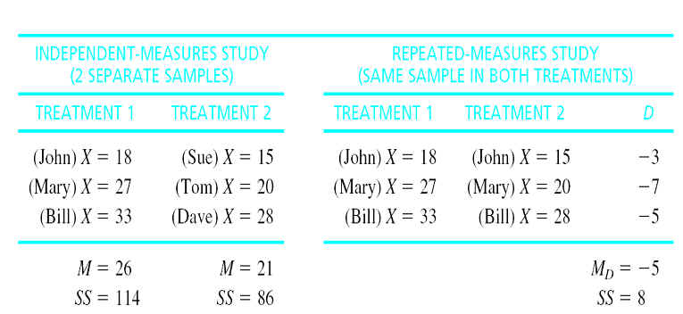

**II. Related (Paired) Samples t-test**

**A. Logic**

**Analogous to single-sample t statistic**

**Based on difference scores rather than raw scores (X values).**

**How much change occurs as a result of the treatment?**

**The two scores for each subject are summarized as a single difference score.   
       B. Example--At the *.01 level of significance*, can it be concluded that the course will result in *a significant weight loss*?**

**Name            Before             After    D**

**Wellman            155             154        -1**

**Gersten              228             207        -21**

**Tamayo              141             147        6**

**Miller                 162             157        -5**

**Ringman           211             196        -15**

**Garbe                 185             180        -5**

**Monk                 164             150        -14**

**Heilbrunn         172             165        -7**

**Difference score = D = X2 – X1**

**For a two-tailed test:**

**H 0: µD =0**

**H 1:µD ≠0**

**What about for a one-tailed test?**

**C. Formulas**

**ftp://web.mnstate.edu/malonech/images/Image1.gifftp://web.mnstate.edu/malonech/images/Image2.gif**

**ftp://web.mnstate.edu/malonech/images/Image3.gif**

**ftp://web.mnstate.edu/malonech/images/Image4.gif**

**ftp://web.mnstate.edu/malonech/images/Image5.gif**

**ftp://web.mnstate.edu/malonech/images/Image6.gif**

**ftp://web.mnstate.edu/malonech/images/Image7.gif**

**III. Assumptions of the related samples t-test**

**A.  The observations within each treatment condition must be independent.**

**B.  The population distribution of difference scores (D values) must be normal.**