**Psy 230 Repeated-Measures ANOVA (GW 13)**

  I. The Logic

*F* = variance between treatments / variance expected by chance or error

Because individual differences can be eliminated or removed from the error in a repeated-measures study, the structure of the final F-ratio can be modified as follows:

*F* = variance between treatments (no individual differences possible)/variance expected by chance (with individual differences removed)

The partitioning of variability for a repeated-measures design:

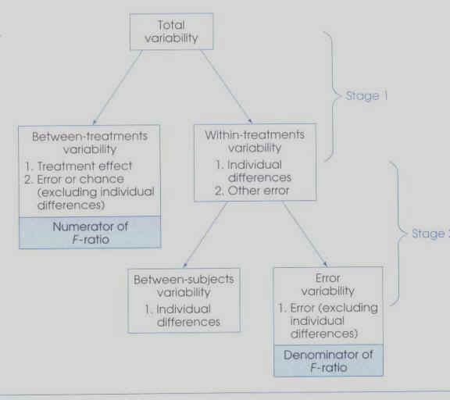

II. Notation & Formulas

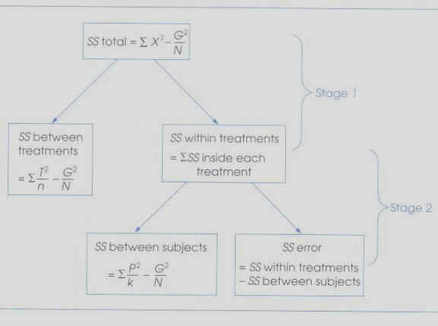

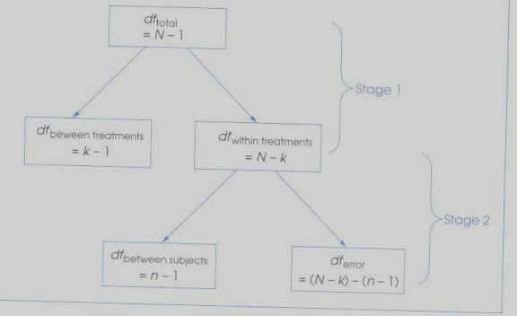

The first stage of the repeated-measures ANOVA uses the same notation and formulas as the between-subjects ANOVA. In the first stage, total variability is divided into variability between treatments and variability within treatments.

The second stage is new--it removes individual differences from the within treatment variability, making for a smaller, more precise estimate of error . The remaining variability in the denominator is called residual variance or error variance because it measures how much variance is expected just by chance after the individual differences have been removed.

k = number of treatments

n = number of scores in each treatment

N = total number of scores in the entire study

G = grand total of all scores in the experiment

T = the sum of the scores in each treatment condition

P = the total of scores for each participant (participant totals)--THIS IS NEW--only possible in a repeated (or paired samples) design

III. Examples

***Scenario 1:***

***An instructor in a computer literacy course wanted to measure progress in learning to use a versatile word-processing program. His intention was to encourage students to use a variety of formatting commands available, particularly by using the macro-writing ability of the program.***

***His plan was to give students 5 test sessions during which they would attempt to use the word-processing program to enter a document into the computer. He prepared five different documents, each differing in content but using the same number of formatting instructions. The five documents were arranged in five different orders that were properly counterbalanced. He selected five students who were approximately equally skilled in typing and computer experience. They were given the training manual to study one week before the experiment began, following which time they were given a series of five tests during which they attempted to enter a document into the computer within a one-hour time limit. The dependent variable consisted of the number of different formatting commands the student used in attempting to reproduce the document with the word-processing program.***

***Is there a significant difference in the number of formatting commands used across the five test conditions? Set alpha at .05.***

***Number of Formatting Commands used During Each Test Session***

***Test 1  Test 2  Test 3  Test 4  Test 5***

***P1*** 5 6 14 19 22

***P2*** 2 7 11 18 24

***P3*** 1 3 8 25 22

***P4*** 6 5 9 18 22

***P5*** 6 8 15 22 29

***Scenario #2:***

***A school psychologist would like to test the effectiveness of a behavior-modification technique in controlling classroom outbursts of unruly children. The teacher used the response-cost technique. Every time a child disrupts the class, he/she loses 10 minutes of free time. Therefore, each unruly act costs the student 10 minutes of free time. The effectiveness of the technique will be measured by counting the number of outbursts in class after different periods of time.***

***Is there a significant difference in number of outbursts across the observation periods? Set alpha at .05.***

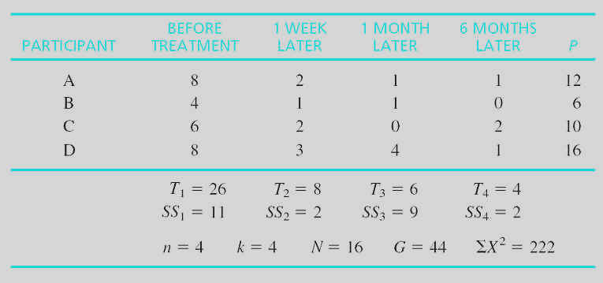

**Table 14-3 (p. 457)**The effect of response-cost treatment on the number of outbursts in class after different periods of time.

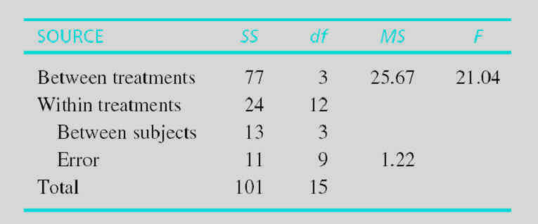

**Table 14-4 (p. 460)**Analysis of variance summary for Example 14.1.

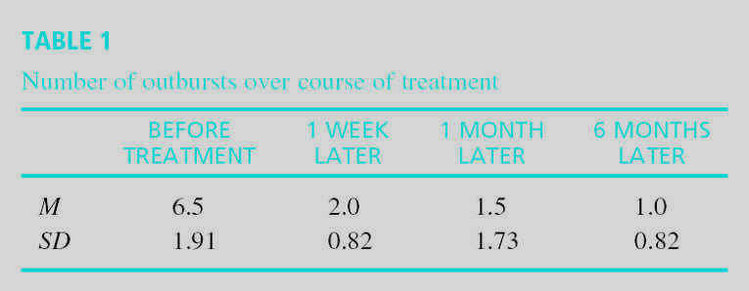

***Questions to think about:***

**What two general types of information are reported in an APA results section? Which type of information is generally reported first?**

**How can the results of a study be depicted graphically?**

**How is eta squared computed for a single-factor within-subjects design?  
Remember that our goal is to calculate the proportion of total variability that has not been explained by other factors. So we can represent the denominator in two ways--they will both get us to the same result.**

ftp://web.mnstate.edu/malonech/images/Repeat101.gif OR ftp://web.mnstate.edu/malonech/images/Repeat102.gif

**How can we use Tukey's *HSD* for post-hoc tests?**

Recall that in a between-subjects design, ftp://web.mnstate.edu/malonech/images/Repeat301.gif

In a repeated-measures design, ftp://web.mnstate.edu/malonech/images/Repeat401.gifand use degrees of freedom for ***MSError*** when looking up ***q***

************************************************************Not required material

**How can we use the Scheffe test with a repeated-measures design?**

As before, the numerator of the F-ratio is the ***MSbetween treatments***that uses the SS for only the two treatments we’re interested in and divides by k-1 from the entire experiment.

The denominator is the error term (***MSerror*** ) that was used for the overall ANOVA.

Looking up the critical value: As in chapter 13, *df* for the numerator is *k from entire experiment – 1*. And since we’re using the error term from the overall ANOVA, we end up with the same *df* in the denominator as the overall ANOVA. Bottom line: We use the same critical value that was used to evaluate the overall ANOVA.