**Psy 230   
Probability and Samples**

I. Sampling and Sampling Error

A. Sampling Error

- discrepancy or "error" between a sample statistic and the population parameter

II. Distribution of Sample Means

- the collection of sample means for ALL possible random samples of a particular size (n) that can be obtained from a population.

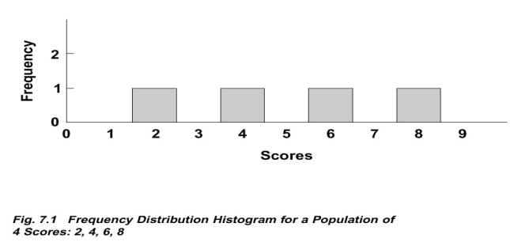

 A. Sample Distribution

- a distribution of statistics obtained by selecting all the possible samples of a specific size from a population

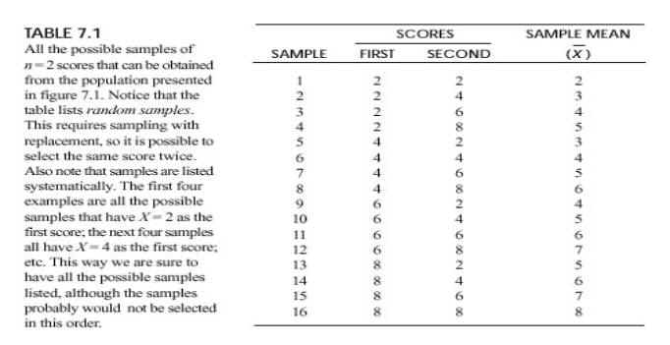

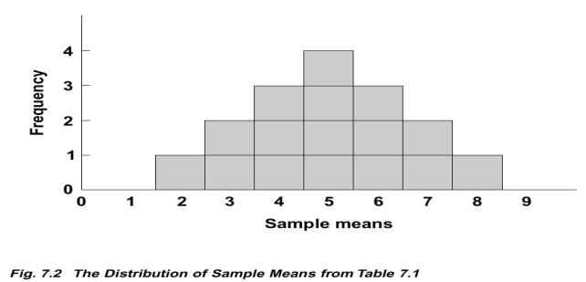

B. Characteristics

1. sample means tend to pile up around population mean

2. the distribution of sample means is approximately normal in shape

3. you can use distribution of sample means to answer questions like:

"What is the probability of obtaining a sample mean greater than 7?"

C. The Central Limit Theorem

"For any population with a mean  and a standard deviation of , the distribution of sample means for sample size n will approach a normal distribution with a mean of  and a standard deviation of  /sqrt(n) as n approaches infinity."

1. it describes the distribution of sample means regardless of shape, mean or standard deviation of any population

2. the distribution of sample means approaches normal rapidly

- by the time n = 30, it is essentially normal

D. Shape

- the shape of the distribution will be almost normal if either of the following:

1. the population distribution is normal

2. the size of n is greater than 30

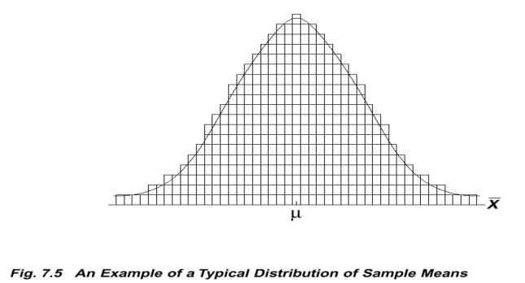

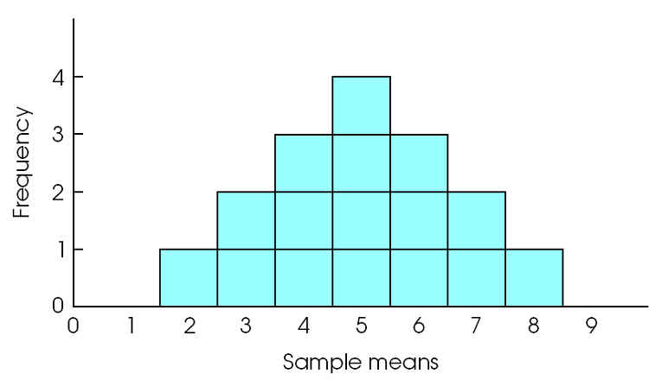

**Figure 7- 2 (p. 204)**The distribution of sample means for *n* = 2. The distribution shows the 16 sample means from Table 7.1.

E.  The Mean of the Distribution

- called the Expected Value of M

- will equal the population mean, 

 F. The Standard Deviation of the Distribution

- called the Standard Error of M or just standard error

-        symbol is: σM

- these are the "error bars" one typically plots on graphs

**For n=1, the standard error = the population standard deviation

As n increases, the standard deviation of the sampling distribution decreases--more sample means tend to pile up at or very near the population mean

So what does the standard error tell us about how well our sample mean represents the mean of the population?

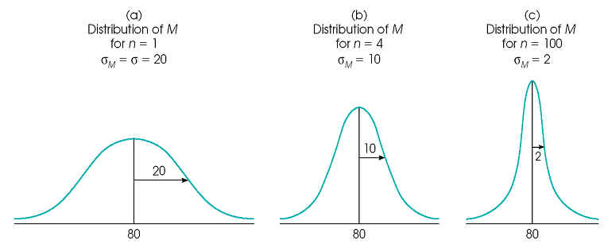

**III. Probability and the Distribution of Sample Means**

- primary use: to find the probability of any particular sample drawn from a known population

- find standard error and then z-score (below)

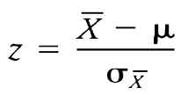 $OR z= \frac{M- μ}{σ_{M}}$

**IV. Standard Error and Statistical Inference**

- in general, standard error estimates amount of error expected between sample statistic and population parameter

- depends on:

variability of scores

sample size

- reliability: what type of consistency can you expect?

- stability: small standard error, adding a new score has little effect on the mean

- statistical inference: how much statistic will vary from parameter as a result of chance

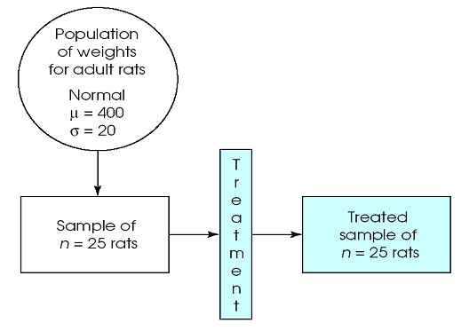

The purpose of the study is to determine whether or not the treatment (a growth hormone) has an effect on weight for rats.

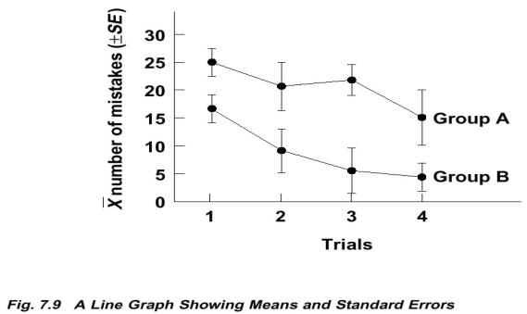 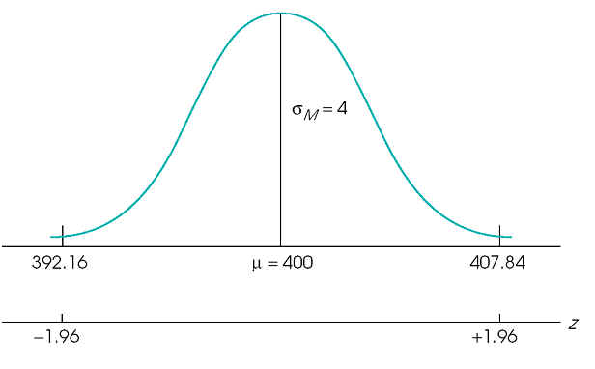

  - when error bars overlap:

- one could be truly higher

- the other could be truly higher

- they could be the same

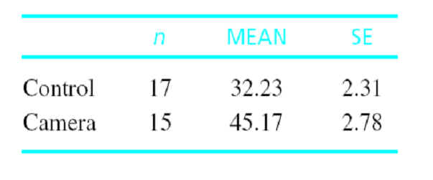

Mean self-consciousness scores for participants who were working in front of a video camera and those who were not (controls).