**Psy 230 Variability** **(G&W Ch. 4)**

Variability--a quantitative measure of the degree to which scores in a distribution are spread out or clustered together...If there are small differences between scores then variability will be small; if there are large differences between scores then variability will be large.

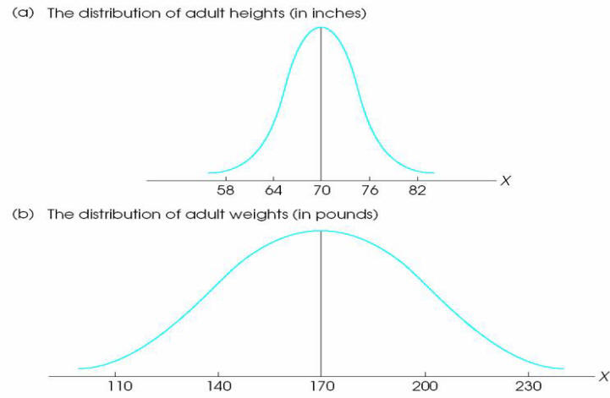

I. Range

A. use upper and lower real limits  
***range = URL Xmax - LRL Xmin***

B. quartiles

1. interquartile range:

**Q3 - Q1**

2. semi-interquartile range:

**(Q3 - Q1)/2**

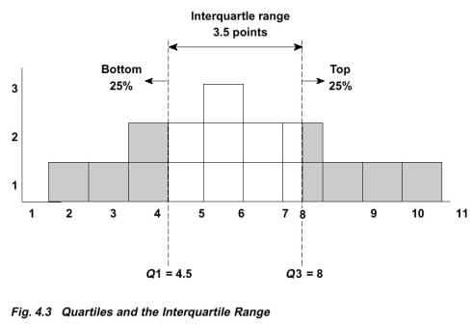

**II. Standard Deviation and Variance: Populations**

A. sum of squares: SS

1. definitional

ftp://web.mnstate.edu/malonech/images/GW4.ht2.gif

2. computational

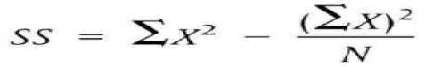

B.  Variance

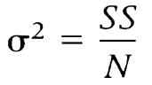

C. Standard Deviation

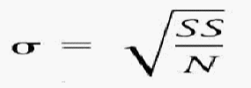

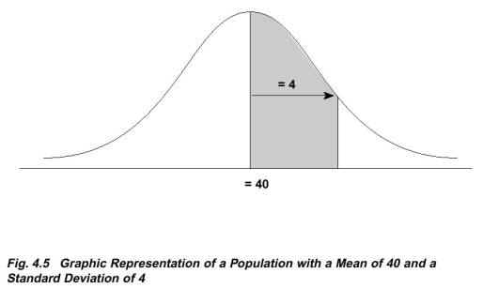

**III. Standard Deviation and Variance: Samples**

 A. sum of squares: SS

1. definitional

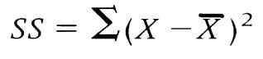

2. computational

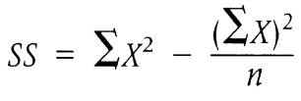

B. Variance

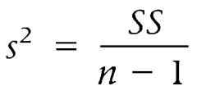

C. Standard Deviation

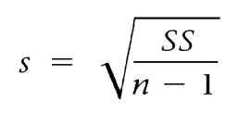

IV. Factors that affect variability

A. Extreme scores

B. Sample size

C. Stability under sampling

D. Open-ended distributions

V. Relationship to other measures