**Psy 230 Z-Scores (G&W Ch. 5)**

**I. z-scores and location in a distribution**

A. What is a z-score?

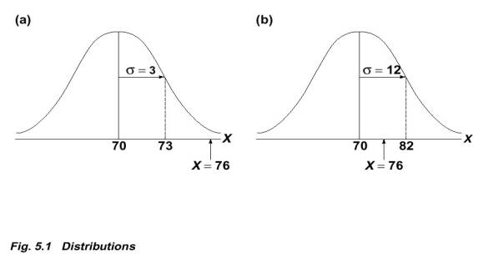

- standardize a distribution

 uses mean and st. dev. to produce a number

- Sign (+ or -) indicates above or below mean

- number gives distance from mean in st. dev. units

- Thus, a score that is located two standard deviations above the mean will have a z-score of +2.00.  And, a z-score of +2.00 always indicates a location above the mean by two standard deviations.

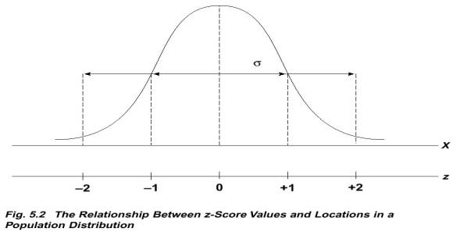

B. Formula

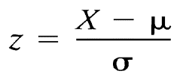

C. Deriving a raw score from a z-score

*X =  + z*

 D. Characteristics of the z-score distribution

- shape will be same as the distribution of raw scores

- mean will always equal 0

- st. dev. will always equal 1

**II. Using z-scores for making a comparison**

A. Standardized Distribution

- transposed scores

- make dissimilar comparable

- "standard score"

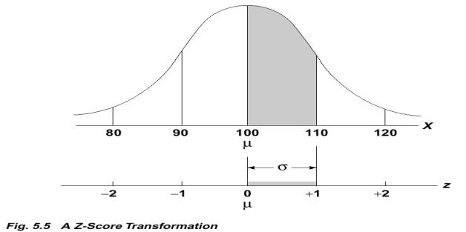

B. Why are z-scores important?

- probability (ch. 6)

- evaluating treatment effects (ch. 8)

- measuring relationships

**III. Other Standardized scores based on z-scores**

A. Transformed Distributions

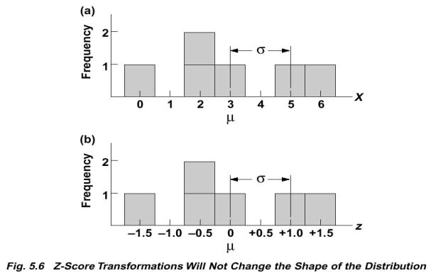

B. Steps for Transforms

- raw score to z-score (need old   and  )

- z-score to new X score in new distribution with pre-determined mean and standard deviation (need new  and  )