Effect of Indoor Plant Density on Creative and Repetitive Tasks

Jane R. Doe

Minnesota State University of Moorhead

Abstract

Previous research has shown plants increase positive affect (Shibata & Suzuki, 2004), but also decrease productivity as plant density is increased (Larsen, Adams, Deal, Kweon, & Tyler, 1998). The effect of plant density on creative tasks and repetitive tasks was explored in the current study. Participants were randomly assigned to a room with either low plant density (3 plants), or high plant density (6 plants) and randomly given a creative or repetitive task to assess productivity. Since Shibata (2004) has shown plants increase positive affect, it was predicted that creative tasks, which are boosted with positive affect, would have higher scores in the room with high plant density (Isen, Daubman, & Nowicki, 1987). It was also predicted that repetitive tasks, which have lower productivity when affect is positive, would have lower scores with high plant density. The current study found no significance in results, however it did show a pattern emerging between repetitive tasks influencing higher productivity levels with low plant density. The current study also found an emerging pattern between higher plant density and higher happiness levels.

Effect of Indoor Plant Density on

Creative and Repetitive Tasks

There are many studies showing that indoor plants can boost mood, lessen work absences due to sickness, and enhance productivity in the workplace (Shibata & Suzuki, 2004; Bjørnstad, Patil, & Raanaas, 2016; Nieuwenhuis, Knight, Postmes, & Haslam, 2014). The problem is, there is also evidence of a limit to the amount of plants in a given space before productivity begins to decline (Larsen, Adams, Deal, Kweon, & Tyler, 1998). However, research investigating productivity declines is lacking, therefore it is unknown whether this decrease in productivity extends to all task types in the workplace. The current study investigated the effects of high and low plant density on the productivity between two task types: creative tasks that require innovative thinking, and repetitive tasks that require minimum thinking.

Exposure to the outdoor environment and nature has many benefits. According to Hartig, Evans, Jamner, Davis, and Gärling (2003), walking outdoors can diffuse or decrease anger, as well as influence a faster recovery time after being exposed to a stressful situation in comparison with urban settings. Davydenko and Peetz (2017) shows time spent in nature also decreases stress compared with time spent in urban (or man-made) settings. Nature, in general, benefits people in additional ways such as providing psychologically restorative effects and decreasing fatigue, compared to indoor settings (Bodin & Hartig, 2003; Niedermeier, Einwanger, Hartl, & Kopp, 2017). However, not everybody can get outdoors to receive these benefits. This begs the question of whether bringing aspects of nature indoors can help us in some way when outdoor access is limited.

Studies show evidence that bringing nature indoors (or secondary exposure to nature) also has significant benefits. Just watching a video featuring nature can alleviate physiological and emotional stress (Ulrich, Simons, Losito, Fiorito, Miles, & Zelson, 1991), so it is to be expected that physical nature, such as indoor plants, can also have benefits.

Research provides many examples of indoor plants benefitting people. Having plants in the indoor environment increases “fascination” (visuals that spontaneously grab our interest in an easily processed way) of the room regardless of access to an uncovered window providing a view of nature (Evensen, Raanaas, Hagerhall, Johansson, & Patil, 2015). So even with a view to outdoor nature, access to indoor plants may benefit people. It has also been shown that indoor plants increase mood and positive affect (Shibata & Suzuki, 2004). Not only that, but a significant amount of people find having plants in a room make the room more attractive, and rooms that are perceived as attractive reduce stress (Dijkstra, Pieterse, & Pruyn, 2008). This means having plants in the workspace could make employees happier and less stressed. In fact, those with access to indoor plants reported a “higher quality of life” than those who do not (Dravigne, Waliczek, Lineberger, & Zajicek, 2008). Participants in Dravigne et al’s study were surveyed with the question, “Overall, how would you rank your overall quality of life?” and those who had plants, a window, or both stated that they were “very satisfied” or “mostly satisfied,” compared to participants who had no plants and no window access. In comparison, the group who had no plants and no window access were the only group to contain participants that marked “unsatisfied” on the quality of life question and were the lowest in overall satisfaction scoring. This means access to viewing aspects of nature could influence perceived overall quality of life.

While indoor plants influence higher quality of life regarding emotion, they also help in a more physical way as well. It is suggested that indoor plants help enhance recovery of patients after surgery by lowering blood pressure, pain, and reducing time spent in the hospital after surgery (Park & Mattson, 2009; Ulrich, 1984). The presence of indoor plants also influences patients to feel like they are receiving higher quality care and help them become more resilient to stress, aiding in recovery time (Raanaas, Patil, & Alve, 2016). There is also evidence from lab and office studies that with the right number, indoor plants reduce air pollutants (Tarran, Torpy, & Burchett, 2007). This is important because air pollutants can cause symptoms such as headaches or nausea, which increase illness-related absences from work (Bergs, 2002). A study by Fjeld (2002) showed that physical ailments such as headaches, nose, and eye irritations significantly decreased when a large amount of indoor plants were added to a room. Therefore, the benefits of indoor plants can be powerful and worth implementing in indoor environments.

Despite the numerous benefits, there is evidence that indoor plants lower productivity in repetitive tasks (Larsen et al., 1998). Research on the subject is lacking, however, it is speculated that negative affect helps create a productive mindset for repetitive tasks (Larsen et al., 1998; Isen, Daubman, & Nowicki, 1987). Since Shibata & Shizuki (2004) found that indoor plants increase positive affect, perhaps positive affect negatively affects productivity in repetitive tasks. With indoor plants present, positive affect is increased, and negative affect is decreased, which may harm productivity in repetitive tasks that might thrive with negative affect.

On the other hand, positive affect increases productivity for creative tasks, or tasks utilizing “ingenuity” or “innovative” thinking (Isen, Daubman, & Nowicki, 1987). Therefore, having plants around to increase positive affect may increase productivity for creative tasks. The current study investigated these aspects of plant density and productivity. It focused on plant density affecting creative and repetitive tasks. In summary, adding plants to indoor environments can be beneficial. However, there does appear to be a limit to the amount of plants in the environment before productivity drops in the case of repetitive tasks (Larsen et al., 1998). There is little research about why productivity is lowered with many plants compared to a moderate number of plants, and the current study was designed to help fill in those gaps.

The purpose of this study was to provide needed research on plants’ influence on productivity and examine whether a high density of plants only lowers productivity in repetitive tasks, or whether it affects creative tasks as well. The reason this is important is because work environments may desire the benefits indoor plants provide, but the potential loss of productivity may prevent them from doing so. On the other hand, work environments that utilize creativity may benefit from increasing indoor plants in the environment if a high density of plants does boost creativity. It could be speculated that jobs involving repetitive tasks could be something like data entry, while jobs involving creative tasks could be something like journalism. Any office job could benefit from the mood boost that indoor plants may provide; however, it would be important to note any limit on productivity that might result from plant density. It would also be beneficial to note any boost in productivity influenced by plant density.

In the current study, participants were randomly assigned to either a creative or repetitive task, and randomly assigned to a room with high plant density or low plant density. A between measures design was used to investigate plant density and task type productivity. Considering the study by Isen et al. (1987) which showed that creativity is boosted with positive affect, it was predicted that the room with high plant density would foster higher productivity when paired with a creative task, and lower productivity when paired with a repetitive task. It was also predicted that participants in the high-density room would have higher levels of happiness.

**Method**

**Participants**

Participants were 48 lower-level psychology students from Minnesota State University Moorhead ranging from age 18-65. Most were between 19-22 years of age (67%), with the most common age being 19 (12 participants). 75% of participants were female. They were recruited through a sign-up sheet posted in the psychology department. Participants signed an informed consent form before participating and were awarded a participation slip at the end of the study. All participants were treated according to the ethical standards of American Psychological Association (APA).

**Design**

The design was a 2x2 between-subjects factorial ANOVA, as there are two independent variables. The first independent variable was the plant density, with the two levels being a low plant density of three plants and a high plant density of six plants. The second independent variable was the task given, with the two levels being a repetitive task and a creative task. The dependent variable was the performance result, which was a productivity score for the amount of work finished in ten minutes for each task.

**Materials**

Six healthy, leafy plants varying in type and size were used. For low plant density of three plants, one plant was large (30 or more inches) and two were medium (8 - 20 inches). For high density of six plants, two plants were large (30 or more inches) and four plants were medium (8 - 20 inches). Measurements included base of the pot, to the top of the plant. They were plants that are typically found in public spaces, which was intended to reduce incidents of allergic reaction as well as simulate an environment that participants may have found in daily life or working in an office. A variety of plants were given in size and type to fill the space more evenly, give symmetry, and look more decorative (see Appendix A for examples of plants).

There were two tasks given. One task was a creative task requiring the participants to write a story about a Where’s Waldo picture (see Appendix B). Creative productivity was measured by taking the most detailed story generated across all participants and using the number of story elements generated as the maximum 100% creativity score for all other participants. These story elements included number of characters, plots, verbs, and adjectives contained in the story written by each participant. The number of story elements generated were expressed as a percent of the maximum. For example, a participant who generated 20 elements compared to the maximum 30 elements earned a creativity score of 66%. The other task was a repetitive task requiring the participants to count people or objects in the same images used in the creative task (see Appendix C). Repetitive productivity was calculated based on the number of objects accurately counted by each participant compared to the actual number of objects in the picture. For example, a participant who counted the total number of objects in the picture would earn a repetitive score of 100%. A filler task of a simple word find puzzle was given (see Appendix D). Shibata and Suzuki’s 2004 survey on the participants’ mood and impressions of the room was given, resourced from their study *Effects of an Indoor Plant on Creative Task Performance and Mood* (see Appendix E). An age and gender demographic survey was given to help the experimenter describe the basic characteristics of the sample (see Appendix F). The demographic survey contained a question asking participants how long they had spent outdoors prior to the study, in order to assess outside influences.

**Procedure**

The participant was randomly assigned to a plant density condition and the room was set up accordingly. One of the rooms had a low density of plants (three plants), and the other room had a high density of plants (six plants). Both rooms were small research labs with one table and a computer.

After informed consent was obtained, the participant was given a mood survey, and then sat in the assigned room for five minutes to acclimate to the surroundings. A neutral filler task was given during the acclimation time in the form of a simple word find puzzle and the participant was informed they had five minutes. After the five minutes of acclimation, the participant received a task at random (either a creative task or repetitive task), the researcher left the room, and the participant completed the task. The researcher came back after ten minutes and gave the participant an envelope to place the response sheets in for confidentiality. The participant then completed the mood survey a second time, as well as a survey on negative or positive impressions of the room, and a demographic survey.

The participant was then debriefed. Any questions were answered, and participants were thanked for participating and awarded an extra credit card. The study lasted about twenty minutes.

**Results**

The productivity scores were collected for each task and converted to proportions in order to compare creative scores to repetitive scores in a balanced way. Table 1 displays the means and standard deviations for both creative and repetitive test scores. Participants’ productivity scores were slightly higher in repetitive tasks with low plant density (*M*= 1.32, *SD*= 2.31), but not by a significant amount. Productivity scores were lowest for creative tasks with low plant density (*M*= 0.66, *SD*= 0.17) but not by a significant amount. Scores for repetitive scores with high plant density (*M*= 0.95, *SD*= 0.47) and creative scores with high plant density (*M*= 0.73, *SD*= 0.12) were not significant. A 2x2 ANOVA was conducted in order to see if there was an interaction between plant density and task type productivity. There were no significant results from the type of task, *F* (1, 44) = 1.663, *p*= .204, *η2* = .036; from the plant density, *F* (1, 44) = 0.191, *p*= .665, *η2* = .004; or the interaction, *F* (1, 44) = .436, *p*= .513, *η2* = .010. Figure 1 shows the emerging pattern of repetitive task type being influenced by low plant density. Though not significant, productivity between repetitive task type and low plant density was higher than other productivity scores.

Mood surveys were collected both before and after the productivity tasks. A happiness score based on a Likert scale, where 1 was not happy at all, and 7 was very happy, was used. Table 2 displays the means and standard deviations for the results. Before the tasks with low plant density (*M*= 5.04, *SD*= 1.43), and after the tasks with low plant density (*M*= 4.33, *SD*= 1.31) showed a dip in happiness levels. Before the tasks with high plant density (*M*= 5.00, *SD*= 1.02) and after the tasks with high plant density (*M*= 4.92, *SD*= 1.18) showed a dip in happiness level, but much less than the low plant density conditions. A within subjects ANOVA was run to see if there was an interaction between mood and plant density. A pattern was emerging, however the results were not significant for the interaction, *F* (1,46) = 3.668, *p*= .062, *η2* = .074. Figure 2 shows the emerging pattern between mood and plant density.

The survey asking how long participants had spent outdoors prior to the study showed that the majority of participants had spent no more than 5 minutes outdoors that day. Only six participants had spent over an hour outdoors prior to the study.

**Discussion**

The hypothesis predicted that productivity for creative tasks would be higher in the room with a high amount of plants, and the other hypothesis predicted lower productivity for repetitive tasks in the room with high density of plants. No results for productivity were significant, however there was a pattern showing that productivity for repetitive tasks was higher with the low plant density. Since there were only twelve participants per condition, this could be affecting accuracy in significance. As seen in Table 1, the standard deviation for repetitive task and low plant density was high compared to others. This means there is a larger fluctuation in results because of the low number of participants. Perhaps if there were thirty or more participants, a stronger pattern or correlation would emerge.

In checking the results for mood, overall happiness levels decreased after both task types were completed. However, happiness levels were higher in the room with a high density of plants compared to low density. This fits in with research showing that plants increase happiness and feelings of well-being, so this study helps support existing research about plants creating or boosting positive affect. It could be that without the plants, the participants would have been even less happy after the tasks were completed. Since participants had lowered happiness levels after both tasks, a counter-balance to raise mood should have been implemented after each task, however this mood lowering was not anticipated or known until after data collection.

One limitation was number of participants. Twelve per condition was not enough to produce stable, reliable results. Another limitation might be the stressful materials. Since participants in the current study were showing significant unhappiness after each condition, that could be a potential confound in the results. In relation to that, a limitation could be time spent on each task. The amount of time necessary for the task completion, combined with the type of task designed, may have contributed to the significant mood change. Since it is important for participants to be exposed to the plants for a certain length of time in order for the plants to affect the productivity scores, a task that could be carried out for ten minutes or more without stress could be more neutral, and productivity in relation to the plant density could become clearer. If a more neutral task cannot be found, then perhaps the filler task should be longer, and the productivity task could be shorter. The last limitation could be the choice of filler task. Only one participant came close to finishing the word find within the 5-minute time limit. In fact, the majority of participants had barely scratched the surface of it within the given time frame. Many expressed a reluctance to move on from the filler task. The frustration from not being allowed to finish and the perceived difficulty of the filler task may have lowered the happiness levels in participants.

It is also possible that the high plant density condition was not high enough for an effect. Perhaps six plants compared to three plants were enough to boost positive affect, but not enough of a boost to positively affect creative productivity. It could be more effective if the ratio was 1:3 instead of 1:2, or in other words, had used nine plants for the high-density condition in this study.

Future studies may want to focus on a higher amount of plants in relation to a more neutral creative task. Perhaps it would be more insightful to fill a room as much as possible and lower the amount to find the threshold, instead of starting low and building up. It might also be beneficial to have a control group of no plants. For now, it is not certain whether productivity for creative tasks can become higher with a higher amount of plants, but it could certainly be a possibility with the right amount of plants to influence effect.

References

Bergs, J. (2002). Effect of healthy workplaces on well-being and productivity of office workers. *Proceedings of International Plants for People Symposium.* Retrieved fromhttp://www.raimondihg.com/assets/blog/RHG_Symposium.pdf

Bjørnstad, S., Patil, G. G., & Raanaas, R. K. (2016). Nature contact and organizational support during office working hours: Benefits relating to stress reduction, subjective health complaints, and sick leave. *Work: Journal Of Prevention, Assessment & Rehabilitation, 53*(1), 9-20. doi:10.3233/WOR-152211

Bodin, M., & Hartig, T. (2003). Does the outdoor environment matter for psychological restoration gained through running?. *Psychology Of Sport And Exercise, 4*(2), 141-153. doi:10.1016/S1469-0292(01)00038-3

Davydenko, M., & Peetz, J. (2017). Time grows on trees: The effect of nature settings on time perception. *Journal of Environmental Psychology, 54*, 20-26. doi:10.1016/j.jenvp.2017.09.003

Dijkstra, K., Pieterse, M. E., & Pruyn, A. (2008). Stress-reducing effects of indoor plants in the built healthcare environment: The mediating role of perceived attractiveness. *Preventive Medicine: An International Journal Devoted To Practice And Theory, 47*(3), 279-283. doi:10.1016/j.ypmed.2008.01.013

Dravigne, A., Waliczek, T. M., Lineberger, R.D., & Zajicek, J. M. (2008). The Effect of Live Plants and Window Views of Green Spaces on Employee Perceptions of Job Satisfaction. *HortScience, 43*(1), 183-187.

Evensen, K. H., Raanaas, R. K., Hagerhall, C. M., Johansson, M., & Patil, G. G. (2015). Restorative elements at the computer workstation: A comparison of live plants and inanimate objects with and without window view. *Environment And Behavior, 47*(3), 288-303. doi:10.1177/0013916513499584

Fjeld, T. (2000). The effect of interior planting on health and discomfort among workers and school children. *HortTechnology*, *10*, 46–52. Retrieved from http://www.wolvertonenvironmental.com/Fjeld-98.pdf

Handford, M. (2009). Where’s Waldo?. Retrieved from https://www.techspot.com/news/75939-ai-powered-facial-recognition-robot-zaps-fun-where.html

Hartig, T., Evans, G. W., Jamner, L. D., Davis, D. S., & Gärling, T. (2003). Tracking restoration in natural and urban field settings. *Journal Of Environmental Psychology, 23*(2), 109-123. doi:10.1016/S0272-4944(02)00109-3

Isen, A. M., Daubman, K. A., & Nowicki, G. P. (1987). Positive affect facilitates creative problem solving. *Journal Of Personality And Social Psychology, 52*(6), 1122-1131. doi:10.1037/0022-3514.52.6.1122

Larsen, L., Adams, J., Deal, B., Kweon, B.-S., & Tyler, E. (1998). Plants in the workplace: the effects of plant density on productivity, attitudes, and perceptions. *Environment and Behavior, 30*(3), 261+. doi:10.1177/001391659803000301

Niedermeier, M., Einwanger, J., Hartl, A., & Kopp, M. (2017). Affective responses in mountain hiking--A randomized crossover trial focusing on differences between indoor and outdoor activity. *Plos ONE, 12*(5). doi:10.1371/journal.pone.0177719

Nieuwenhuis, M., Knight, C., Postmes, T., & Haslam, S. A. (2014). The relative benefits of green versus lean office space: Three field experiments. *Journal Of Experimental Psychology: Applied, 20*(3), 199-214. doi:10.1037/xap0000024

Park, S., & Mattson, R. H. (2009). Ornamental indoor plants in hospital rooms enhanced health outcomes of patients recovering from surgery. *The Journal Of Alternative And Complementary Medicine, 15*(9), 975-980. doi:10.1089/acm.2009.0075

Raanaas, R. K., Patil, G., & Alve, G. (2016). Patients’ recovery experiences of indoor plants and views of nature in a rehabilitation center. *Work: Journal of Prevention, Assessment & Rehabilitation*, *53*(1), 45–55. https://doi-org.trmproxy.mnpals.net/10.3233/WOR-152214

Raviv, Daniel. (2004). Hands-on Activities for Innovative Problem Solving. American Society for Engineering Education Annual Conference & Exposition.

Shibata, S., & Suzuki, N. (2004). Effects of an indoor plant on creative task performance and mood. *Scandinavian Journal Of Psychology, 45*(5), 373-381. doi:10.1111/j.1467-9450.2004.00419.x

Tarran, J., Torpy, F., & Burchett, M. (2007). Use of living pot plants to cleanse indoor air: A research review. *Proceedings of sixth international conference on Indoor Air Quality, Ventilation & Energy Conservation in Buildings—Sustainable Built Environment, 3*, 249-256. Retrieved from https://greenplantsforgreenbuildings.org/wp-content/uploads/2014/01/PlantsCleanseIndoorAir.pdf

Ulrich, R. S. (1984). View through a window may influence recovery from surgery. *American Association for the Advancement of Science. 224*, 420-422.

Ulrich, R. S., Simons, R. F., Losito, B. D., Fiorito, E., Miles, M. A., & Zelson, M. (1991). Stress recovery during exposure to natural and urban environments. *Journal Of Environmental Psychology*, *11*(3), 201-230. doi:10.1016/S0272-4944(05)80184-7

Table 1

*Average Production Scores for Plant Density and Task Type*

|  |  |  |
| --- | --- | --- |
|  | Repetitive | Creative |
| Low Density | *M*= 1.32  *SD*= 2.31 | *M*= 0.66  *SD*= 0.17 |
| High Density | *M*= 0.95  *SD*= 0.47 | *M*= 0.73  *SD*= 0.12 |

Table 2

*Average Happiness Scores as Influenced by Plant Density*

|  |  |  |
| --- | --- | --- |
|  | Low Density | High Density |
| Mood Before | *M*= 5.04  *SD*= 1.43 | *M*= 5.00  *SD*= 1.02 |
| Mood After | *M*= 4.33  *SD*= 1.31 | *M*= 4.92  *SD*= 1.18 |

*Figure 1*: The graph above shows no significant interaction between plant density and task type, however a pattern is emerging between repetitive task and low plant density.

*Figure 2:* The graph above shows an emerging pattern between mood and plant density.

*Appendix A*

Plants Used for Density

Example Photo:

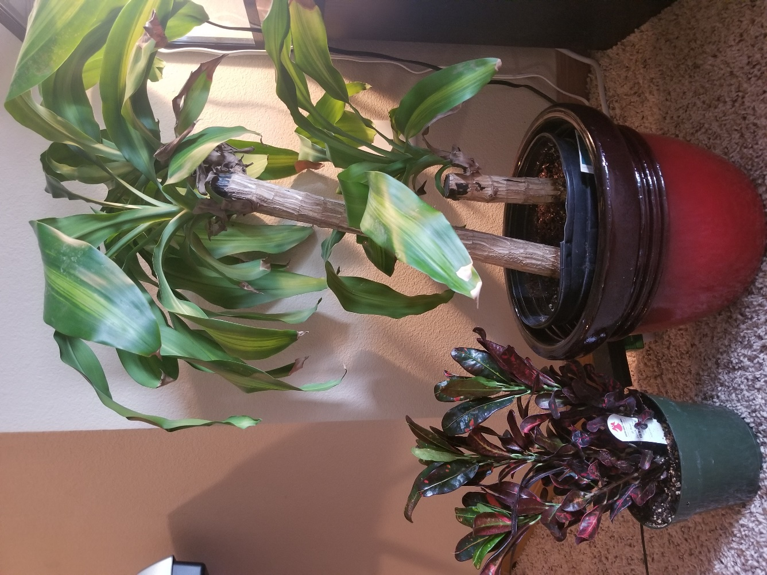  
*Figure 1*. Small plant, Croton; Large plant, Dracaena (own photo).

*Appendix B*

Creative Task Example

Tell a detailed story about what’s going on in the image:



Figure 1. Image from Where’s Waldo? (Handford, 2012).

*Appendix C*

Repetitive Task Example

Count the number of people in the image:



Figure 1. Image from Where’s Waldo? (Handford, 2012).

*Appendix D*

Simple Puzzle

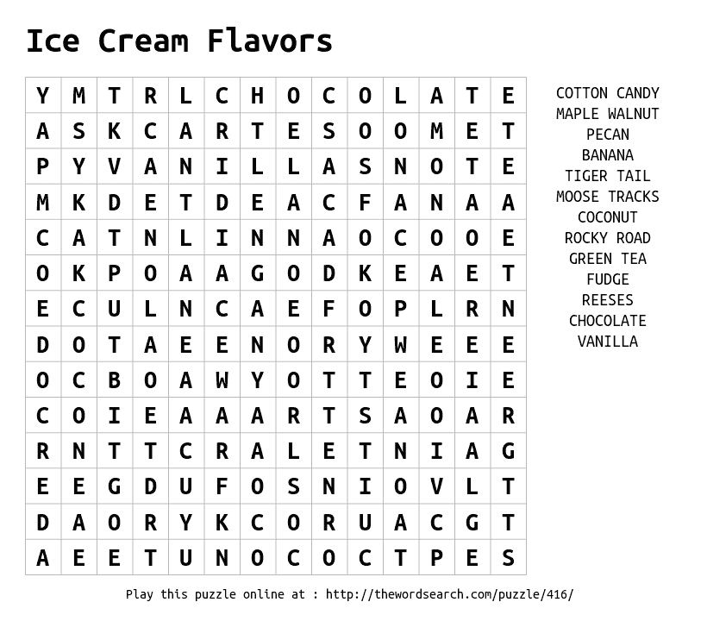

*Figure 1*. Example word find filler task (The Word Search).

*Appendix E*

Mood and Environment Survey

Rate Your Current Mood  
1 = Strongly Disagree, 7 = Strongly Agree

Happy 1 2 3 4 5 6 7

Tired 1 2 3 4 5 6 7

Calm 1 2 3 4 5 6 7

Confident 1 2 3 4 5 6 7

Tense 1 2 3 4 5 6 7

Concentrated 1 2 3 4 5 6 7

At ease 1 2 3 4 5 6 7

Energized 1 2 3 4 5 6 7

Distracted 1 2 3 4 5 6 7

Rate the Environment  
1 = Strongly Disagree, 7 = Strongly Agree

Sober 1 2 3 4 5 6 7

Energetic 1 2 3 4 5 6 7

Distracting 1 2 3 4 5 6 7

Spacious 1 2 3 4 5 6 7

Tense 1 2 3 4 5 6 7

Bright 1 2 3 4 5 6 7

Tranquil 1 2 3 4 5 6 7

Familiar 1 2 3 4 5 6 7

Dark 1 2 3 4 5 6 7

Concentrating 1 2 3 4 5 6 7

Small 1 2 3 4 5 6 7

(Shibata & Suzuki, 2004)

*Appendix F*

Gender and Demographic Survey

Gender:

Age:

How much time have you spent outdoors today?