# Abstract

The effect of various types of social media on self-esteem and affect will be investigated. Studies have shown that social media has a significant effect on individuals’ self-esteem and affect (Bányai, Zsila, Király, Maraz, Elekes, Griffiths, Andreassen, & Demetrovics, 2017). To further test that, ninety college age participants will view one of three different types of social media pages: one featuring non-human subjects, one featuring unhealthy behaviors, and one featuring famous influencers and celebrities. These will encourage no social comparison, downward social comparison, and upward social comparison, respectively. It is predicted that the type of social comparison individuals use will temporarily affect their levels of self-esteem and affect. Specifically, the upward social comparison group should have the lowest self-esteem and highest negative affect, the downward social comparison group should have the highest self-esteem and lowest negative affect, and the control group should be in the middle.

**Method**

**Participants**

Sixty participants will be used in the study. Participants will be 18 or older, male and female, and students at Minnesota State University Moorhead. They will volunteer for the study by signing up on the bulletin board outside the Psychology Department office. Participants will receive a blue card that can be turned in for extra credit in any participating psychology course. All participants will be treated according to the ethical principles of the American Psychological Association (APA).

**Design**

The study will be a single factor between-subjects design. It will have one independent variable with three levels: accounts showing non-human photos (control), accounts showing unhealthy behaviors (encouraging downward social comparison), and accounts showing influencers and celebrities (encouraging upward social comparison). There will be two dependent variables: self-esteem and mood.

**Materials**

There will be a series of images from Instagram accounts that participants will view corresponding to their randomly assigned groups. The downward social comparison group will view images from four public Instagram accounts (see Appendix A) portraying unhealthy behaviors, such as lack of exercise, excessive time on screens, and low achievement. This group will be given four accounts to look at because the subjects they are viewing are less successful than those in the other groups and thus have fewer posts. The four accounts will give participants in all groups approximately the same amount of posts to view. The upward social comparison group will view images from two public accounts (see Appendix B) that are posted by either influencers or celebrities. These accounts will contain images focused on the idealized lifestyle of influencers and celebrities. It will include images of travel, beauty, fitness, and luxury. The control group will view images from two public accounts (see Appendix C) featuring non-human subjects such accounts portraying nature.

Participants will take two assessment measures: The Rosenberg Self-Esteem Scale (see Appendix D) and the Positive and Negative Affect Scale (PANAS) (see Appendix E), both of which have been shown to be scientifically valid. The Rosenberg Self-Esteem Scale contains ten statements where the participant answers strongly agree, agree, disagree, or strongly disagree. Statements two, five, six, eight, and nine are reverse scored. Higher scores indicate higher levels of self-esteem. The PANAS has twenty statements and the participant answers very slightly or not at all, a little, moderately, quite a bit, or extremely. Statements one, three, five, nine, ten, twelve, fourteen, sixteen, seventeen, and nineteen are concerned with positive affect and the other ten statements are concerned with negative affect.

Participants will also complete a series of demographic questions. These include gender, year in school, and the average amount of time (in minutes) spent on Instagram per day (see Appendix F). The last question will be asked to see if there is a correlation between time spent on Instagram and levels of self-esteem and positive and negative affect.

**Procedure**

Participants will arrive at the testing room in Bridges Hall on Minnesota State University Moorhead campus during the time slot they signed up for previously. They will be given a consent form at the beginning of the session. They will then be randomly assigned to one of three groups: the control group, the upward social comparison group, or the downward comparison group.

After participants view the images assigned to their specific group for ten minutes, they will take two measures: the Rosenberg Self-Esteem Scale and the Positive and Negative Affect Scale (PANAS) in a counter balanced order. Next, participants will be asked a series of demographic questions, including gender, year in school, age, and the amount of time (in minutes) spent on Instagram per day. Once this is completed, participants will be debriefed, thanked for their participation, and given the appropriate documentation for extra credit in the form of a blue card. The session will last an average of 20 minutes.

**Appendix A**

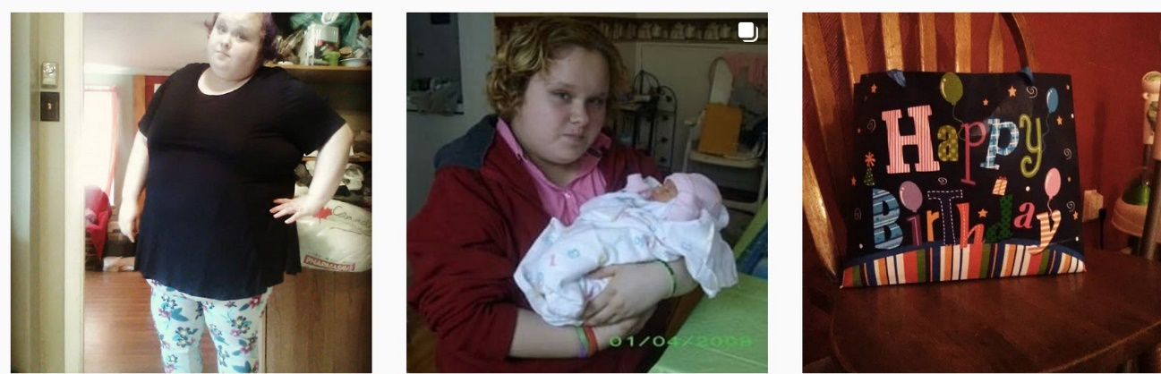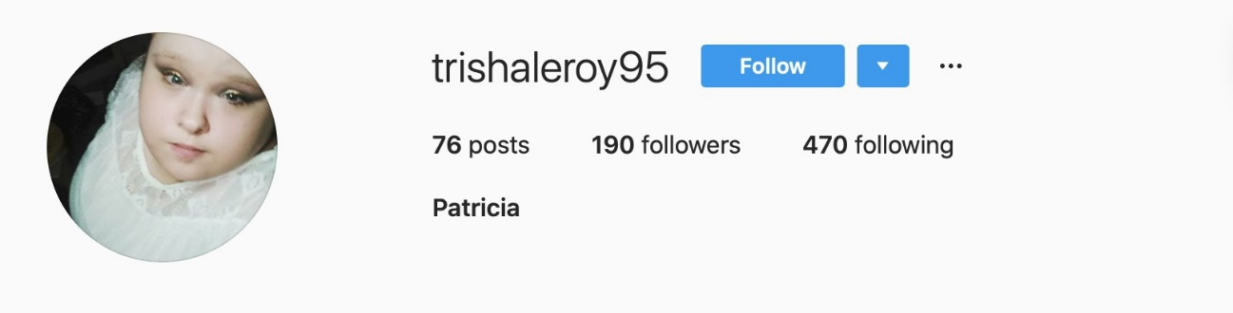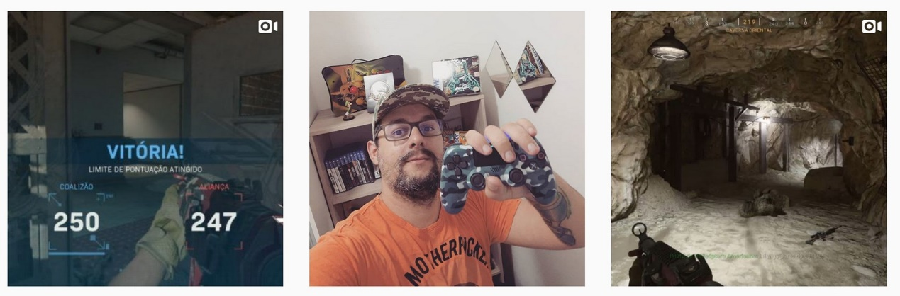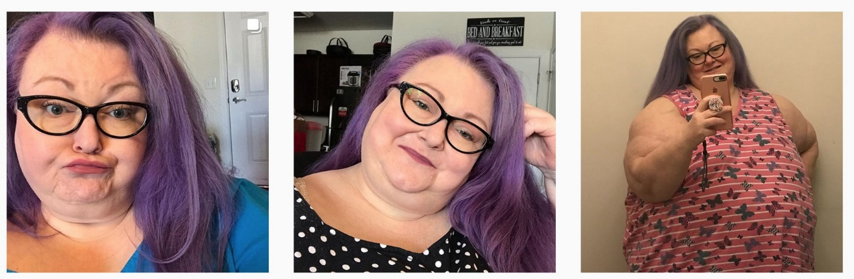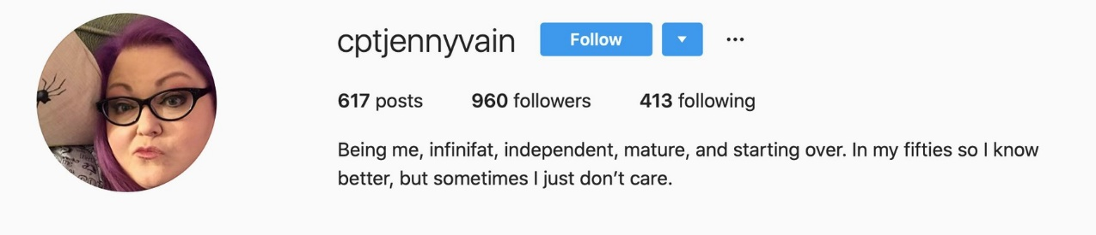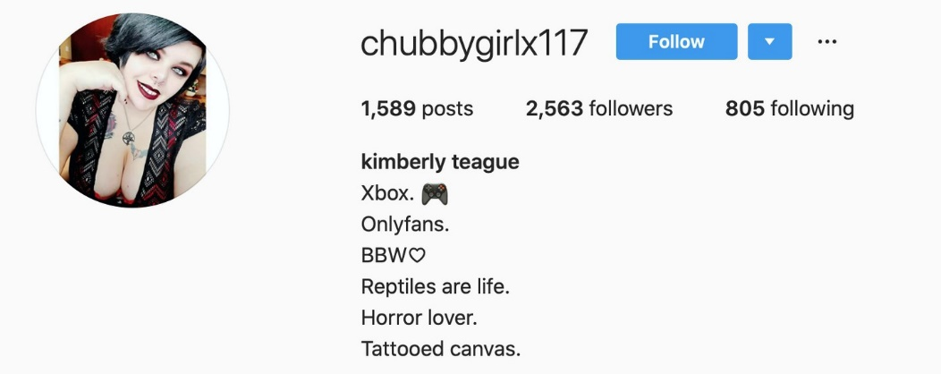

**Appendix B**

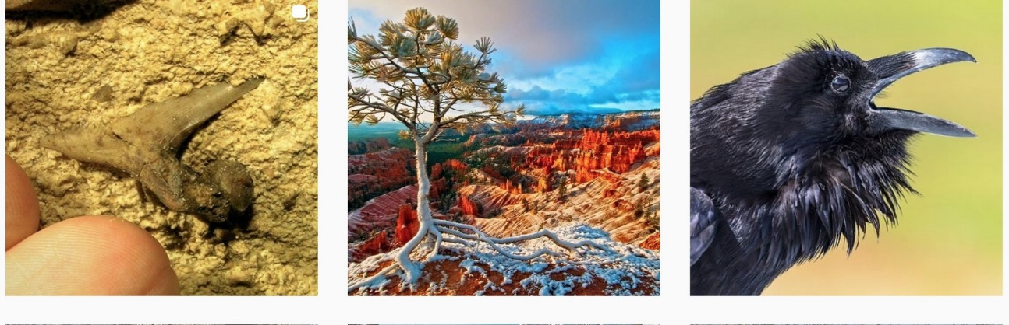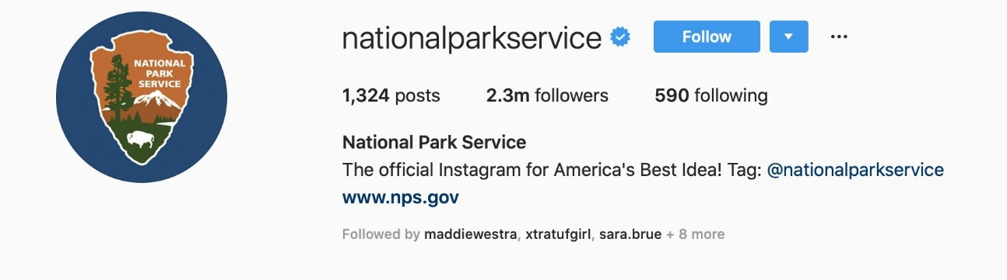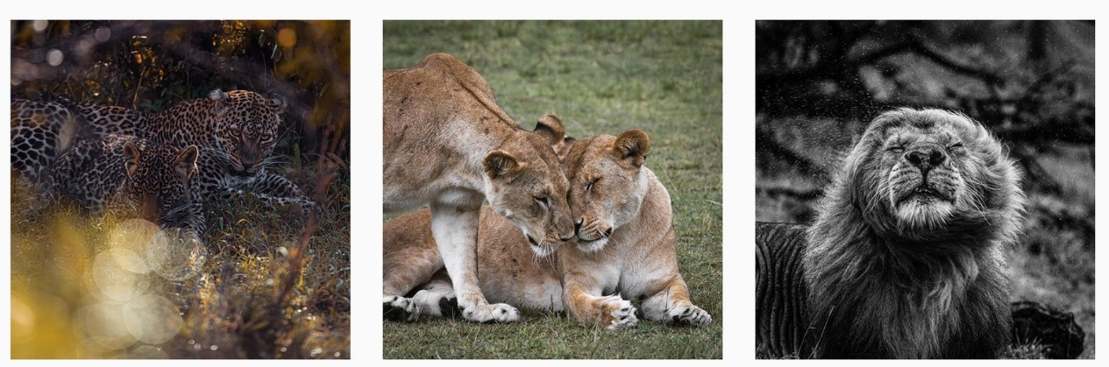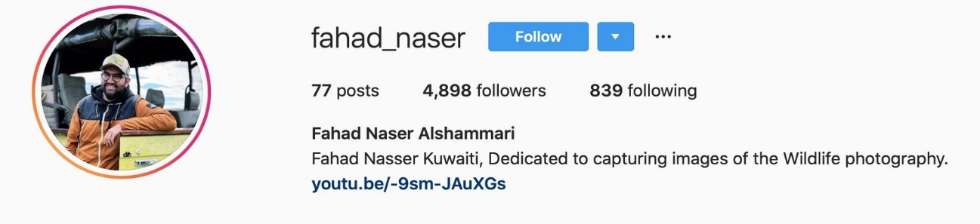

**Appendix C**

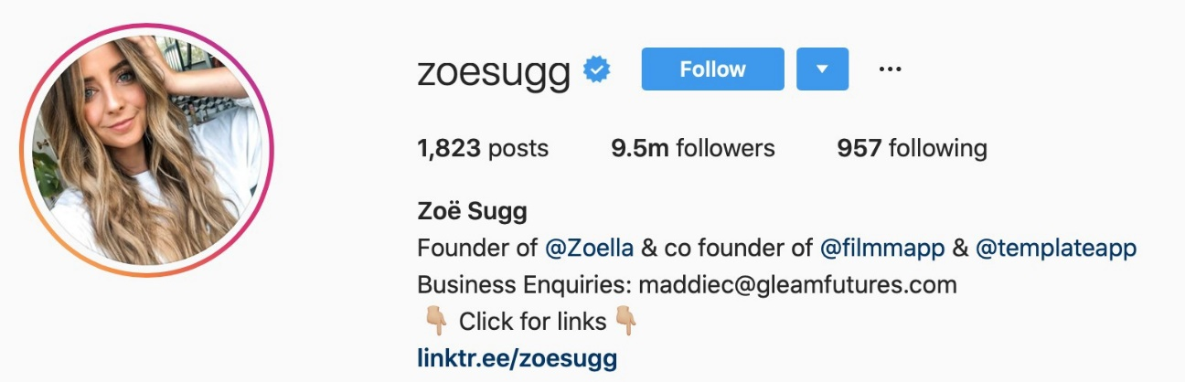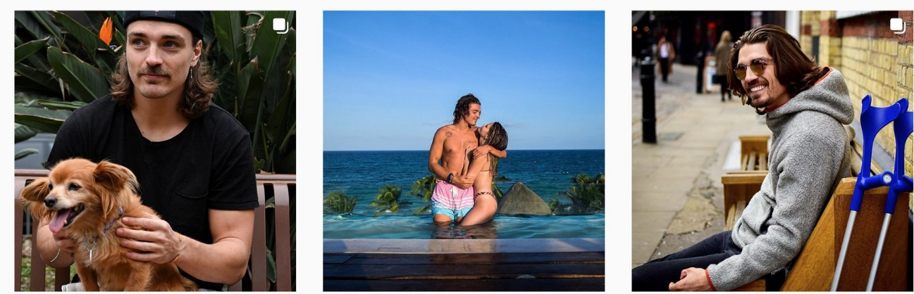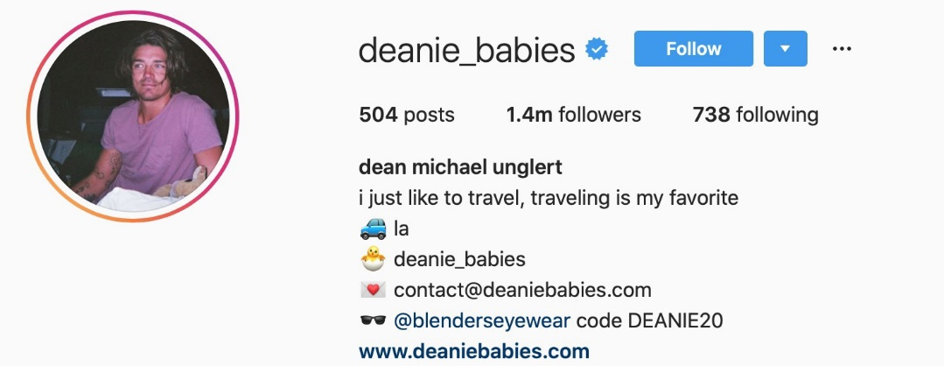

**Appendix D**

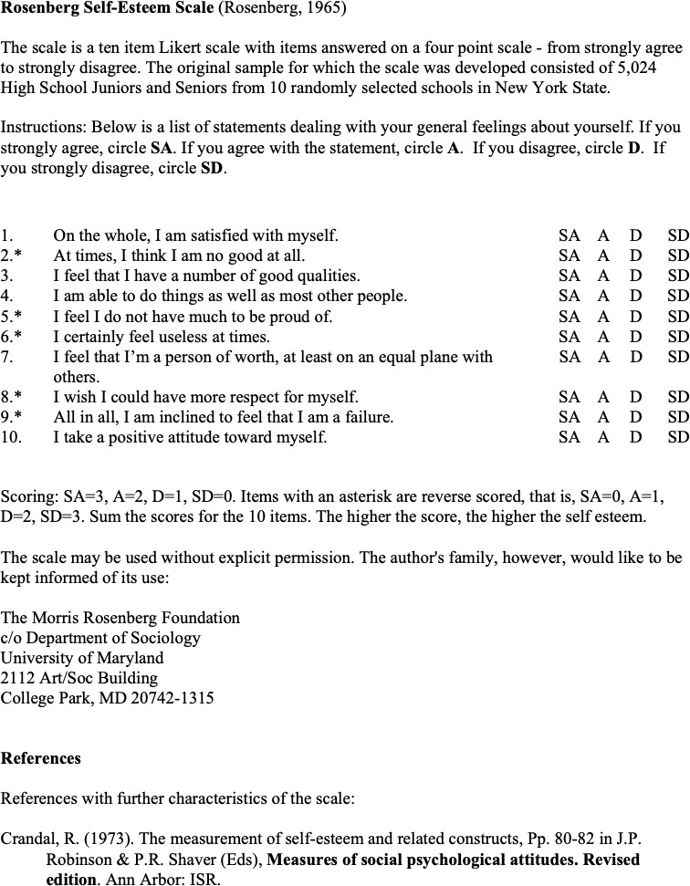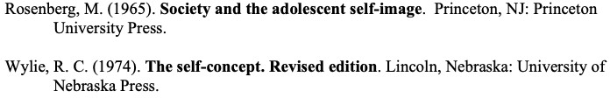

**Appendix E**

*Only questions concerning negative affect will be asked (2, 4, 6, 7, 8, 11, 13, 15, 18, & 20 of the original PANAS)*

**PANAS-GEN**

This scale consists of a number of words that describe different feelings and emotions. Read each item and then mark the appropriate answer in the space next to that word. Indicate to what extent you NOW feel, that is, how you feel AT THIS MOMENT.

Use the following scale to record your answers.

|  |  |  |  |  |  |
| --- | --- | --- | --- | --- | --- |
|  | **Very slightly or not at all** | **A little** | **Moderately** | **Quite a bit** | **Extremely** |
| Distracted |  |  |  |  |  |
| Upset |  |  |  |  |  |
| Guilty |  |  |  |  |  |
| Scared |  |  |  |  |  |
| Hostile |  |  |  |  |  |
| Irritable |  |  |  |  |  |
| Ashamed |  |  |  |  |  |
| Nervous |  |  |  |  |  |
| Jittery |  |  |  |  |  |
| Afraid |  |  |  |  |  |

The total score is calculated by finding the sum of the items. A lower score indicates less of a negative affect.

# Appendix F

Questionnaire

What is your gender?

Male Female

Other Prefer not to answer

What is your year in school?

1st

2nd

3rd

4th

5th

Other

On average, how many minutes do you spend on Instagram per day?

|  |  |  |
| --- | --- | --- |
| 0-15 | 15-30 | 30-45 |
| 45-60 | 60-75 | 75-90 |
| 90-105 | 105-120 | 120+ |