**Psy 633 Lab 6 PRACTICE  
Chi-Square Statistic**

**(1)  A school district is looking to change their middle school social studies text.  The selection committee has narrowed the choice to three series (all include a 6th grade, 7th grade, and 8th grade text). The three series are distributed to 120 middle school teachers throughout the district.  After a two-week inspection period, teachers must identify which series they prefer.  The preference distribution is as follows:**

**Series 1    Series 2    Series 3  
  54                38                28**

**Do the results indicate a significant preference among the three textbook series?**

***Analyze, Nonparametric, Legacy Dialogs, Chi-Square***

**Write the results in APA format. *See next page.***

(2**)**  A frequency distribution (see below) shows the level of self-esteem according to the level of academic performance for a sample of n = 150 ten-year-old children.**What can we conclude about the relationship between academic performance and self-esteem in ten-year-olds?**

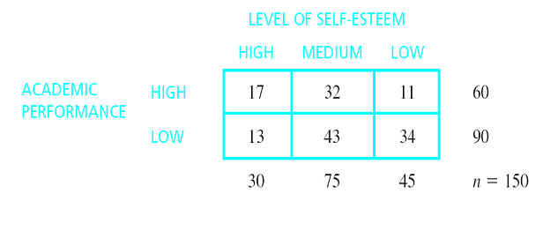

*Analyze, Descriptives, Crosstabs, Statistics: Chi-square, Cells: Expected*

Write the results in APA format. *See the next page.*

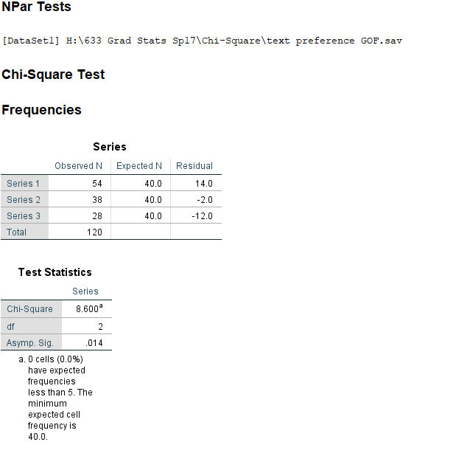

1)

The observed frequencies for the preferred social studies series were as follows: 54 for Series 1, 38 for Series 2, and 28 for Series 3. The analysis showed teachers have a significant preference for Series 1 as the choice for their middle school social studies text, χ2(2, *n*=120) = 8.60, *p* =.014.

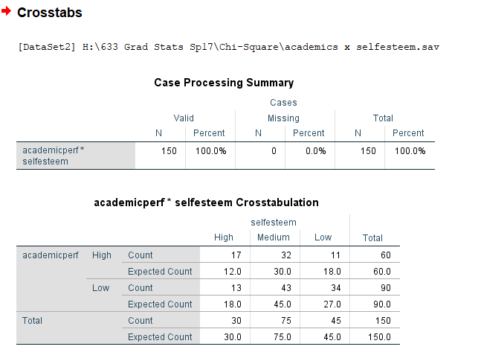

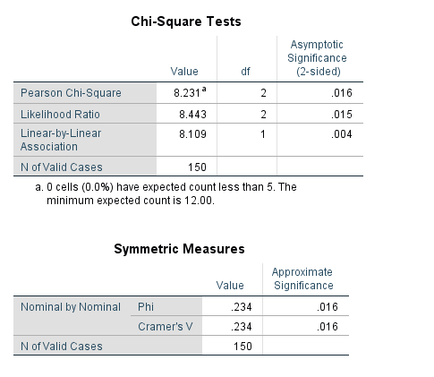

2)

The analysis showed the distribution across academic performance (high vs. low) differs across level of self-esteem (high, medium, low) for ten-year-old children, χ2(2, *n*=150) = 8.23, *p* = .016, Cramer’s *V* = .234. The students with high academic performance were distributed more in the high self-esteem level (*x* = 17) and less in the low self-esteem level (*x* = 11) than expected by chance. This pattern is opposite for those with low academic performance. There are fewer students in the high self-esteem level (*x* = 13) and more in the low self-esteem level (*x* = 34) than expected by chance. The observed frequencies are displayed in Table 1.

*Table 1  
Observed Frequencies for Self-Esteem Level across Academic Performance*

Level of Self-Esteem

High Medium Low

High 17 32 11

Low 13 43 34