Psy 633 Practice – linear regression

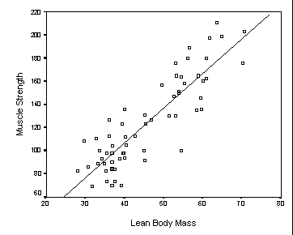 | Strength = -13.97 + 3.02 LBM  r = .87 r² = .76 SEE = 19 p = .000

- What is the likelihood of making a mistake if one concludes that Muscle Strength is correlated with Lean Body Mass, based on this regression solution?

- At what point does the regression line cross the Y-axis?

- What percentage of the differences in Strength scores is explained by LBM?

- What is the value for the slope of this equation?

- How far, on average, would predicted Strength scores be from actual Strength scores?

- How confident would you be in using this regression solution to predict Strength scores?
Explain your answer.

- For the following LBM values, determine the predicted Strength (show work!):

30

70
Scenario 2
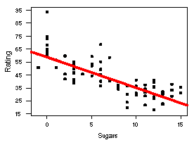 | Rating = 59.3 - 2.40 Sugars  r = - .76 r² = .58 SEE = 9.20 p = .003

- What is the correlation value for Health Rating and amount of Sugars in cereal?

- At what point does the regression line cross the Y-axis?

- What percentage of the differences in Health Rating is explained by amount of Sugar?

- What is the value for the slope of this equation?

- How far, on average, would a predicted Health Rating be from the actual Health Rating?

- What is the likelihood of making a mistake if one concludes that Health Rating is correlated with amount of Sugar in cereal, based on this regression solution?

- How confident would you be in using this regression solution to predict Health Rating scores?
Explain your answer.

- For the following amounts of Sugar, determine the predicted Health Rating (show work!):

3

12

