633 One-way MANOVA – example output
example from: http://www.ats.ucla.edu/stat/spss/whatstat/whatstat.htm
MANOVA (multivariate analysis of variance) is like ANOVA, except that there are two or more dependent variables. In a one-way MANOVA, there is one categorical independent variable and two or more dependent variables. For example, say we wish to examine differences in academic performance with 3 DVs read, write and math broken down by the IV program type (prog) with three levels (1=general, 2=academic, 3=vocation).
Just as with ANOVA's we also run Levene's test for the homogeneity assumption.
In addition, there are several other tests of the other assumptions that we usually include in the output.
However, the main event is the MANOVA test output. It usually looks like the following.
When the IV has 3 or more groups/levels, Wilks' Lamda is the appropriate version of the F-test.
When the IV has exactly 2 groups, Hotelling's Trace is the appropriate version of the F-test. The MANOVA only tells us whether there is a sig. effect of the IV somewhere among the DV's, but not specifically which of the DV's was affected.
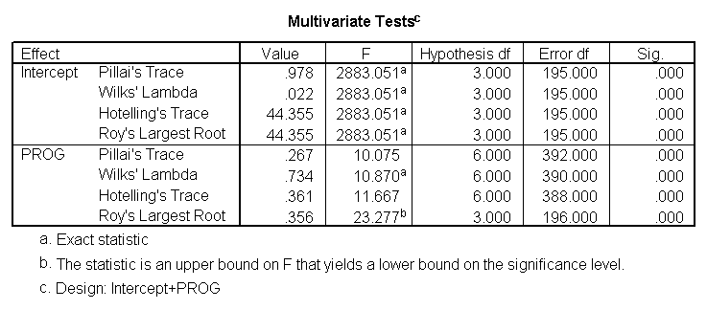
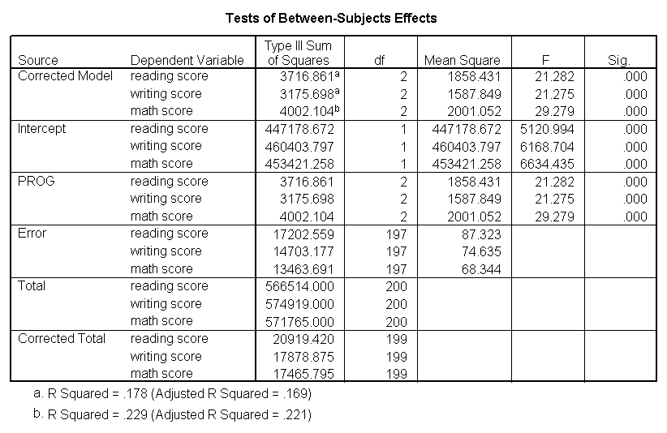
When the MANOVA F-test is significant, then we run multiple one-way ANOVA's as a follow-up to see
which of the dependent variables is significantly affected by the IV.

Once one knows which of the DV's is significantly affected by the IV, then one can proceed further to do a traditional "post-hoc" test to see which levels of the IV differ from one another on each of the separate DV's.

One can also run Factorial MANOVA's – they are like Factorial ANOVA's, except that they have two or more DV's as well as two or more IV's. The MANOVA printout is similar to the foregoing, except that it includes each of the IV's as well as their interactions.

