BIOL 347
Plant Physiology Final Exam

Name __________________________ (PRINT FULL name CLEARLY!)

Take home portion of the final exam. This is due IN CLASS on Monday 12th December at 2.00 pm when you sit the rest of the final exam

NO OTHER LOCATION WILL BE ACCEPTED
This is an open book/open note test

(1) Explain the effect of osmosis relative to a plant cell. What is the optimal relative solution to a plant cell and why is this so? (5 Points)

(2) Explain, fully, the concept of transpiration pull, to include leaf stomatal resistance and boundary layer resistance (10 Points).


(3) Consider this picture. FULLY explain leaf senescence and withdrawal of nutrients to the plant (10 points).
From the wikimedia free licensed media file repository

(4) FULLY explain everything that this diagram depicts (10 Points).
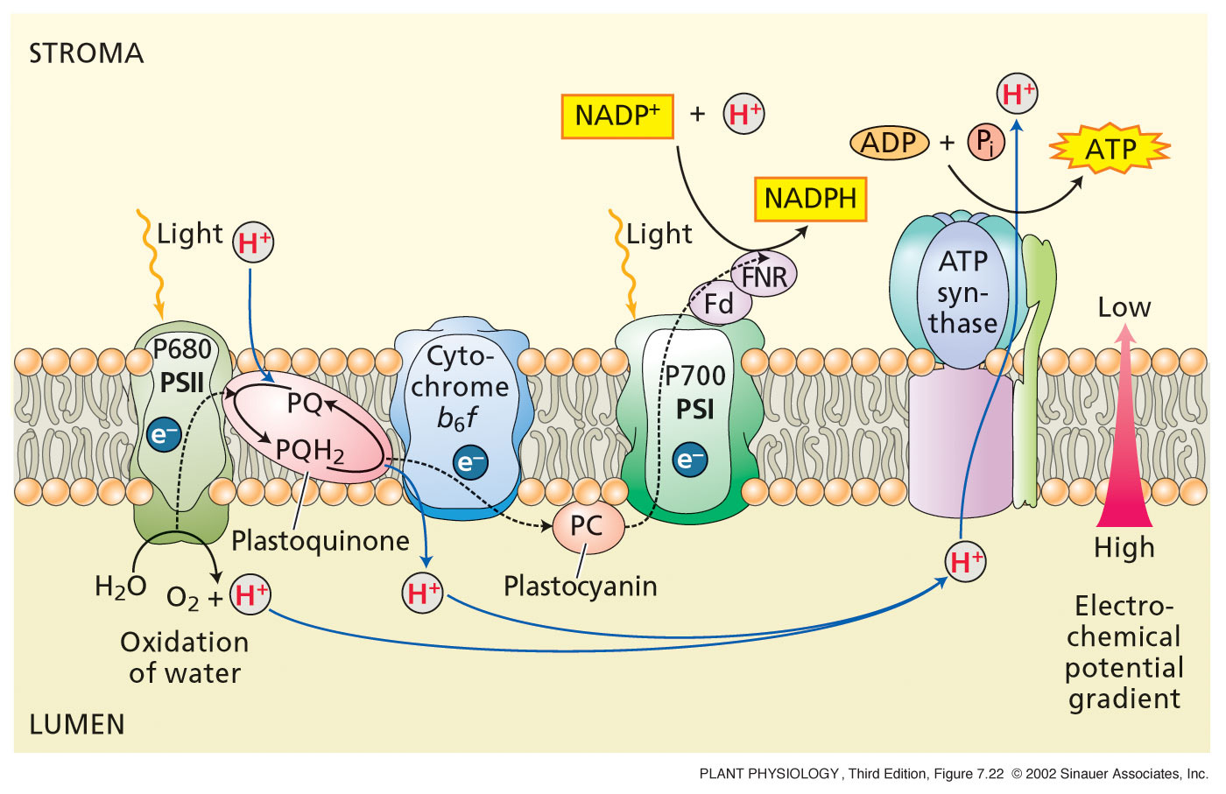

(5) Fully explain the acid growth hypothesis, to include the involvement of any plant hormones and /or enzymes. (10 points).

(6) Fully explain the main components of the plant primary cell wall. What are their structures? (Give full details!) How are they connected to each other? How far apart are they from each other? (10 Points)

THE END!

