**Lab for Section 6.7** Name_________________________

*Use good notation and show appropriate work. Write solutions to application problems in* ***complete sentences***.

1. (a) 0.8% of 470 (b) What percent of 32 is 40? (c) 6% of what number is 45?

2. Consider the graph for Health Care Costs. 3. Consider the graph of the rectangle.

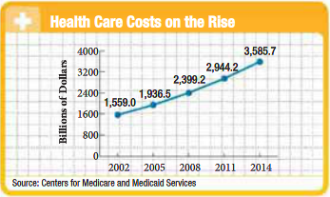 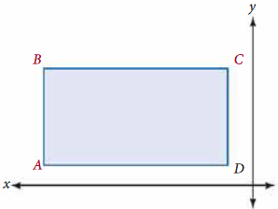

(a) How much did health care cost in 2002? Rectangle *ABCD* has length 5 cm and width   
 3 cm. The coordinates for *D* are (–1, 1). Find   
 the coordinates for point *A*, *B*, and *C*.

(b) How much is health care projected to cost in 2014?

(c) Is the rate of change greater from 2002 to 2005   
 or from 2008 to 2011?

4. Find the slope of the line through each pair of points.

(a)  and  (b) (–1.4, 2.3) and (–0.5, 0.5) (c) (–4, 5) and (–4, –7)

5. (a) Find the *x*-intercept and *y*-intercept for 6. (a) Graph the line passing through points

6*x* – 3*y* = 18 (5, 3) and (–3,–5).

 *x*-intercept: 

*y*-intercept:

(b) Use the intercepts to graph 6*x* – 3*y* = 18.



(b) Find the *x*-intercept and *y*-intercept.

7. Use the graph to complete the 8. Graph *x* = –2. Find the 9. Graph *y* = 3. Find the

following table. *x*-intercept and slope. *y*-intercept and slope.

  

|  |  |
| --- | --- |
| *x* | *y* |
| –2 |  |
| 0 |  |
|  | 0 |
|  | 6 |

10. Use the slope and *y*-intercept to graph 2*x* – 3*y* = 6.

