Hand Multiplication

Let L represent the number of extended fingers on the left-hand.
Let R represent the number of extended fingers on the right-hand.

Then the left-hand represents the number 5 + L
and the right-hand represents the number 5 + R.

The problem is
(5 + L)(5 + R) = 5(5 + R) + L(5 + R)
= 25 + 5R + 5L + RL

The solution is
10(L + R) + (5 – L)(5 – R) = 10(L + R) + 5(5 – R) – L(5 – R)
= 10L + 10R + 25 – 5R – 5L + LR
= 25 + 5R + 5L + RL

The problem and solution are equivalent
(5 + L)(5 + R) = 5(5 + R) + L(5 + R)
= 25 + 5R + 5L + RL
= 10L + 10R + 25 – 5R – 5L + LR
= 10(L + R) + 5(5 – R) – L(5 – R)
= 10(L + R) + (5 – L)(5 – R)
5 | 6 | 7 | 8 | 9 | 10
 | 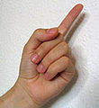 | 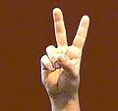 | 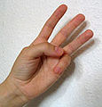 | 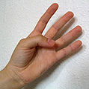 | 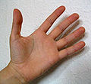
To find the value of a product of two numbers,
- Count the number of extended fingers on each hand.
Add these two values.
This result is the number of tens.
- Count the number of curled fingers on each hand.
Multiply these two values.
- Add the two results to obtain the answer.

 | 1 ten | + | 3 tens
6 X 8 = |  |  |  | = 40 + 8 = 48
 | 4 ones | x | 2 ones

 | 0 tens | + | 4 tens
5 X 9 = |  |  |  | = 40 + 5 = 45
 | 5 ones | x | 1 one

