Polya's four-step approach to problem solving

1. Understand the problem—
It is impossible to solve a problem, if you do not know what the problem is.
What is known or unknown?
Is there enough information or is more information needed?
What do the terms mean?
Etc.

2. Devise a plan—
You must start somewhere.
How are you going to attack the problem?
Possible strategies, “tricks": (i. e. reach into your bag of tricks.)
(a) Guess and check. Trial and error. Guess and test.
(b) Draw a picture.
(c) Look for a pattern.
(d) Make a list.
(e) Solve a simpler problem.
(f) Use a variable.
Etc. See textbook for more strategies, “tricks".

3. Carry out the plan—
If the plan does not seem to be working, then start over and try another way.
Often the first approach does not work.
Do not worry, just because an approach does not work, it does not mean you did it wrong. You actually
accomplished something, knowing a way does not work is part of the process of elimination.

4. Look back—
Did you answer the question?
Is your result reasonable?
Is there another way of doing the problem which may be easier?
(You need to become flexible in your thinking. There usually is not one right way. As a teacher you need to
be able to follow many different approaches students may take in solving problems.)

Problems.

- There are four volumes of Shakespeare's collected works on a shelf. The volumes are in order from left to right. The pages of each volume are exactly two inches thick. The covers are each 1/6 inch thick. A bookworm started eating at page one of Volume I and ate through to the last page of Volume IV. What is the distance the bookworm traveled?
- A hunter left camp and walked five miles south and two miles east. He shot a bear and walked five miles north back to camp. What color was the bear?
- Six normal drinking glasses are standing in a row. The first three are full of water and the following three are empty. By moving only one glass, can you change the arrangement so that no full glass is next to another full glass and that no empty glass is next to an empty glass, and we still have three full and three empty glasses?
- Pat and Kim bought the same item. Pat said he paid 20% less than the list price. Kim said that if she would have paid 25% more for the item, she would have paid the list price. Who paid the least?
- In a class of 25 students, 17 lived with both parents, 21 lived with their mothers, and 20 lived with their fathers. How many lived with neither parent?
- How many forty passenger buses are needed for a school field trip, if 156 students and five teachers will be going on the field trip? (They need to be legal for liability.)
- A grocery store is having a special on cans of soup which is normally price at 45¢ per can. The advertisement reads 3 for $1.00. You buy only one can of soup. How much does it cost?
- Bill and Sue both work a night shift. Bill has every sixth night off and Sue has every fifth night off. If they both have tonight off, how many nights will it be before they are both off at the same time again?
- How many different rectangles with an area of twelve square units can be formed using unit squares?
- Every person at a party of 28 people said hello to each of the other people at the party exactly once. How many "hello's" were said at the party?
- How much dirt is in a hole 2 feet long, 3 feet wide, and 2 feet deep?
- Two U.S. coins have a total value of 55¢. One coin is not a nickel. What are the two coins?
- Walter had a dozen apples in his office. He ate all but four. How many were left?
- Suppose you have only one 5 litre container and one 3 litre container. Describe how you can measure exactly 4 litres of water if neither container is marked for measuring. [You do not have any other containers.]
- What is the minimum number of pitches possible for a pitcher to make in a major league game, assuming that he plays the entire 9–inning game and the game is not called prior to completion?
- It takes 1 hour 20 minutes to drive to the airport, yet the return trip takes only 80 minutes using the same route and driving at what seems to be the same speed. How can this be?

Halloween Patterns

Directions: For each problem,
(a) Find the next 2 picture groups for each pattern.
(b) Find the 100th and 101st picture groups for each pattern.
(c) Find the nth picture group for each pattern. (Caution: the solution has two conditions.)

1. 

2. 

3. 

4. 

5. 

6. 

7. 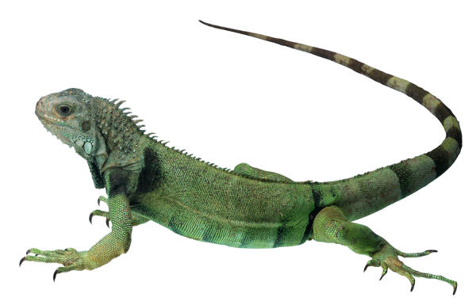

8. 

