ENG 200 – Surveying
Math Review Problems
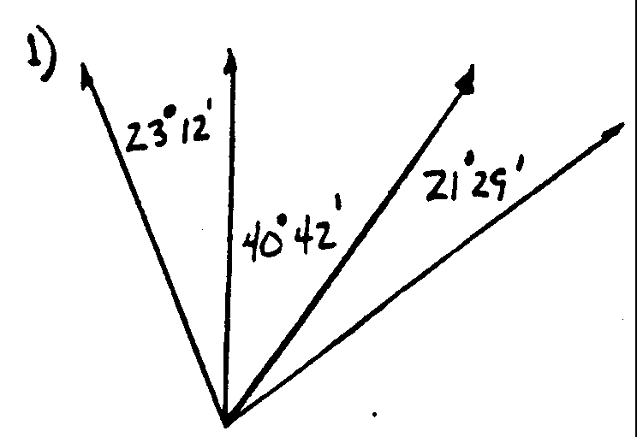
- Given the three angles shown, determine the total angle enclosed.
(answer: 85°13’)
- 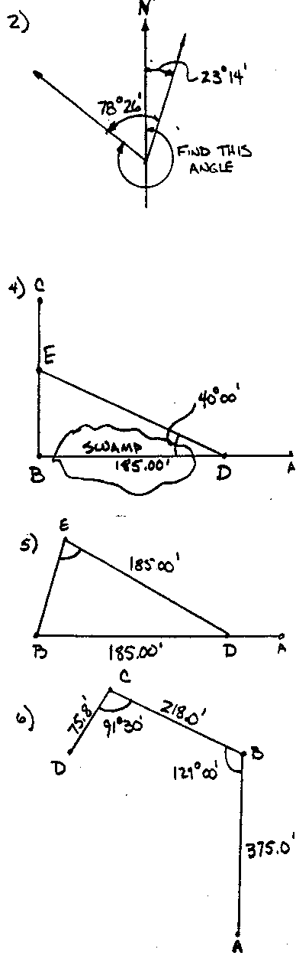A line bears 23°14’ east of North. A counter-clockwise angle of 78°26’ is turned from that line to establish a second line. What clockwise angle from North would coincide with the second line?
(answer: 304°48’)
- A line extends 582.63’ along a bearing 38°15’west of North. How far west and how far north is the end point from the origin?
(answer: N 457.55’, W 360.70’)
- A surveyor is to extend the line from A to B, shown, then turn a 90° angle and proceed to C. However, because of a swamp, she must stop 185.00’ short of B at point D. She can turn a 40° angle and bypass the swamp. How far should she follow that line to establish point E along the line from B to C? Determine the distance from B to E.
(answer: DE = 241.50’, BE = 155.23’)
- The surveyor in problem 4 really needs to set her transit over point B. She turns the 40° angle, and measures along that line 185.00’ to establish point E (note: this point is not on line BC). When she moves up to point E, what angle DEB and distance EB will bring her to point B?
(answer: DEB = 70°00’, BE = 126.55’)
- A surveyor follows the lines and angles shown, starting at A. How far, and in what direction is D from A?
(answer: AB: N = 375.00’ W = 0.00’
BC: N = 137.19’ W = 169.42’
CD: N = -57.64’ W = -49.23’
AD N = 454.55’ W = 218.65’
AD = 504.40’ bearing 25°41’19” W of N )

- Point I is located 50.0’ N and 128.5’ W of point O. Point J is located 189.8’ N and 38.0’ E of O. How far N of O will a true N-S line intersect with a line connecting I and J?
(answer: 157.89’)

