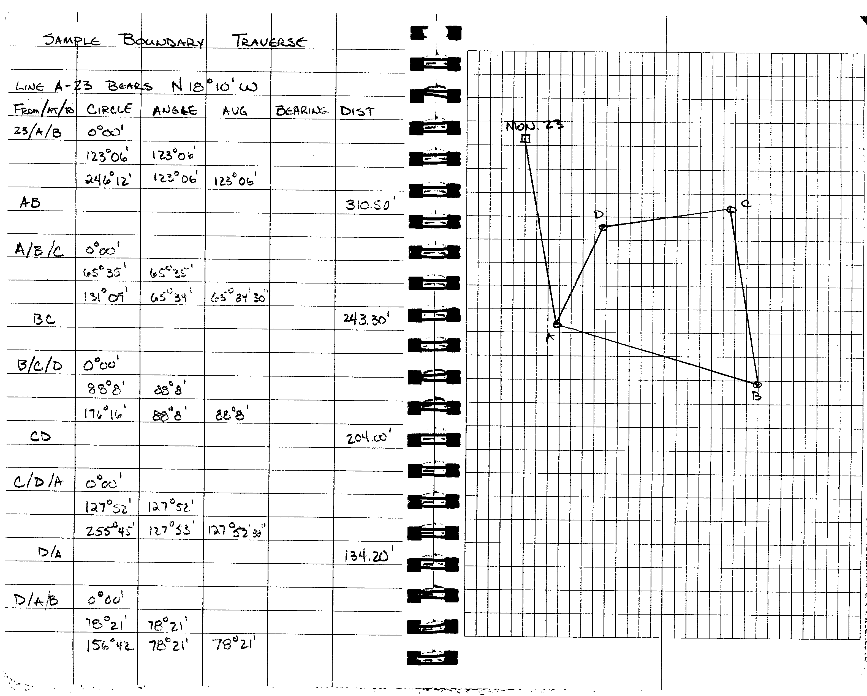
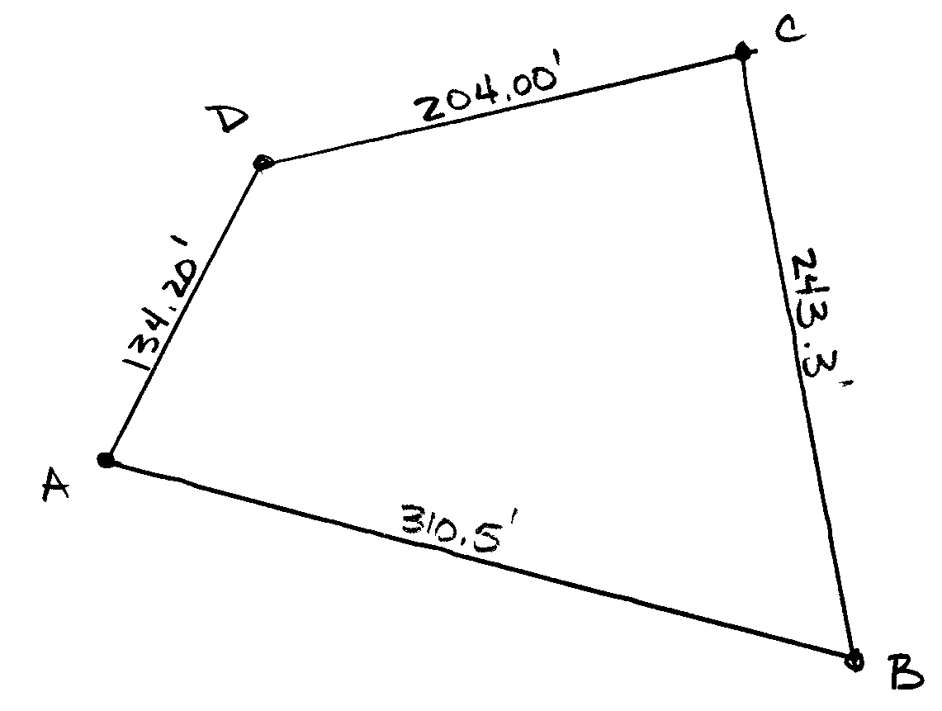

Side | Azimuth | Length | Latitude | Lat Corr. | Adjusted Latitude | Departure | Dep Corr. | Adjusted Departure | DMD | Lat x DMD
AB | 104°56’00” | 310.50
BC | 350°31’00” | 243.30
CD | 258°40’30” | 204.00
DA | 206°34’00” | 134.20
Σ

Side | Azimuth | Length | Point | North  Coord. | North Adj. | Adjusted  N Coord. | East Coord. | East Adj. | Adjusted E Coord. | Sum  Up | Sum Down
AB | 104°56’00” | 310.50 | A | 100.00 |  |  | 200.00
BC | 350°31’00” | 243.30 | B
CD | 258°40’30” | 204.00 | C
DA | 206°34’00” | 134.20 | D
 |  |  | A

