The proposed centerline of a highway or railroad layout are initially designed as a series of straight lines running as a constant grade uphill or downhill to some point of intersection where a new grade line begins. The intersection point is identified as the point of vertical intersection (PVI). The grades chosen are limited to some maximum value (either positive or negative), based on the speed and type of vehicles the roadway is to carry.
The abrupt change in grade between two lines must be smoothed by inserting a vertical curve that provides a transition from the incoming grade, g1, and the departing grade, g2. Vertical curves are typically defined as parabolic curves which can be defined with a formula:
$$y={\text{ax}}^{2}+\text{bx}+c$$
$$y={\text{ax}}^{2}+\text{bx}+c$$
In the picture below, a portion of a parabolic curve has been laid over two points A and B along the gradient slopes of a centerline profile.
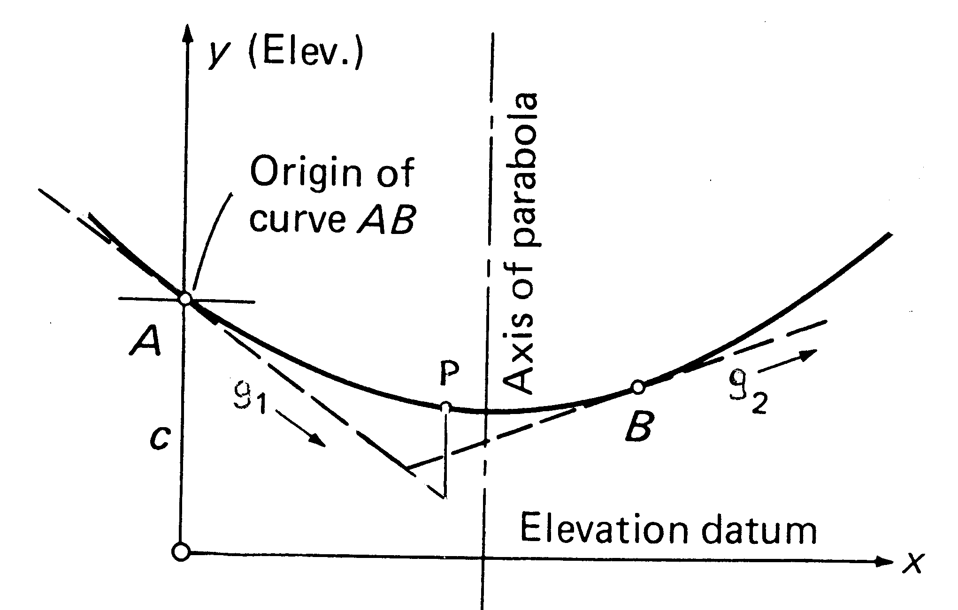

In this case, the formula above would define y, the elevation at any point along the curve, by starting at A, extending the initial slope g₁ to a point directly under point P on the curve, and then determining the vertical distance from the extended gradient to that point on the curve. The equation becomes:
$${\text{El}}_{P}={\text{El}}_{A}+g_{1}x+{\text{ax}}^{2}$$
Here, a is a constant that will define the relationship between the slope and the curve. Parabolic curves are chosen because the form above yields three important relationships:
- The curve at the midpoint will always fall halfway between the PVI and the midpoint of a line connecting A and B.
- The tangent offsets vary as the square of the distance from A.
- The second differences between equally spaced points are equal.
In the figure below, the curve has been broken into 6 equal spaces. Note that the offset from the extended grade g₁ to the first length along the curve is defined as "a", and that the offset to any other point is found by multiplying "a" by the square of the proportional distance - the offset at the 4th station is 16a.
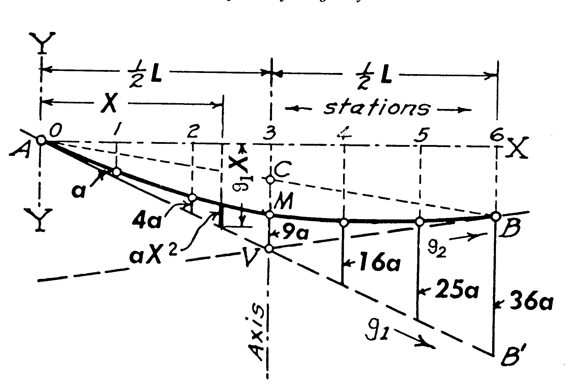
Triangles ACV and ABB' are similar triangles, so the distance CV must be half the distance BB' , 18a. That means the distance from V to M, the midpoint on the curve, equals the distance from M to C, 9a. This can be useful in checking calculations, and matching unequal gradient curves.
Finally, if you determined the difference in elevations between each of these points, and then found the difference between those differences, the numbers would be the same. Again, this can be useful in checking calculations.
Because surveying is almost always done using horizontal distances, the stationing does not change as we shift the profile from the gradients to the curve. All that is typically required is the elevation of the centerline at regular intervals throughout the curve. Unfortunately, our author over-simplifies the calculation by only showing examples where the PVI is at a full or half station If the curves are to be staked every 50 feet, the point of vertical curvature (PVC - point A in our figures) always falls exactly 50 feet from the first point to be staked. In fact, we often need to stake a short adjusting length to get to the first full station, stake the regular 50-ft intervals, and then stake a second adjusting length to complete the curve. This requires that we can use the equation above to determine the curve elevation at any location X along the curve.
To complete the equation above, we need to define "a", the constant that relates the curve to the gradient. The second derivative of a curve equation yields the rate of change of curvature per unit length as you move though the curve. In this case, d²y/dx² = 2a, so for parabolic curves, 2a represents a constant rate of change as the curve moves from g₁ to g₂ over the total length of the curve, L.
If g₁ and g₂ are given in percent, and X and L are in stations,
$$2a=\frac{\left(g_{2}−g_{1}\right)}{L}$$
$$a=\frac{\left(g_{2}−g_{1}\right)}{2L}$$
and
$${\text{El}}_{p}={\text{El}}_{\text{PVC}}+g_{1}X+{\text{aX}}^{2}$$
Check this against the author's calculation for the elevation of a point, given on page 373. The elevation of the PVC is 248.20', and the point to be located is 2.752 stations from the PVC. Then:
$$a=\frac{\left(g_{2}−g_{1}\right)}{2L}=\frac{\left(−3−4\right)}{2\left(8\right)}=−0\text{.}\text{4375}$$
$${\text{El}}_{p}={\text{El}}_{\text{PVC}}+4X−0\text{.}\text{4375}X^{2}=\text{248}\text{.}\text{20}+4\left(2\text{.}\text{752}\right)−\text{.}\text{4375}{\left(2\text{.}\text{752}\right)}^{2}=\text{255}\text{.}\text{90}$$
The design of a vertical curve begins with the choice of a curve length. Typically, the engineer chooses the length based on sight distances and design speed for the vehicles - "How far back must a driver whose eye is 3.5 feet off the ground be able to see an on-coming car in order to avoid collision, if both cars are travelling at 60 mph?", and "How flat a curve will allow the required sight distance?"
Given the length of curve, L, the PVC is located half that distance back, and the point of vertical tangency (PVT - point B in our figures) is located half the distance ahead. The elevations of the PVC and the PVT are found by following the incoming grade and the departing grade, respectively, for a distance of L/2 Then the stationing for regularly-spaced staking is determined, and the centerline elevation at each of those points is calculated. This is best illustrated by example:
Given: g₁ = 3.2%, g₂ = -5.6%, Sta PVI = 321+63, El_{PVI} = 290.75, L = 750 feet.
Sta PVC = (321+63) - (3+75) = 317 + 88, El_{PVC} = 290.75 - 3.2(3.75) = 278.75
Sta PVT = (321+63) + (3+75) = 325 + 38, El_{PVT} = 290.75 + (-5.6)(3.75) = 269.75
a = (-5.6-3.2)/(2*7.5) = -0.5867; El_{P} = 278.75 + 3.2X -0.5867X²
Try using these formulas to set up a spreadsheet that will calculate the elevation at full and half stations along the curve. Check that you end up at the PVT at the elevation calculated above.

