ENG 243 – Statics
Quiz No. 1 – Spring 2005
Take-home Quiz – Due Monday, January 24

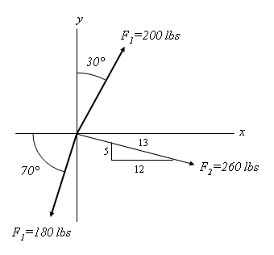
Determine the magnitude and direction, measured counterclockwise from the positive x axis, for the resultant of the three forces shown.

