Flowcharting is a process that allows you to visually represent the steps you will take to accomplish a task. Computer programmers have used the process for decades to break complex programming tasks into manageable steps. More recently, managers have adopted the technique to chart the flow of resources through their production processes.

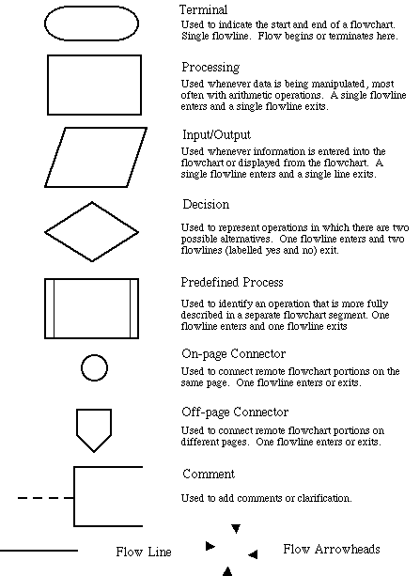The chart itself is made up of standard symbols connected by lines. Some of those symbols include:

Many simple programs can be charted using only the first 4 symbols. The Predefined Process symbol is used when another process takes over the operation. For instance, if you use a built-in function in a spreadsheet to determine the average of several numbers, that function might appear as a Predefined Process – you don’t need to know the steps it takes to determine the average, you simply feed it the list of numbers, and the function does its job.
The flow chart typically runs from top to bottom on a page. If the chart becomes too long for one page, it can be broken with a Connector, and continued on another part of the page, or on a separate page. The chart below is an example of a chart for a simple decision process:
The chart starts with a terminator to indicate the overall beginning of the process. The process starts with an input – your decision to go get coffee.

The next step is a procedure – you pick up a cup, and go to the pot. The steps to be taken may be listed, or may be detailed in a comment to the side.

Now you come to a decision process within the program. In many computer programs, this is a difficult stage. How do you know what decision is being made? Many are done intuitively, and we don’t even realize a decision has been made. You often look at the coffee pot, find that it’s empty, and make more without identifying the yes/no decision shown. But the computer will need this step! The diamond allows two choices. If the pot is not empty, you fill your cup. If it is empty, a Predefined Process called “Make More Coffee” takes over. When that process is completed, you fill your cup.

The process is complete, and the flowchart ends with a terminator. Note that other decisions could be added. What if the coffee in the pot is old? What if you emptied the pot in taking your cup? Should you make more? Would the time of day affect your response?

Flowcharting is a useful tool for solving a variety of problems. This course will focus on specific problems that can be solved using simple computing tools. If the solution will only be generated once, and the process is not likely to be repeated with different numbers, developing a macro or input form is probably unnecessary. But where the process will be repeated, one of your tasks will be to identify the steps taken to process the data by hand, and then lay out a procedure for creating the tools needed for that process.

Consider a situation where several companies are supplying bids for materials for a job. Your staff has collected a list of bids, each containing a bidder’s name, the item bid, and the amount. On a spreadsheet, you typically group the bids for each item, find the low bid for each item, determine if the low bidder is qualified to supply that item and award contracts to the lowest successful bidder. A flowchart for that process follows. Note that the procedure to sort the data first by bid item and then by bid amount is built in to most spreadsheets, and is treated as a Predefined Procedure. Also note that the process to determine if a bidder is “qualified” is not defined here. If the computer is to make that determination, you will have to tell it how to do that.

Again, this process is defined in terms of the steps to be taken, not the code required to make them happen. If the process as a whole accurately describes the steps necessary to solve the problem, you can begin to focus on how to accomplish the steps.

The input step asks you to get a list of bidders, items, and amounts. What form is that list in? Is it currently just a stack of written bids in a file? How will those written bids get into the spreadsheet? Will you type them in, or will a staff person? Will you need to enter more than just the bidder’s name? Or do you have a file that tells you the address and other necessary details for each bidder? A flowchart for this step might be:

