The Body Within Sociology: A Summer Seminar on the Body and its Social Meaning
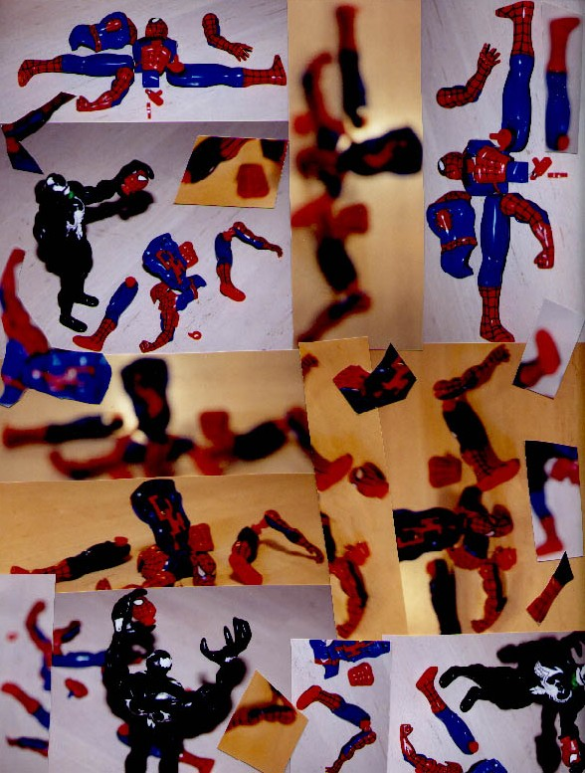

By way of course description…
Where is the body in sociological theory and in social life? The body is everywhere and nowhere in sociology, for without our sentient bodies interacting, there would be no sociology. Yet, the body, in praxis, is taken-for-granted in favor of the study of its social products. This seminar brings the body to the fore by examining its social meaning and its social uses, conflating the traditional (We)stern dualisms of corporeality and psychology, of spirituality and carnality, and the instrumental and expressive binaries that accompany discourses on the body. “We” consider embodiment conundrums in late modernity such as the body as a site for (his)torical and topical hysteria, the body sexed and commodified, the body in (dis)ability and health, the body as a site for biomedical sculpture and bio-powerful improvements, and the telegenetic and cybernetic body –mass marketed in repressive and desublimated forms. This colloquium combines foundational sociologic insights (on inequalities of “race”, class, gender, (dis)ability, and sexuality with feminist and psychoanalytic critiques of the late-modern body: its uses, pleasures, problematics, interpretations, and dilemmas. “We” do this through group discussions and (w)riting practices.

Moreover, this course conflates power-reflexive narrative insights on the body with social-psychoanalytic, feminist, and phenomenologic (w)ritings to illuminate the place of the body in late modern culture. Here, Foucault’s docile and pleasure-seeking body meets Baudrillard’s hyper-real, telegenetically inscribed, and simulated body. Luce Irigaray’s “troubled femininity” in the Freudian sense encounters (Lyotard’s) ephemeral skin in a libidinal economy. And designer vulvas, differently-abled bodies, and Viagra juiced phalluses tell the story of sexed and sexing bodies in the last fin de siecle and into the new millennium.

By way of course requirements…
- This is an advanced seminar for the readings in sociology (soc 497) course. Our interlocutions on the body will be multifaceted and difficult because the readings are themselves difficult and multifaceted, yet immensely interesting. Participants should set aside between 5 to 7 hours per week for reading to ensure both critical and reflexive engagement.
- All participants enrolled for credit must attend our weekly sessions (T.B.A). These meetings will consist of our informed reactions to the readings for the week. Moreover, in addition to consistent attendance and informed participation, for each session, you are required to bring an outline of discussion points. These discussion points, consisting of a few questions, comments, or quotes from the readings, will form the basis of our weekly interlocutions. Your weekly attendance and your discussion points will give you a grade “B/B+”.
- Participants interested in earning an “A” will write a short paper (10-15 pages) on a topical issue related to the sociology of the body that makes explicit use of the course’s theoretical and conceptual themes.

Themes and Readings…

Module 1

The Meaning of Embodiment within the Legacy of Western Dualism
“Who would not believe, to see us compose all things of mind and body, that this very admixture would be readily understandable to us? Yet it is the one thing that we understand the least. Man is to himself the most prodigious object of nature; but he cannot conceive what body is, and still less what mind is, and less than any other thing how a body can be united with a mind. That is the climax of his difficulties, and yet that is his own being: Modus quo corporibus adhearent spiriuts comprehendi ab hominibus non potest; et hoc tamen homo est.” –Blaise Pascal, Pensees, 72 [Latin Translation: “The manner in which the spirit is united to the body cannot be understood by man; and yet it is man.”]
- Max Weber. “Religious Ethics and the World: Sexuality and Art.” In Economy and Society, Vol. 2: 602-610. New York: Bedminster Press, 1968.
- Iris Marion Young. “Breasted Experience: The Look and the Feeling.” In Throwing Like a Girl and Other Essays in Feminist Philosophy and Social Theory (pg. 198-209). Bloomington, Indianapolis: Indiana University Press, 1990.
- Jonathan Watson. “The Idea of Embodiment.” In Male Bodies: Health, Culture, and Identity (pg. 109-123). Buckingham, U.K.: Open University Press, 2000.
- Tony Jefferson. “Muscle, ‘Hard Men’ and ‘Iron’ Mike Tyson: Reflections on Desire, Anxiety and the Embodiment of Masculinity.” In Body and Society, Vol. 4, No. 1: 77-98, 1998.
- “The Songs of Solomon” Chapters 1-8 (New King James Version)

Module 2

Hysterical Wombs/Sexed Maladies: Risks, Problems, and (Dis)eases in (Fe)male Forms
“I suggest female –or perhaps I should call it feminine- desire is to some extent the lynch pin of a consumerist society. Everywhere women are offered pleasure –pleasure for losing weight, pleasure for preparing beautiful meals, pleasure if we acquire something new –a new baby, a new house, a new outfit, a new relationship, a new baby. Pleasure is western society’s special offer. And it is female desire which makes us respond and take up that offer. To be woman is to be constantly addressed, to be constantly scrutinized, to have our desire constantly courted –in the kitchen, on the streets, in the world of fashion, in films, and television, from the radio, there are endless questions about what women desire, endless theories and opinions offered. Desire is stimulated and endlessly defined. Everywhere it seems female desire is sought, bought, packaged and consumed. Female desire is courted with the promise of future perfection, by the lure of achieving ideals –ideal legs, ideal hair, ideal homes, ideal cream cakes, ideal relationships.” –Rosalind Coward, “Female Desire and Sexual Identity” in M. Diaz-Diocaretz and I. Zavala (eds.), Women, Feminist Identity and Society in the 1980s. Amsterdam and Philadelphia: J. Benjamin, 1991, pg. 25-29.
- Luce Irigaray. “Any Theory of the “Subject” Has Always Been Appropriated by the “Masculine.” And “How to Conceive (of) a Girl.” In Speculum of the Other Woman (Translated by Gillian C. Gill). Ithaca, N.Y.: Cornell University Press, 1974.
- Faith Wilding. “Tech Flesh 7: Vulvas with a Difference (The Problem: Lack, or What does Woman Want?)” From Tech Flesh: TF008. Date Publishes: 5/9/2001. www.ctheory.net/text_file?pick=29. Arthur and Marilouise Kroker, Editors.
- Jennifer Harding. “Bodies at Risk: Sex, Surveillance and Hormone Replacement Therapy.” In Foucault, Health and Medicine (pg. 134- 150). London and New York: Routledge, 1997.
- Leonore Tiefer. “The Medicalization of Impotence: Normalizing Phallocentrism.” Gender and Society, Vol. 8, No. 3 (September 1994): 363-377.
- Kathy Davis. “The Rise of the Surgical Fix.” In Reshaping the Female Body (pg. 4-38). NY: Routledge, Inc., 1995.

Module 3
Corporeal Surplus/Corporeal Lack: Dilemmas of Embodiment in (Dis)abled (or, differently-abled) bodies
“Both the female and the disabled body are cast within cultural discourse as deviant and inferior; both are excluded from full participation in public as well as economic life; both are defined in opposition to a valued norm which is assumed to possess natural corporeal superiority. Indeed, the discursive equation of femaleness with disability is common, sometimes in the service of denigrating women and sometimes with the goal of defending them.” –Rosemarie Garland Thomson, Feminist Theory, the Body, and Disables Figure. CA: Sage, 1997.
- Carol Thomas. “Theorizing Disability and Impairment.” In Female Forms: Experiencing and Understanding Disability (pg. 123-144). Buckingham, U.K.: Open University Press, 1999.
- Ruth Hubbard. “Abortion and Disability: Who Should and Should Not Inhabit the World?” In Disabilities Studies Reader (pg. 187-200). Lennard J. Davis, (Editor). CA: Sage, 1997.
- Claire Reinelt and Mindy Fried. “‘I Am This Child’s Mother’: A Feminist Perspective on Mothering with a Disability.” In Karen V. Hansen and Anita Ilta Garey (Editors) Kinship and Domestic Politics (Pg. 339-347), Philadelphia, PA: Temple University Press, 1998.
- Rosemarie Garland Thomas. “Feminist Theory, the Body, and the Disabled Figure.” In Disability Studies Reader, Lennard J. Davis, Editor (pg. 279-292), and CA.: Sage, 1997.
- Lawrence Otis Graham. “Black Man with a Nose Job: How We Defend Ethnic Beauty in America.” In Member of the Club (pg. 223-231). NY: HarperCollins Publishers, Inc., 1995.
- Disability Verses:
Evacuation, Love Poem, and Beauty and its Variations by Kenny Fries
I Am Not One of The and Cripple Lullaby by Cheryl Marie Wade

Module 4

Foucault’s Corpse: Docile Bodies in the Genealogical Expansion of Bio-power
“When I think of the mechanics of power, I think of its capillary form of existence, of the extent to which power seeps into the very grain of individuals, reaches right into their bodies, permeates their gestures, their posture, what they say, and how they live and work with other people.” –Michel Foucault and J. L. Brochier, Entretien sur la prison: le livre et sa methode [1975]; trans. C. Gordon, Prison Talk, Radical Philosophy, No. 16 (Spring 1977), pg. 28.
- Michel Foucault. “Docile Bodies.” In The Foucault Reader (Paul Rabinow, Editor), pg. 179-187. N.Y.: Pantheon Books, 1984.
- Hubert L. Dreyfus and Paul Rabinow. “The Genealogy of the Modern Individual Subject.” In Michel Foucault: Beyond Structuralism and Hermeneutics (pg. 168-183), 1982.
- Liz Eckermann. “Foucault, Embodiment and Gendered Subjectivities: The Case of Voluntary Self-Starvation.” In Foucault, Health and Medicine (pg. 134- 150). London and New York: Routledge, 1997.
- Deborah Lupton. “Foucault and the Medicalization Critique.” In Foucault, Health and Medicine (pg. 134- 150). London and New York: Routledge, 1997.
- David Lyon. “Body Parts and Probes.” In Surveillance Society: Monitoring Everyday Life (pg. 69-87). Buckingham, U.K.: Open University Press, 2001.

Module 5

The Por(no)graphic Eye/I: The Body (Re)presented in Sexuality
“Sexual behavior is not, as is too often assumed, a superimposition of, on the one hand, desires which derive from natural instincts, and on the other hand, of permissive or restrictive laws which tell us what we should or shouldn’t do. Sexual behavior is more than that. It is also the unconsciousness one has of what one is doing, what one makes of the experience, and the value one attaches to it.” M. Foucault, an Interview in Salmagundi, 1982, No. 58-61, pg. 10-11.
- Rosi Braidotti. “Body images and the Pornography of Representation.” In Nomadic Subjects: Embodiment and Sexual Difference in Contemporary Feminist Theory (pg. 57-74). NY: Columbia University Press, 1994.
- Ruth Butler. “Double the Trouble or Twice the Fun? Disabled Bodies in the Gay Community.” In Ruth Butler and Hester Parr (Editors) Mind and Body Spaces: Geographies of Illness, Impairment and Disability. London: Routledge, 1999.
- Chris Nagel. “Pornographic Experience.” In Mundane Behavior, Vol. 3, No. 1: 1-13. http://www.mundanebehavior.org/issues/v3n1/nagel3-1.htm. Last Accessed: 03-19-03.
- Jean Baudrillard. “Crash.” In Simulacra and Simulation. MI: The University of Michigan Press, 1994.
- Erica McWilliam and Skye O’Donnell. “Probing Protocols: The Genital Examination as a Pedagogical Event.” In Body and Society, Vol. 4, No. 3: 85-101, 1998.

Thought Leader: Lee Garth Vigilant, Ph.D., A.M., Boston College
Electronic Mail: vigilant@mnstate.edu
Website: web.mnstate.edu/vigilant
Telephone: 218/287-8487 (Residence)
218/236-2034 (office)
Office Hours (summer): By appointment
Cover: “The Beloved Spiderman is Dead!” (Photographic Collage’02)

