Unveiling New Orientalism: An Exploration in Images

By

Emma Hoglund

Methods
Dr. Vigilant
3 May 2009

Introduction
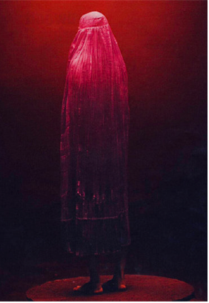
The image of the Oriental veiled woman has always sparked the imagination of the Western colonizer. Initially, Oriental women were veiled in sensuous mystery. For Western men, the veil symbolized the erotic mysteries of the east and Middle Eastern women posed a sexual conundrum, both erotic and hidden, an irresistible combination in the West. The harem, for example, was both enticing for Western men who had a desire to catch a glimpse of Eastern women unveiled, but also inaccessible, impenetrable for their Western eyes. Presently, however, veiled women are perceived quite differently. The veil has come to represent all that is wrong with the Muslim world – suppression, abuse, and terror. The image above epitomizes the modern conception of veiling: a nameless, faceless woman turned away from the camera. In addition to being internationally controversial, the practice of veiling is highly varied, from a token headscarf to the full burqa. In the West, however, particularly in “art” images, veiled women are ubiquitously depicted in full burqas and often from behind. What is the purpose of depicting Muslim women in such a monochromatic fashion, and what messages and perceptions do these images of veiled Muslim women in printed media perpetuate in the Western consciousness? It is essential to note that it is not my intention to pass any sort of judgment on the practice of veiling. I am primarily interested in exploring what we in the West can learn about ourselves in the way we chose to depict the veiled Muslim woman.
The Muslim world is as varied and intricate as our own here in the West. Similarly, the experiences of women are equally assorted. For example, Lebanon is the first country in the world that has granted women loans in order to pay for plastic surgery, and women in some northern African countries hold important court positions. On the other hand, women in Saudi Arabia are required to cover their heads and not permitted to drive a vehicle. What these examples prove is that there is no one standard with which we can judge the experiences of women in the Muslim world. This is also true regarding women’s experiences with veiling. It is a gross misconception that all Muslim women practice veiling. In fact, only 16% of women in the Middle East can be said to adhere to some form of “veiling” and veiling is not a Qur’anic requirement. The practice of veiling was originally only intended for the wives of the prophet Muhammad, the founder of Islam. As the Islamic empire spread across much of the civilized world, however, many Muslim women adopted the practice of veiling from the Persian culture, for which veiling was a sign of high status. As time progressed the tradition of veiling became one of many Muslim traditions.
Presently, veiling is practiced in a variety of ways and is culturally dictated primarily by geography. Women in the Levant area of the Middle East wear a hijab that most resembles a simple headscarf used to cover the head and neck leaving the face exposed. More conservative choices include the niqba and the burka, with the former leaving the eyes uncovered and the latter with leaving none of the face exposed. This form of veiling is most often associated with oppression and is favored in Saudi Arabia and the Afghani-Pakistani region. The Women of the Gulf region often prefer the Shayla, a long, rectangular scarf that is wrapped comfortably around the head. Finally, the chador is most often seen in Iran and is a full body cloak somewhat similar to the burqa. The purpose of outlining the various forms of veiling is to demonstrate the variability of the practice.
Literature Review
Since the dawn of Colonialism, Westerners have fantasized about the Orient, so much so that the Western understanding of the non-Western world was little more than a Western invention. Edward Said defines this process as Orientalism, “a way of coming to terms with the Orient that is based on the Orient’s special place in European Western experience.” According to Said, Western perceptions of the Orient reveal more about the nature of Western consciousness than the Orient. By applying this concept to Western perceptions of veiling, therefore, we might gather invaluable insights into the Western consciousness. This understanding may then allow us to constructively challenge these perceptions. Essentially, we need to remember that “every writer on the Orient…assumes some Oriental precedent, some previous knowledge of the Orient, to which he refers and on which he relies.” Our task will be to recognize this and work to avoid being ensnared by the traditional Orientalist mentality.
It is obvious that images of veiled women strike an intense emotional chord for Western women, particularly feminists, but why? Misguided Western feminists have latched onto the veil as the ultimate symbol of female oppression in Islam and seeing Muslim women unveiled symbolizes the achievement of female liberation. Many women who practice veiling, however, do so because of the sense of liberation they claim it provides them. Instead of being judged by their bodies, these women claim they are appreciated more for their minds. Of course, this may not be the experience of all veiled women but that some women claim this experience certainly points to the variability of veiling experiences. While the purpose of veiling may universally be interpreted as protecting female modesty, it is not universally oppressive. And if the veil is universally interpreted as restricting female sexuality, it is often the woman who is choosing to be restricted. This nuance, however, is often lost on modern feminists who celebrate the “victory” of seeing a woman unveiled. Meyda Yegenoglu writes, “unveiling and thereby modernizing the woman of the Orient signified the transformation of the Orient itself.” Westerners often fail to realize that female liberation is seldom determined by how a woman dresses. Further Yegenoglu writes:
Western women’s bodies stand in for the truth of women universally. They are used as the explanatory norm to unravel the desires and pleasures of bodies that are located in other histories and cultures: one culture’s coding of bodies becomes the template through which all bodies are conjured.
This coding is particularly apparent in the images of veiled women perpetuated in the Western world.
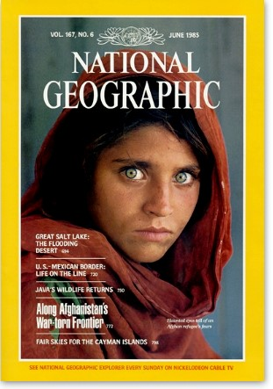
One of the most internationally recognized images of a veiled woman is of an Afghani girl who graced the cover of National Geographic in 1985. The image was so striking that in 2002 the magazine launched a search for the female subject. This woman over seventeen years had become reduced to an image; her name and other personal information were never recorded. Images of veiled woman are popular in today’s media. There is a difference, however, between the images used in newsprint to accompany news stories and those used to grace the covers of books written about the Muslim world. The latter, which I think of as “art” images, serve a very different purpose than the images used to capture moments of historical significance published in newspapers and magazines like The New York Times.
The New York Times is the largest metropolitan newspaper in the United States, and for this reason I selected a few recent published images of veiled women to demonstrate the difference between news images and art images. The first shows a woman gazing into the camera from inside a small building with a young child huddled next to her. This is a fairly standard image of a veiled woman. The fact that she is veiled is not the central focus of the image. Instead this is an image that functions to illustrate a story, one that has nothing to do with veiling.
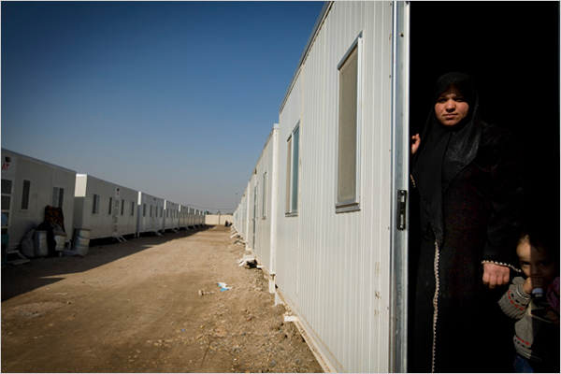
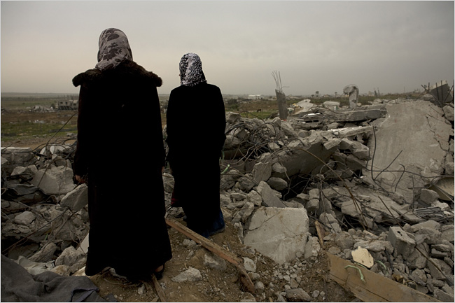
As I will explore in more detail later, there is a common practice of capturing veiled women from the back. This second image from The New York Times depicts this very situation. However, I would argue that there is less intention than will be obvious when I analyze several book covers that depict Muslim women from the back. This news story image is used in the context of its story. While I am certain there is value in exploring the nature of these newspaper images more in depth, I am more interested in examining the homogenous nature of bestselling bookcovers in the United States.
Methodology
For the purpose of this paper, I selected seven bookcovers to analyze. Each of the books concerns the Islamic world, some as memoirs and others as works of fiction and most being American bestsellers. While I had read most of the books, I did have to read three of them in order to complete my analyses. My choice of books was dictated primarily by my familiarity of books related to the Islamic world that have also been bestsellers. I feel the books I have chosen represent a good selection of popular texts on the Islamic world, the analysis of which will offer valuable insight into the Western consciousness.
Findings
A Thousand Splendid Suns: Through the crisscrossing grid of the burqa, she saw his shadow arms lift his shadow Kalashnikov.
The first book cover I will examine is that of A Thousand Splendid Suns by Khaled Hosseini. Hosseini’s first book The Kite Runner spent a remarkable 103 weeks on the New York Times bestseller list, and A Thousand Splendid Suns is following suit. The novel is a perfect example of what Fatemeh Keshavarz labels as a “New Orientalist narrative.” Her definition of a New Orientalist narrative is worth quoting at length:
The emerging Orientalist narrative has many similarities to and a few differences
from this earlier incarnation. It equally simplifies its subjects. For example, it explains almost all undesirable Middle Eastern incidents in terms of Muslim men’s submission to God and Muslim women’s submission to men. The old narrative was imbued with the authority of an all-knowing foreign expert. The emerging narrative varies somewhat in that it might have a native – or seminative – insider tone. Furthermore, as the product of a self-questioning era, it shows a relative awareness of its own possible shortcomings. Yet it replicates the earlier narrative’s strong undercurrent of superiority and of impatience with the locals, who are often portrayed as uncomplicated. The new narrative does not necessarily support overt colonial ambitions. But it does not hide its clear preference for a western political and cultural takeover. Most importantly, it replicates the totalizing – and silencing – tendencies of the old Orientalists by virtue of erasing, through unnuanced narration, the complexity and richness in the local culture.
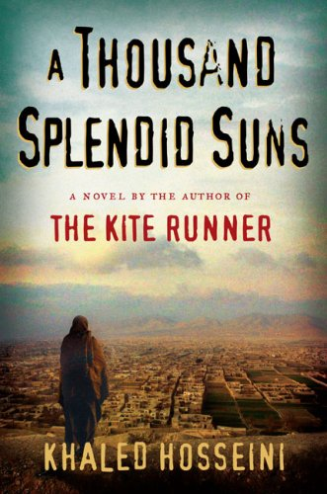
Keshavarz orients Khaled Hosseini within this New Orientalist framework for good reason. The cover of his book alone fulfills the definition of New Orientalism. The cover depicts a veiled woman from the back facing a presumably Afghani city. She is positioned right of center and is the most important aspect of the bookcover’s composition.
The story itself centers on the lives of two Afghani women, one of whom is stoned to death at the end of the novel. While an exciting, gripping story, A Thousand Splendid Suns does not necessarily reflect an accurate image of life for Afghani women. This is not to say that Afghani women do not face a tremendous set of challenges, but Hosseini’s novel explores a supremely negative and extreme case of abuse, one that may be far from typical of the average woman’s experience in Afghanistan.
The Swallows of Kabul: Mummified under her veil, Zunaira is suffocating.
Another novel, The Swallows of Kabul by Yasmina Khardra, is similar to A Thousand Splendid Suns. The author, writing under a nom de plume, is in reality an Algerian army officer named Mohammed Moulessehoul. Moulessehoul writes of the lives of two Afghani couples. Although a well-written novel, the author has no apparent experiences in Afghanistan on which to base his story. Originally written in French, the English translation of the novel has no less than three different covers. All three of which depict Afghani women from the back.
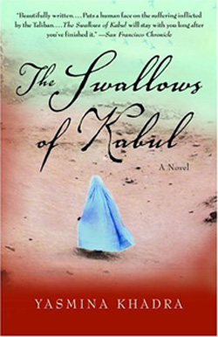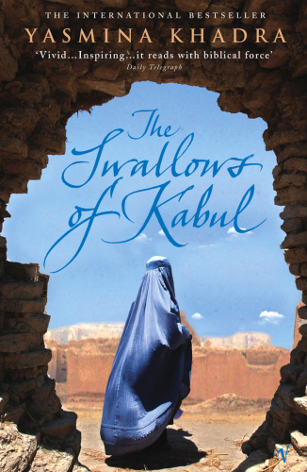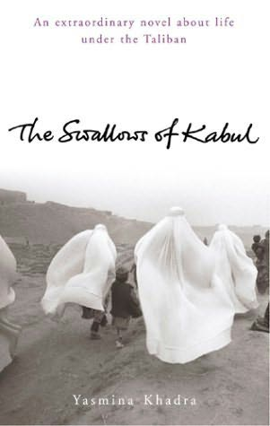
The first two covers depict a blue burqa-clad woman from the back. In both, she stands alone, centered on the cover. The third, in black and white, show burqa-clad women walking with a little boy in tow. The story itself concerns the lives of two Afghani women and two Afghani men. And like A Thousand Splendid Suns, The Swallows of Kabul ends with one of the main female characters being stoned, as we have seen, a seemingly clichéd story line. Why would the cover, in three different instances, depict only Afghani women? What does this monochromaticism suggest? The men of the novel played equal or greater characters throughout the course of the plot. The image of the burqa-clad woman, however, has a greater emotional pull on the Western audience, not to mention its marketability. By featuring the most extreme case of veiling, the burqa, readers are confronted with extreme oppression. A woman wearing a simple headscarf would be far less emotionally charged. For example, while anorexia is a rare eating disorder, it the most commonly researched, studied, and featured in the media. Why? Because it is the most disturbing form of eating disorder. For similar reasons, images of burqa-clad women are exploited for their extreme emotional pull on the Western consciousness.
The Bookseller of Kabul: She keeps losing sight of the billowing burka, which merges with every other billowing burka.
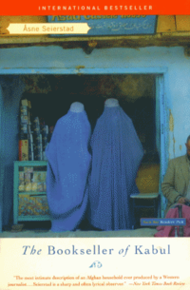
Asne Seierstad’s book, The Bookseller of Kabul, another Amiercan bestseller, explores the experiences the author has with a family in Kabul. As with A Thousand Splendid Suns, Keshavarz identifies this work of nonfiction within the New Orientalist context. Seierstad openly identifies the weaknesses and limitations of her narrative, the most important of which is that her “family” is atypical in Afghani culture. In any case, the main character of her recollections is the patriarch of the family and one of Kabul’s esteemed booksellers. In addition to telling the story of the bookseller, she does explore the experiences of the women of the family, but they are by no means the focus of her recollections. Despite the fact that Afghani women are but one aspect of the author’s narrative, they dominate the cover. A more logical choice may have been to have had the bookseller, Sultan Kahn himself, grace the cover of the book written primarily about his life and family. However, the image of two blue, burqa-clad women from the back is far more emotionally charged.
Nine Parts of Desire: Drenched with sweat and trying not to trip on my chador, I filed off the bus and joined the tight black phalanx, making its way down the alley with sobbing chants of “O Khomeini! O Imam!”
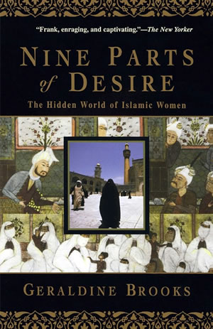
Geraldine Brooks’ Nine Parts of Desire is another work of nonfiction and another bestseller. It concerns a Western female journalist’s experiences in the Middle East. Despite Brooks’ apparent desire to write an accurate narrative of “the hidden world of Islamic women,” she slips easily into the framework of the New Orientalist narrative. Brooks devotes an entire chapter to the practice of veiling and continues to explore the topic throughout her text. And throughout the text she fails to come to any sort of nuanced understanding of the diversity in the practice of veiling. For her part, she identifies the veil as primarily the black chador of Iran and Saudi Arabia, without considering the more moderate veiling practices of the Levant. In any case, the cover of her book, as with other covers I have explored, depicts a black chador-clad woman from the back. For a woman writing from the feminist perspective, I find it interesting that Brooks would not have chosen a book cover that more clearly illustrated feminist ideals.
Reading Lolita in Tehran: My constant obsession with the veil had made me buy a very wide black robe that covered me down to my ankles, with kimonolike sleeves, wide and long.
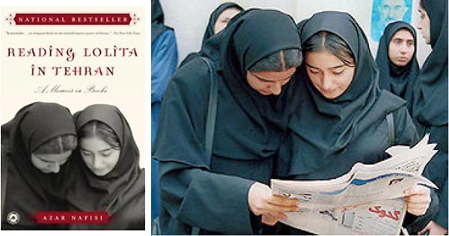
While the cover of Reading Lolita in Tehran does not depict veiled women from the back, it, nevertheless, is a product of New Orientalism. Azar Nafisi’s book follows the life story of its author and her attempts to teach Western literature to a group of young Iranian women. Iranian herself, Nafisi was present during the Revolution of 1979 and was strongly opposed to the Islamic ideals that the revolutionaries promoted. The cover of Reading Lolita in Tehran shows two veiled young women with heads bowed. I interpret this as representing two young women piously submitting to some outside will. The image on the cover, however, is not what it seems. In reality, the two girls are bending over a newspaper, which they are reading to discover the results of a recent election. What is the purpose of cropping such a powerful image? What is more encouraging than the idea of women being interested in and participating in the election process in Iran? Of course, this conception of Iran does not mirror the author’s and therefore is “cropped” into obedience. The blatant abuse of the original image of women reading the newspaper is a prime example of New Orientalism. Keshavarz writes, “Like many works contributing to the New Orientalist narrative, RLT [Reading Lolita in Tehran] contains a few patches of truth. In its entirety, however, it is a tapestry with many holes, a mosaic that has every other piece missing.”
Three Cups of Tea: Mortenson picked out Twaha’s seven-year-old daughter, Jahan, standing tall and straight beneath her headscarf.
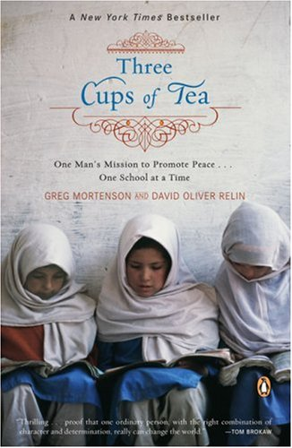
Like Reading Lolita in Tehran, Three Cups of Tea depicts young, veiled girls with their heads bowed. The difference between the two images, however, is immense. Mortenson’s book explores his adventures in peace making in Pakistan as he builds one school at a time. Unlike all of the previous books, Mortenson’s is far more nuanced in its understanding of not only veiling practices but also the role of women in Islam. The women in Mortenson’s and Relin’s book have strong personalities, make choices for themselves, and embrace education. In addition, these women hail from the most poverty-stricken, uneducated locales in the world. While both the cover of Reading Lolita in Tehran and Three Cups of Tea depict young, veiled girls with their heads bent, the latter clearly shows the girls reading. The former originally depicted girls reading, but the newspaper and context for their bowed heads was completely removed for the final image. While Three Cups of Tea is more of a biography about an American man who made it his mission to provide education for girls living in the most remote areas in Pakistan, it also offers a fairly nuanced picture of the lives and experiences of men and women in Pakistan.
Jasmine and Stars: The reader, therefore, moves from disaster to disaster without a moment’s relief: compulsory wearing of the veil, seclusion, divorce, physical violence, genital mutilation!
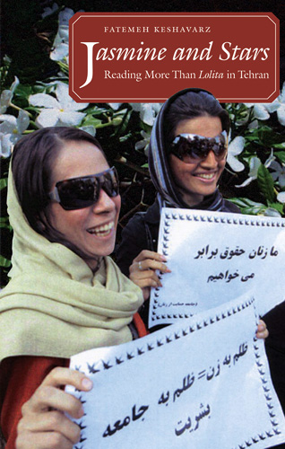
The final bookcover to explore is that of Jasmine and Stars by Fatemeh Keshavarz. This text is the antithesis of the previous New Orientalist narratives. Written largely in response to Reading Lolita in Tehran, this work of non-fiction explores the author’s experiences in Iran before, during, and after the revolution. The cover in the book is also in direct contrast with those previously explored. The cover depicts two women participating in a protest, holding signs, and smiling broadly. They are veiled, but this is not the focus of the photo. They are not directly facing the camera, but they are not depicted from the back either. Keshavarz’s book does have a certain level of bias – she is determined to paint a different picture of Iran than that created by Azar Nafisi. In some ways, Keshavarz is perhaps overly dismissive of problems that do exist in the Islamic world, but for the most part, Keshvarz manages to explore her experiences in Iran in such a way that challenges commonly held stereotypes of how Islam, including veiling, functions in society. In any case, the women in her narrative are multi-faceted and, seemingly, more representative of the diversity of experiences lived by women in the Islamic world.
Conclusions
After exploring the images from the covers of seven different books, what conclusions can we draw? What does the prevailing homogeneity of these images suggest about Western culture? What do they say about women in the East? Certainly, they say more about Western culture than the reality of life in the East. More of an epidemic during the twentieth century, Orientalism is, nevertheless, a problem that persists today, taking on new forms. Instead of Western scholars speculating about the East, New Orientalism often takes the form of an “insider” providing insight. Often journalists or “exiled Easterners,” these insiders often have an agenda, one that promotes traditional Orientalist values. The covers of their books reflect this.
While I do not intend on making a case for or against veiling, I believe a few observations should be made. Veiling has been particularly concerning to feminists, but is this justifiable? Many feminists argue that veiling is no more oppressive than what western women put themselves through in pursuit of Western conceptions of beauty. Fatema Mernissi suggests that men in both societies oppress their women, but in different ways. The West only allows youthful women to express their sexuality and only in certain ways. Islamic societies allow sexual expression but limit women’s physical space. Another scholar, Meyda Yegenoglu writes, “veiling is no more cruel or barbaric than the control, supervision, training, and constraining of bodies by other practices, such as bras, stiletto heels, corsets, cosmetics, and so on.” In any case, veiling is a complicated and nuanced practice that is far from black and white.
The West, however, is particularly fascinated with the practice of veiling. Scholar Robert J. C. Young writes, “the nature of the western response to the veil is to demand and desire its removal, so that strategies of liberation in the name of saving women supposedly forced to wear the veil coincide uncomfortably with the colonial violence of the veil’s forcible removal.” The West frames the practice of veiling in such a way that more is revealed of Western culture than of the women who participate in the practice. Further, the frame the West creates is potentially far more oppressive than the veil itself.
As explored before, veiling practices are far more varied than the bookcovers above would suggest. The images of burqa-clad women from the back denies the very same women the agency to face the camera, denies them their individuality. These covers of western bestsellers provide a sort of morbid satisfaction for the Western audience and foster a sense of Western superiority. What they deny is Muslim women her agency and independence. What they deny us in the West is an accurate, nuanced understanding of the practice of veiling. But a deeper understanding of the complex practice of veiling is not something that is particularly valued in the West. We are much more interested in defining the veiled woman as “other” and using this definition to define ourselves. These bookcovers confirm the belief that Western women are liberated, independent, and superior to veiled Eastern women. These images also further justify modern colonialism in the form of Westernization. While the United States may not be occupying Saudi Arabia, Iran, or Afghanistan, we certainly are exporting Western values and ideals, unveiling being just one such example. I would go so far as to suggest that these bookcovers also validate the continued occupation in Iraq and further involvement of the United States in the Middle East. In essence, these bookcovers are just part of a larger propaganda scheme that perpetuates the East/West schism that has been effectively exploited for so long.
This exploitation, however, is even more complex. I would argue that it also exploits modern feminism. Western feminists achieved a sense of equality not so long ago. The concept of feminism is still highly emotionally charged and with the taste of victory sweet on the lips, many Western feminists feel the next major crusade is to liberate Muslim women from the barbaric, oppressive practice of veiling. What these Western women do not understand is that they are “orientalizing” the issue - they are defining a situation in light of their own experiences – and the images explored above condone this attitude. The image of the burqa-clad woman from the back speaks to Western feminists need to liberate Muslim women from a practice they do not fully understand. In any case, women in the West have little place to pass judgment on women who chose to veil. Yegenoglu writes, “Only if we see the veiling of women in Muslim culture as a unique cultural experience, we can then actually learn what it is to veil or unveil as woman, rather than simply re-setting the liberal scene and repeating commonsensical and clichéd standards in the name of universal emancipation.”
In the end, the analyses of these images of veiled women suggests a homogeneity too obvious to be ignored. Shots of women wearing the burqa, from the back grace the covers of several American bestsellers, and these images perpetuate a New Orientalism that Fatemeh Keshavarz so aptly defines. This is not to suggest that there is no value in these texts. Instead, awareness is the key. These books must be approached with an awareness of the Orientalist practices that are being perpetuated within. More often than not, however, these bestsellers are read by the casual American. In these cases, both the text and the images on the cover subconsciously ingrain the concept of Orientalism further into the American psyche.

Kevin Tachman, “Her Feminine Mystique: The Veiled.” The New York Times Magazine, 29 June 2008, 55.
Sondra Hale, “The West and Veiling,” from the UCLA Center for Near Eastern Studies [electronic source]. http://www.international.ucla.edu
“In graphics: Muslim Veils” from BBC News [electronic source]. http://news.bbc.co.uk/2/shared/spl/hi/pop_ups/05/europe_muslim_veils/html/1.stm
Edward Said, Orientalism. (New York: Vintage Books, 1978), 1.
Said, Orientalism, 20.
Meyda Yegenoglu, “Sartorial Fabric-ations: Enlightenment and Western Feminism,” in Postcolonialism, Feminism, and Religious Discourse, edited Laura E. Donaldson and Kwok Pui-Lan (New York: Routledge, 2002), 84.
Yeganoglu, “Sartorial Fabric-ations,” 93.
Khaled Hosseini, A Thousand Splendid Suns. (New York: Riverhead Books, 2007), 329.
Fatemeh Keshavarz, Jasmine and Stars: Reading More than Lolita in Tehran. (Chapel Hill: University of North Carolina Press, 2007), 3.
Yasmina Khardra, The Swallows of Kabul. (New York: Anchor Books, 2002), 97.
Asne Seierstad, The Bookseller of Kabul. (New York: Back Bay Books, 2002), 84.
Geraldine Brooks, Nine Parts of Desire: The Hidden World of Islamic Women. (New York: Anchor Books, 1995), 13.
Azar Nafisi, Reading Lolita in Tehran. (New York: Random House, 2004), 167.
Keshavarz, Jasmine and Stars, 18.
Greg Mortenson and David Oliver Relin, Three Cups of Tea: One Man’s Mission to Promote Peace…One School at a Time. (New York: Penguin Books, 2006), 32.
Keshavaraz, Jasmine and Stars, 116-117.
Faisal al Yafai, “What Western Feminists Should do About the Veil: Abandon the obsession with clothing and focus on what really matters in terms of women’s struggle in the Muslim world.” Electronic source. http://www.guardian.co.uk/commentisfree/2008/sep/08/religion.gender/print
Meyda Yegenoglu, “Sartorial Fabric-ations,” 93.
Robert J.C. Young, Postcolonialism. (Oxford: Oxford University Press, 2003), 86.
Yeganoglu, “Sartorial Fabric-ations,” 97.

