The scientific study of behavior

Ethogram

The application of the scientific method requires that behavior is quantified in a standardized way so that measures of frequency or duration or intensity can be compared by statistical inference among experimental groups, and broadly comparable among different investigators. There are many approaches to quantifying behavior, but before we can do that we must first have a precise and unambiguous classification of behavior. This is accomplished through the development of an ethogram.

An ethogram is a description of an animal's behavioral repertoire. Ethograms are typically organized into general categories, i.e. locomotory behavior, foraging behavior, antipredator behavior, social behavior, courtship behavior, etc. These categories imply the function of the behavior. However, the names of individual behaviors should not imply function but simply describe the motor pattern observed. For example: tail raise, wing spread, head bobbing, foot stamping, etc. The reason for function-neutral names for behaviors is that individual behaviors may be used in more than one context. For example, tail raise may serve to signal the presence of a predator (antipredator signal), and also as a signal for copulation (courtship signal).

Ethogram descriptions are surprisingly difficult to do well. Strive to be as clear and succinct as possible. To say "it moves its leg back and forth" is not as clear as "the leg is drawn anteriorly until the leg is parallel to the ground then quickly pulled posteriorly and ventrally. This sequence is repeated in rapid succession about 3 or 4 times per second for 5 to 10 seconds." A reader not familiar with the animal should be able to recognize the described behavior if they spend time watching its behavior.

Agonistic behaviors

Many animals establish social hierarchies through agonistic behavior. Agonistic behavior includes acts of aggression (threat displays, overt fighting, chasing) and acts of submission and appeasement. Social hierarchies are important because they often determine the distribution of resources (access to food, shelter and mates) and ultimately to differential reproductive success. Thus, there is often intense selection for effective agonistic behavior. This takes two forms: the first is that while forms of aggression that result in victory are rewarded, aggression that includes a risk of injury is not rewarded. Thus, we can predict (and subsequently observe) that many animals settle contests through display rather than direct contact. If displays honestly indicate the animal’s fighting ability then the contestants can determine winner and loser without having to risk injury or death through fighting. Only when contestants are closely matched in fighting ability do contests escalate to physical fighting. The second form of agonistic behavior is signaling submission to avoid escalation. An animal that cannot indicate subordinate status will be attacked by competitively superior individuals and be injured or killed.
Fiddler Crab Behavior

Fiddler crabs are crustaceans in the genus Uca that inhabit sandy and marshy shores of temperate and tropical coasts around the world. There are 97 species of Uca. Uca pugilator, the sand fiddler, is the predominant species on the Atlantic and Gulf coast of Florida. Other local species include U. panacea, U. longisignalis, U. speciosa, and U. minax (which live in low salinity environments).

Male fiddler crabs have one enlarged claw that they use to display to females and to rival males. Fiddler crabs are semiterrestrial, living in closely grouped burrows in the intertidal zone and feeding on nearby beaches or marsh areas. The crabs must be near saltwater for two reasons. First, they must keep their gills moistened and second, their offspring are planktonic. Multiple species are commonly found living in the same area, but may be separated by substrate type or variations in moisture availability. U. pugilator is commonly found in sandy areas where as U. longisignalis is commonly found in areas with muddy substrate.

Fiddlers construct individual burrows, which they maintain and defend. These burrows can reach depths of 60cm and are usually surrounded by small balls of extruded sediment on the surface. During periods of high tide, crabs retreat to their burrows and wait for low tide. Upon surfacing, crabs feverishly repair their burrows and feed. Fiddler crabs groom the surface, pulling fungus, bacteria, and detritus from the substrate. Once all the nutrients have been removed from the sediment it is deposited as a small ball outside of the burrow.

Fiddler crabs darken during the day light hours and turn lighter as the daylight recedes. This coloration is also tidally induced resulting in a daily rhythmic color change. The social behavior of the crabs is also rhythmic. Activities like display, territory protection, wandering, and mating are associated with the crab’s diurnal patterns. These are especially noticeable around period of mating and larval release, which is usually near full and new moons when tidal flow is highest.

Fiddler Crab ID
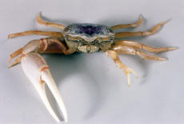  Male Uca pugilator | Male Uca longisignalis | Male Uca speciosa | Male Uca minax
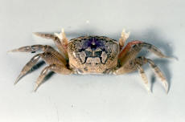  Female Uca pugilator |  | generally green-brown, brown or gray. Chelae are typically white. | chestnut brown with a gray color in the front. The claws of this crab has red joints

Pratt AE, McLain DK & Lathrop GR. 2003. The assessment game in sand fiddler crab contests for breeding burrows. Animal Behaviour 65, 945-955.

Assignment

Our lab today will test the effect of body size, claw size and sex on the use of agonistic behavior to establish dominance hierarchy in groups of fiddler crabs. We will use Pratt et al. (2003) as the model for our data collection.

We have 25 fiddler crabs in the lab of varying sizes. Only males have an enlarged claw (sometimes left-handed, sometimes right-handed). Another way to distinguish the sexes is by the shape of their abdomen. Females have a broad and rounded abdomen (kept tucked up against the cephalothorax) while males have a slender abdomen (below).
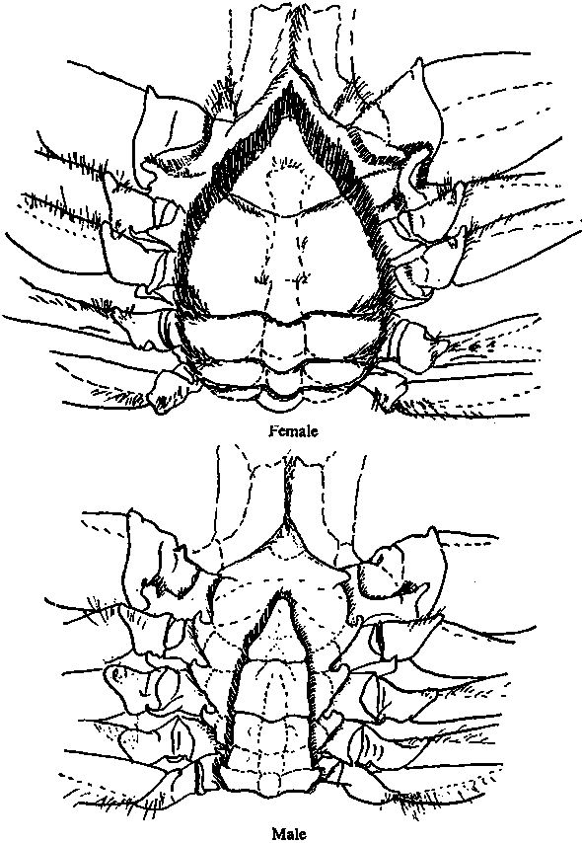

Female Male

Step 1: Observe the crabs and watch the specific behaviors they exhibit. We will discuss as a class the definitions of agonistic behaviors for our ethogram so that we all use the same terms to describe the same actions. Then we will create 5 replicate social groups in tubs of mud.

Score the number of agonistic acts given and received by each crab for 10 min. Then repeat these observations for another 10 min. Average these two trials together to produce a behavioral ranking score. Use calipers to measure the maximum width of the carapace and length of the enlarged claw of males.

Hand in:
- Ethogram of agonistic behaviors used
- Graph of class data of mean social rank as a function of rank of carapace width
- Graph of class data of mean social rank as a function of rank of claw length (for males)
- Answers to these questions:
  - What was the effect of body size, claw size and sex on social hierarchy?
  - Why is the enlarged claw found only on males?

