Visualizing acoustic signaling by birds

Communication is a two-way co-evolved process between a sender and a receiver (Fig below was modified from Bradbury and Vehrencamp 2011).

Information
Environment
Sender Receiver:

detect, decide, respond

Senders transmit a signal containing information through the environment. The environment imposes selection on signals because some forms of stimuli transmit through the environment more effectively than others do. Receivers detect the signal and decode its meaning. Therefore, there is selection that promotes receivers that elaborate sensory receptors for detecting signal presence and discerning subtle distinctions in signal quality. Concomitantly, there is selection on senders to maximize the detectability of their signal. To increase detectability, senders employ signals that stand out against the background environment, use behaviors and sensory stimuli (sound, color, odor, mechanosensory) that maximally stimulate sensory receptors of intended receivers and minimize detection by unintended receivers. Senders also ritualize their signals (exaggerate, stereotype, simplify) because receivers are more likely to evolve detection mechanisms (receptors, behavioral responses) when signals are reliably performed.

Dialects:
There are genetic and environmental components to the acquisition of song in many bird species. A genetically-based sub-song is matched with a model song (usually sung by the father) experienced during a sensitive period in early development. Upon sexual maturity the bird starts with the sub-song and repeats it until it sounds exactly like the model song it has in its memory. The learned component of bird song creates the conditions for the formation of regional dialects. Dialects form by random drift (as with people), regional differences in environmental sound transmission properties or interference with other species (other bird species with similar songs, predators that may be attracted to certain song elements). A celebrated example of song dialects is the case of white-crowned sparrows along the west coast of North America. Up to 13 distinct dialects have been identified


Proximate Cause Case Study: The White Crowned Sparrow.
Taken from http://www.as.wvu.edu/daly/438/ch2.htm
Distribution
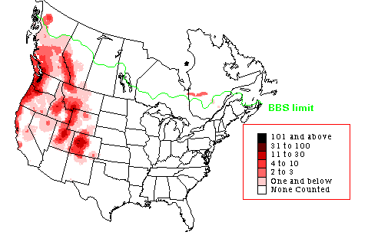
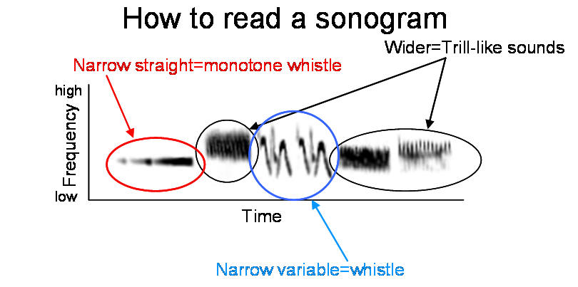
Permission to use this material generously supplied by Doug Neilson Director of the Borror Lab at OSU.
Song learning: Modern experimental studies of song learning in birds began in the 1950's in laboratory of W.H. Thorpe. He and Peter Marler hand-reared from an early age and showed that young male song birds learn their songs from adults of the same species. If a bird is reared without hearing the normal adult song of its species, a simplified "isolate" song is produced.
A song developed by a male white-crowned sparrow raised in the laboratory from the age of 5 days without hearing the song of an adult.
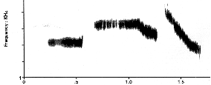

A song developed by a male white-crowned sparrow that was tutored early in the first 2 months of life with a white-crowned sparrow song.
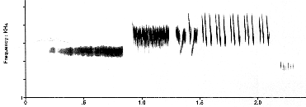

Here is the tape-recorded song he was tutored with. Notice there are small differences between the tutor and the imitation, but overall the copy is quite good. These small learning errors or improvisations introduce individual variation into the local populations of songs.
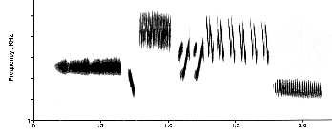

Song learning facts:
- Juveniles can sing but need adult examples from which to learn to produce normal song.
- Juveniles have a preference/learn songs of their species better than they learn other species songs.
- There is variability across individuals
Stages of song development
Normal song development proceeds through a series of stages:
- In the first, the young male memorizes the songs of one or more adult birds. In many species, males are most sensitive to memorize songs in the first few months of life, the so-called "sensitive phase."
- Actual vocal production begins during or soon after the sensitive phase when the male begins subsong. Subsong has been compared to babbling in human infants. The function is still not clear, but only song birds go through this stage; birds that do not learn to sing do not produce subsong. Here is a seven second long segment of subsong performed by a 240 day old white-crowned sparrow. In the laboratory, hand-reared birds perform subsong throughout their first autumn and winter.
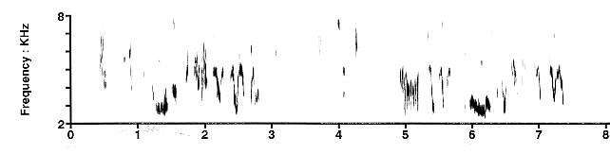
- As days lengthen in the late winter and early spring, subsong gives way to plastic song, in which the first evidence of imitations of tutors appears in the male's singing. Shown below is a 9 second long segment of plastic songs by a 260 day old sparrow (the 5-10 sec long quiet intervals between successive songs have been shortened to 2 secs here) containing three different songs. The three tutors that the male memorized during the sensitive phase are shown above, and are connected by arrows to the young male's imitations. Note that in plastic song, imitations are often incomplete. Also, note that the last song is a "hybrid" song composed of parts of two different tutor songs. This male is "overproducing," he sings more imitations than eventually appear as his final crystallized song. Click on each of the three tutors and the segment of plastic song to hear them, and compare the young male's imitations to his tutors.
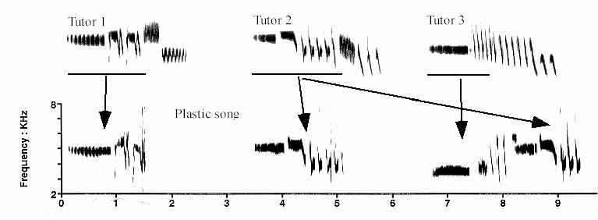
- After 35 days the same male is singing his single crystallized song type. The first song is the tape playback, 3 seconds later the male responds with his rendition of the matching song type. He has stopped singing his imitations of Tutors 2 & 3, (above) and will retain his crystallized imitation of Tutor 1. This is an example of selective attrition of songs from the overproduced plastic song repertoire, guided by hearing the song of another bird.
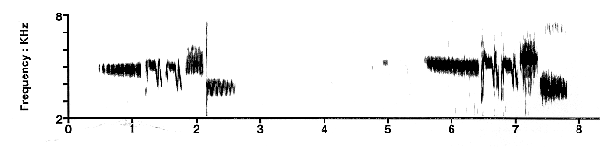
Songs of the Puget Sound white-crowned sparrow can be grouped into about 12 dialects spanning the Pacific Northwest coast from northern California to British Columbia. Shown on the next page are sound spectrograms of 10 dialects along with their geographic distributions. Two small dialects, 8 and 9, on Whidbey and Camano Islands, Washington are not illustrated. Dialects are numbered in the approximate order in which they were discovered by Luis Baptista (1977), Mike Baker (1987), Glen Chilton and Ross Lein (1996) and our own work. Dialect 4 is probably extinct.



Lab Objectives:
- Review the biology of song acquisition in birds
- Understand the basic principles of communication theory
- Discover evidence of the evolution of signal design
- Gain experience with a common tool for visualizing bird song

Raven software

We can hear bird calls and song, but studying bird song in a systematic way requires the use of tools that allow visualization and quantification of aspects of song. The Bioacoustics Research Program at Cornell University has developed Raven® software for this purpose. The Raven Lite version is a free download at: http://www.birds.cornell.edu/brp/Raven/RavenOverview.html

Go to this url and download the software.

Retrieve bird songs (passerines are the most interesting) from the internet at one of these sites. Save the sound file as a *.wav file on your computer. Then open it in Raven to visualize the song. Try playing it. Adjust the rate to 0.5 or 0.1. Play the song backwards. Import several songs and get familiar with the software.

There are many on line sources of bird song files. Here are two:
http://www.naturesongs.com/birds.html
http://www.bio.umass.edu/biology/kunkel/gjk/homepage.htm

Source of content below: http://aba.org/birding/v43n1p26w1.html

White-crowned Sparrows and the Evolution of Song
January 2011 Birding, News and Notes, WebExtra
by Paul Hess

Urban noise is well known as an agent of change in the structure and style of birdsong, but natural conditions beyond the hubbub of cities also govern variations in vocal characteristics.
For example, in 2003 Timothy Brown and Paul Handford reported contrasting effects of atmospheric conditions in open fields and closed forest areas on the structure and style of Swamp Sparrow and White-throated Sparrow songs (Ibis145:120–129; see Birding, April 2004, p. 129). Handford additionally explained how acoustic features of various habitats can promote different song dialects in the Rufous-collared Sparrow (Zonotrichia capensis) in South America (Birding, September/October 2005, pp. 510–519).
Elizabeth Derryberry now demonstrates in a series of papers how song variations in differing natural environments and in periods several decades apart may affect crucial aspects of White-crowned Sparrows’ territorial and mating behavior—and perhaps even influence the species’ evolutionary future.
Her results suggest that increased differences among local populations’ songs may become barriers to gene flow among these populations. Conceivably, an eventual result of such barriers could be speciation, although Derryberry does not speculate directly about that potential outcome.

In her initial paper of 2007 (Evolution 61:1938–1945), Derryberry compares White-crowned Sparrows’ responses to songs recorded by the late Luis Baptista at California’s Tioga Pass in 1979 with responses to songs she recorded at the same location in 2003. Acoustic features of these vocalizations in this population of the oriantha subspecies changed during the quarter-century in three ways. The whistled portion decreased in dominant frequency, and the trill decreased in rate and increased in frequency bandwith. Hear these differences in sound files and see them in sound spectrograms (“sonograms”) provided by Derryberry for Birding to accompany this WebExtra.

Current females’ mating response and current males’ territorial response to the contemporary songs differed appreciably from their responses to the historical songs. Females gave more solicitations for copulation during playback of the current songs, indicating a preference for males that sing the contemporary version. Males approached a playback speaker more closely when the current song was played, suggesting a stronger territorial reaction. The old songs were clearly not so meaningful as the new ones.

The second paper in 2009 (American Naturalist 174:24–33) evaluates mechanisms that might drive changes in song. One result of Derryberry’s study associates differences in White-crowned Sparrows’ trills with differences in density of vegetation in the birds’ habitat.

Derryberry compared songs of the oriantha, pugetensis, and nuttalli subspecies recorded at five locations in 1969–1971 with songs she recorded in 2005 at the same locations. Trills in the recent songs were slower and had lower minimum frequencies. Meanwhile, measurements from aerial photographs taken at those locations in approximately the same two time periods showed that scrub vegetation had increased in density. Based on principles of sound transmission, the changes in trill rate and structure were what Derryberry had predicted for optimum transmission of the signal in more densely vegetated surroundings.
Her third paper, published online in 2010 in Biology Letters , explores male White-crowned Sparrows’ response to territorial song variations from both a historical and a geographic perspective. She compared males’ responses to current and historical songs in their local area at Tioga Pass, to current songs in another oriantha population about 50 kilometers north at Sonora Pass, California, and to songs in a population about 600 kilometers away at Manzanita in coastal northwestern Oregon.

Males at Tioga Pass responded most strongly to current local songs. They responded less strongly to songs recorded one to several decades previously in their local area and to current songs at Sonora Pass. They responded least strongly to songs of the distant population in Oregon. The analysis suggests that males’ different levels of response are based on how a song’s frequency, tempo, and duration differ from songs they currently experience in their local population. Once again, the study indicates how differences in birds’ learned songs and corresponding responses in behavior can evolve rapidly over time spans as short as several decades.

Derryberry’s studies of White-crowned Sparrow song continue, this time in collaboration with David Luther, whose recent paper on the effect of urban noise on the species’ song in San Francisco is described in Birding (January 2011, pp. 27–28). Luther compared current urban songs with those Luis Baptista had famously recorded there three decades previously. The recent urban songs were higher in minimum frequency than the historical versions, whereas songs’ frequencies studied by Derryberry in rural areas changed in the opposite direction from songs Baptista had recorded in those same areas.
During the 2010 breeding season, Luther and Derryberry tested how males in San Francisco’s Presidio neighborhood responded to these changes in song. They expect their results to be published soon.
This sound spectrogram (“sonogram”) and corresponding audio files provided to Birding by Elizabeth Derryberry demonstrate how White-crowned Sparrows’ songs have evolved between 1979 and 2003 in a population at Tioga Pass, California.

The sonogram compares a song recorded by Luis Baptista at that location in 1979 with a song recorded there by Elizabeth Derryberry in 2003. The first segment is a whistle, and the last segment is a trill. Note in the sonogram how the whistle has decreased in frequency and how the trill has both decreased in rate and increased in bandwidth between 1979 and 2003. The two sound files bring these changes to life, and the difference is clearly evident.

White-crowned Sparrow
song recorded in 1979 at Tioga Pass, California.
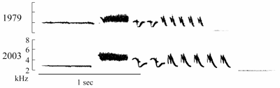
Play sound file
(Right click to download sound file.)

White-crowned Sparrow
song recorded in 2003, also at Tioga Pass.
Play sound file
(Right click to download sound file.)

